Name: ____________________________ Date: ____________________ Period: ____

Unit 1 Review Packet: Introduction to AP Biology and Biochemistry

Textbook Chapters: 2 (Chemistry of Life), 3 (Properties of Water), 4 (Carbon Chemistry), and 5 (Macromolecules)

Standards and Measures of Success: see Unit 1 Objectives list distributed mid-unit

Review Resources: Notes, Reading Guides, Macromolecule Modeling Worksheet, Ch. 2 and 3 Quiz

Test Format: 36 multiple choice questions and three short answer questions (you should be able to answer these in approximately 4-6 sentences)

Key Vocabulary:
Atom  Proton/Neutron/Electron  Electronegativity  Ion  Isomer  Valence Electrons  Polar  Hydrophilic / Hydrophobic  Hydrogen bond  Covalent bond  Ionic Bond  Van der Waals Attraction  Cohesion/Adhesion  Surface tension | Capillary Action/Transpiration  Specific heat  Heat of vaporization  Evaporative cooling  Solvent  Carbon skeleton  Isomers (know all types)  Functional groups (know all types)  pH  Acid/Base  Buffer  Homeostasis  Polymer/Dehydration reaction | Hydrolysis  Mono/Di/Polysaccharide  Starch/Glycogen/Cellulose  Glycerol/Fatty Acids  Triglyceride  Saturated/Unsaturated  Phospholipid  Steroid  Amino acid  Primary/Secondary/Tertiary/  Quaternary Protein structure  Denaturation  Nucleotide

Sample Questions: For this unit, I will be giving you sample questions for each topic. In the future, we will write these questions as a class.

- Which bonds are found within/inside a single molecule, and which are found between molecules?

- Explain how the polarity of a covalent bond has to do with the electronegativity of the two atoms involved in that bond.

- Do carbon and hydrogen atoms form polar covalent or nonpolar covalent bonds? How do you know?

- Explain the process involved in the formation of van der Waals attractions. Are they strong or weak bonds?

- How does an ionic bond differ from a covalent bond?

- How is pH related to hydrogen ion concentrations? When the pH value goes up by one, what happens to the hydrogen ion concentration?

- What is a buffer, and how does it help to regulate pH values? Provide an example of a buffer in a living organism.

- Describe how the polarity of a water molecule (regions of positive and negative charge) allows hydrogen bonding between different water molecules.

- Explain how polarity and hydrogen bonding enable the following properties of water.

- Cohesion

- Adhesion:

- Surface Tension:

- High Specific Heat

- High Heat of Vaporization

- Low Density as a Solid

- Which type of substance—polar or nonpolar—is most soluble in water (dissolves in water)?

- What types of bonds are found between hydrogen and oxygen atoms in a water molecule? ______________________
What types of bonds are found between hydrogen and oxygen atoms of TWO DIFFERENT water molecules? _____________________

- Explain how the addition of a hydroxyl group (OH) to a hydrocarbon chain makes the molecule more soluble in water?

- Draw a picture of the dissociation of NaCl (an ionic compound) in water. To help you out, I’ve gotten you started by breaking NaCl into its component ions—Na⁺ and Cl⁻. Show how water molecules surround each of the ions.

Cl⁻
Na⁺

- Explain how carbon’s electron configuration makes it an ideal atom for creating long chains, such as we see in a fatty acid.

- Provide an example of the following types of isomers: geometric, structural, and enantiomers. Are the different structures of isomers biologically significant?

- Hexose sugars have ____(#) carbons. Glucose, an example of a hexose sugar is a monosaccharide / disaccharide / polysaccharide (circle one).

- Explain the structural AND functional differences between the following types of polysaccharide – cellulose, starch, and glycogen.

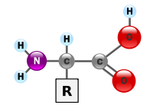
- Identify each part of the amino acid pictured to the right.

- Explain the process of polymerization / dehydration synthesis, making sure to describe the role of water molecules in the process.

- Explain the process of hydrolysis, making sure to describe the role of water molecules in the process.

- Identify the locations and types of bonds involved in each of the four levels of protein structure.

Level | Locations and Types of Bonds
Primary

Secondary

Tertiary

Quaternary

- Identify each of the following molecules as a carbohydrate, lipid, nucleic acid, or protein.
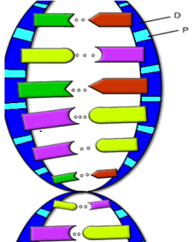
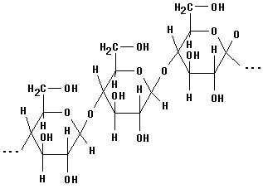
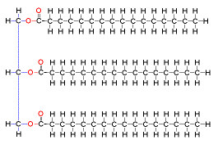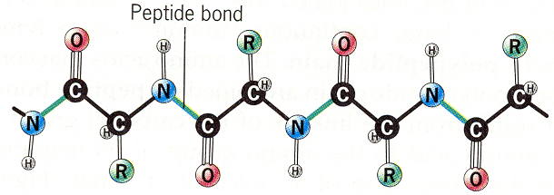

- Explain the meaning of the following statement with regard to the four macromolecules: structure determines function.

- What happens to a protein molecule when it denatures? How does this affect the protein’s ability to perform its specific function?

