Name: _____________________________________________ Date: ____________________________ Period: ______

AP Biology Exam Review: Cell Energy – Enzymes, Photosynthesis, and Cell Respiration (Unit 3)

Textbook Chapters: 8 (An Introduction to Metabolism), 9 (Cellular Respiration), 10 (Photosynthesis)

Helpful Videos and Animations: See links on Wiki page
- Bozeman Biology: Gibbs Free Energy
- Bozeman Biology: Life Requires Free Energy
- Bozeman Biology: Coupled Reactions
- Bozeman Biology: Enzymes
- Bozeman Biology: Positive and Negative Feedback Loops
- Bozeman Biology: Photosynthesis and Respiration
- Bozeman Biology: Photosynthesis
- Bozeman Biology: Cellular Respiration

Topic Outline:

- Metabolism is the sum total of an organism’s chemical reactions
- Know the difference between an anabolic and catabolic pathway
- Know the difference between kinetic and potential energy
- Understand why chemical energy is a form of potential energy
- Know the two laws of thermodynamics (the study of energy transformations that occur in matter)
- 1st Law = the energy of the universe is constant (energy can be transferred and transformed but it cannot be created or destroyed)
- 2nd Law = every energy transfer or transformation increases entropy (the amount of disorder or randomness in the universe)
- Know the differences between an exergonic or endergonic reaction (do they proceed spontaneously, do they have a positive or negative delta G?, etc.)
- Know how energy coupling can capture the energy released by an exergonic reaction (ex: the hydrolysis of ATP) to power an endergonic reaction

CC 2.A.1
a. Life requires a highly ordered system.
Evidence of student learning is a demonstrated understanding of each of the following:
1. Order is maintained by constant free energy input into the system.
2. Loss of order or free energy flow results in death.
3. Increased disorder and entropy are offset by biological processes that maintain or increase order.
b. Living systems do not violate the second law of thermodynamics, which states that entropy increases over
time.
Evidence of student learning is a demonstrated understanding of each of the following:
1. Order is maintained by coupling cellular processes that increase entropy (and so have negative
changes in free energy) with those that decrease entropy (and so have positive changes in free energy).
2. Energy input must exceed free energy lost to entropy to maintain order and power cellular
processes.
3. Energetically favorable exergonic reactions, such as ATP→ADP, that have a negative change in free
energy can be used to maintain or increase order in a system by being coupled with reactions that have
a positive free energy change.
c. Energy-related pathways in biological systems are sequential and may be entered at multiple points in the
pathway.
To demonstrate student understanding of this concept, make sure you can explain the following:
- Krebs cycle
- Glycolysis
- Calvin cycle
- Fermentation
d. Organisms use free energy to maintain organization, grow and reproduce.
Evidence of student learning is a demonstrated understanding of each of the following:
1. Excess acquired free energy versus required free energy expenditure results in energy storage or
growth.
2. Insufficient acquired free energy versus required free energy expenditure results in loss of mass and,
ultimately, the death of an organism.

- Enzymes
- Know how enzyme catalysts affect a reaction curve for an exergonic and endergonic reaction
- Be able to use the following vocabulary terms when describing enzyme function: catalysts, activation energy, active site, substrate, enzyme-substrate complex
- Understand how pH, temperature, substrate concentration, and enzyme concentration changes affect the efficiency of the enzyme
- Describe how the lock and key model of enzyme function is different from the induced fit model of enzyme function (Which one is more accurate?)
- Explain how cofactors and coenzymes assist with enzyme function
- Explain how competitive vs. noncompetitive inhibitors affect enzyme function
- Explain how allosteric regulation functions in feedback inhibition (both positive and negative feedback)
CC 4.B.1-
a. Change in the structure of a molecular system may result in a change of the function of the system.
b. The shape of enzymes, active sites and interaction with specific molecules are essential for basic functioning
of the enzyme.
Evidence of student learning is a demonstrated understanding of each of the following:
1. For an enzyme-mediated chemical reaction to occur, the substrate must be complementary to the
surface properties (shape and charge) of the active site. In other words, the substrate must fit into the
enzyme’s active site.
2. Cofactors and coenzymes affect enzyme function; this interaction relates to a structural change that
alters the activity rate of the enzyme. The enzyme may only become active when all the appropriate
cofactors or coenzymes are present and bind to the appropriate sites on the enzyme.
c. Other molecules and the environment in which the enzyme acts can enhance or inhibit enzyme activity.
Molecules can bind reversibly or irreversibly to the active or allosteric sites, changing the activity of the
enzyme.
d. The change in function of an enzyme can be interpreted from data regarding the concentrations of product
or substrate as a function of time. These representations demonstrate the relationship between an enzyme’s
activity, the disappearance of substrate, and/or presence of a competitive inhibitor.

- Cellular Respiration
- Explain the difference between aerobic cellular respiration and anaerobic cellular respiration (aka fermentation)
- Write the full balanced chemical equation for cellular respiration
- Cell Respiration = Exergonic
- A Series of Redox Reactions: Oxidation (loss of electrons / energy) ; reduction (gain of electrons / energy)
- Gycolysis
- In cytosol
- Glucose 2 Pyruvate (electrons and H+ taken from glucose to reduce 2 NAD+ 2NADH ; 2 net ATP gained)
- Oxidation of Pyruvate
- Transport protein moves pyruvate from cytosol to matrix of mitochondrion
- 2 Pyruvate 2 Acetyl CoA (an enzyme removes CO2, takes away electrons to reduce NAD+ NADH, and adds coenzyme A)
- Citric Acid Cycle
- 2 turns of the cycle (1 per acetyl CoA) one molecule of glucose is fully oxidized to CO2
- A series of oxidation / reduction reactions produces 2CO2, 3NADH, 1FADH2 (another electron / hydrogen carrier) and 1 ATP per turn of the cycle (Total = X2)
- Electron Transport Chain + Chemiosmosis
- ETC NADH and FADH2 “dump” electrons off to the inner mitochondrial membrane’s electron transport chain proteins use energy from electrons passed between them to “pump” H+ across the inner mitochondrial membrane into the intermembrane space
The final electron acceptor is O2 H2O
- Chemiosmosis H+ flow back down their gradient (proton motive force) through a channel in ATP synthase into the matrix ATP synthase turns and creates ATP from ADP and Pi
Chemiosmosis is an energy-coupling mechanism that uses energy stored in the form of an H+ gradient across a membrane to drive cellular work (creation of ATP by ATP synthase)
This method of making ATP is known as oxidative phosphorylation (ADP is phosphorylated and oxygen is necessary to keep the electrons flowing)
Oxidative phosphorylation accounts for 26-28 of the 30-32 total ATP created during cellular respiration
- Fermentation / Anaerobic Respiration (creating ATP without oxygen)
- An expansion of glycolysis (the Kreb’s / Citric Acid Cycle and Electron Transport Chain are not used)
- Glycolysis 2 ATP
- Reactions that regenerate NAD+ to act as an electron acceptor for electrons released during the breakdown of glucose to pyruvate
2 Types of Fermentation = alcohol fermentation and lactic acid fermentation
Alcohol Fermentation pyruvate is converted to ethanol, releasing CO2 and regenerating NAD+ from NADH
Lactic Acid Fermentation pyruvate is reduced by NADH (NAD+ is formed in the process), and lactate is formed as a waste product
- Facultative anaerobes can use aerobic respiration if oxygen is present but can switch to fermentation under anaerobic conditions ; obligate anaerobes cannot survive in the presence of oxygen

- Photosynthesis
- Know the difference between autotrophs and heterotrophs
- Know the structure of a chloroplast and the location of cells with high concentrations of chloroplasts (mesophyll tissue of leaf) ; Be able to identify the following structures within a chloroplast – stroma, thylakoid,granum, thylakoid space
- Know the location of stomata on a leaf’s surface (bottom surface) and their function in transpiration and gas exchange (How do stomata open and close?)
- Know the full balanced chemical equation for photosynthesis
- Summary of the two steps in photosynthesis: Light Reactions and Calvin Cycle
- Light Reactions (in thylakoid membrane)
-Light is absorbed by chlorophyll and drives the transfer of electrons from water to NADP+ NADPH
-Water is split when electrons are removed, and O2 is released from the stomata
-ATP is generated, using chemiosmosis to power the addition of a phosphate group to ADP ATP in a process called photophosphorylation
-Vocabulary: photons, pigments, chlorophyll, carotenoids / accessory pigments, absorption spectrum of a pigment, action spectrum for photosynthesis, photosystems (I and II), reaction centers, primary electron acceptor
-Key Skills: Explain the difference between linear (noncyclic) electron flow and cyclic electron flow
- Calvin Cycle
-electrons and H+ from NADPH and energy from ATP are used to reduce CO2 into organic molecules (Glyceraldehyde-3 Phosphate / G3P… the precursor molecule to glucose) in a process called carbon fixation
-Vocabulary: ribulose bisphosphate (RuBP), rubisco, glyceraldehydes 3-phosphate (G3P)
-Key Skills: Describe the role of the rubisco enzyme in carbon fixation
- Understand how C4 and CAM plants fix carbon in hot, arid climates where stomata must remain closed at times ; know the difference between spatial and temporal separation (Remember, normal plants = C3 plants)
Vocabulary: photorespiration, bundle-sheath cells, mesophylol cells, PEP carboxylase

CC 2.A.2 -
a. Autotrophs capture free energy from physical sources in the environment.
Evidence of student learning is a demonstrated understanding of each of the following:
1. Photosynthetic organisms capture free energy present in sunlight.
2. Chemosynthetic organisms capture free energy from small inorganic molecules present in their
environment, and this process can occur in the absence of oxygen.
b. Heterotrophs capture free energy present in carbon compounds produced by other organisms.
Evidence of student learning is a demonstrated understanding of each of the following:
1. Heterotrophs may metabolize carbohydrates, lipids and proteins by hydrolysis as sources of free
energy.
2. Fermentation produces organic molecules, including alcohol and lactic acid, and it occurs in the
absence of oxygen.
c. Different energy-capturing processes use different types of electron acceptors.
To demonstrate student understanding of this concept, make sure you can explain
- NADP+ in photosynthesis
- Oxygen in cellular respiration
d. The light-dependent reactions of photosynthesis in eukaryotes involve a series of coordinated reaction
pathways that capture free energy present in light to yield ATP and NADPH, which power the production of
organic molecules.
Evidence of student learning is a demonstrated understanding of each of the following:
1. During photosynthesis, chlorophylls absorb free energy from light, boosting electrons to a higher
energy level in Photosystems I and II.
2. Photosystems I and II are embedded in the internal membranes of chloroplasts (thylakoids) and are
connected by the transfer of higher free energy electrons through an electron transport chain (ETC).
3. When electrons are transferred between molecules in a sequence of reactions as they pass through
the ETC, an electrochemical gradient of hydrogen ions (protons) across the thykaloid membrane is
established.
4. The formation of the proton gradient is a separate process, but it is linked to the synthesis of ATP
from ADP and inorganic phosphate via ATP synthase.
5. The energy captured in the light reactions as ATP and NADPH powers the production of
carbohydrates from carbon dioxide in the Calvin cycle, which occurs in the stroma of the chloroplast.
e. Photosynthesis first evolved in prokaryotic organisms; scientific evidence supports that prokaryotic
(bacterial) photosynthesis was responsible for the production of an oxygenated atmosphere; prokaryotic
photosynthetic pathways were the foundation of eukaryotic photosynthesis.
f. Cellular respiration in eukaryotes involves a series of coordinated enzyme-catalyzed reactions that harvest
free energy from simple carbohydrates.
Evidence of student learning is a demonstrated understanding of each of the following:
1. Glycolysis rearranges the bonds in glucose molecules, releasing free energy to form ATP from ADP
and inorganic phosphate, and resulting in the production of pyruvate.
2. Pyruvate is transported from the cytoplasm to the mitochondrion, where further oxidation occurs.
3. In the Krebs cycle, carbon dioxide is released from organic intermediates ATP is synthesized from
ADP and inorganic phosphate via substrate level phosphorylation and electrons are captured by
coenzymes.
4. Electrons that are extracted in the series of Krebs cycle reactions are carried by NADH and FADH2 to
the electron transport chain.
g. The electron transport chain captures free energy from electrons in a series of coupled reactions that
establish an electrochemical gradient across membranes.
Evidence of student learning is a demonstrated understanding of each of the following:
1. Electron transport chain reactions occur in chloroplasts (photosynthesis), mitochondria (cellular
respiration) and prokaryotic plasma membranes.
2. In cellular respiration, electrons delivered by NADH and FADH2 are passed to a series of electron
acceptors as they move toward the terminal electron acceptor, oxygen. In photosynthesis, the terminal
electron acceptor is NADP+.
3. The passage of electrons is accompanied by the formation of a proton gradient across the inner
mitochondrial membrane or the thylakoid membrane of chloroplasts, with the membrane(s) separating
a region of high proton concentration from a region of low proton concentration. In prokaryotes,
the passage of electrons is accompanied by the outward movement of protons across the plasma
membrane.
4. The flow of protons back through membrane-bound ATP synthase by chemiosmosis generates ATP
from ADP and inorganic phosphate.
5. In cellular respiration, decoupling oxidative phosphorylation from electron transport is involved in
thermoregulation.
h. Free energy becomes available for metabolism by the conversion of ATP→ADP, which is coupled to many steps in metabolic pathways.

Practice Multiple Choice Questions

1. An airtight, temperature-controlled glass box containing actively growing tomato plants was placed under a light source. Plastic wrapping that only transmits green light was placed over the box, and two days later air samples from inside the box were collected and analyzed. The most likely change in air quality is
(A) an increase in nitrogen (N2)
(B) an increase in carbon dioxide (CO2)
(C) an increase in oxygen (O2)
(D) a decrease in carbon dioxide (CO2)

2. Which of the following statements most directly supports the claim that different species of organisms use different metabolic strategies to meet their energy requirements for growth, reproduction, and homeostasis?
(A) During cold periods pond-dwelling animals can increase the number of unsaturated fatty acids in their cell membranes while some plants make antifreeze proteins to prevent ice crystal formation in tissues.
(B) Bacteria lack introns while many eukaryotic genes contain many of these intervening sequences.
(C) Carnivores have more teeth that are specialized for ripping food while herbivores have more teeth that are specialized for grinding food.
(D) Plants generally use starch molecules for storage while animals use glycogen and fats for storage.

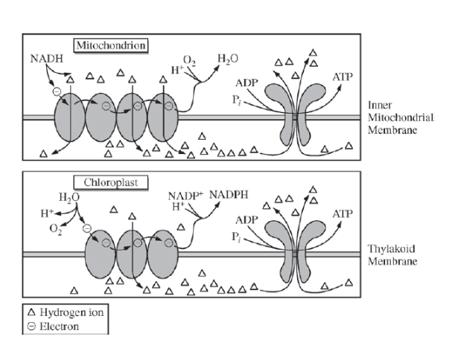
The figures below illustrate the similarities between ATP synthesis in mitochondria and chloroplasts.

3. The figures can best assist in answering which of the following questions?
(A) Do electron transport chains create a gradient so that ATP synthase can generate ATP molecules?
(B) What are the sources of energy that drive mitochondrial and chloroplast electron transport systems?
(C) What is the optimal temperature at which ATP synthase chemically converts ADP and a phosphate group into one molecule of ATP?
(D) What is the evolutionary relationship between the ATP synthase in mitochondria and the ATP synthase in chloroplasts?

The chemical reaction for photosynthesis is 6 CO₂ + 12 H₂O + light energy --> C₆H₁₂O₆ + 6 O₂ + 6 H₂O
4. If the input water is labeled with a radioactive isotope of oxygen, ₁₈O, then the oxygen gas released as the reaction proceeds is also labeled with ₁₈O. Which of the following is the most likely explanation?
(A) During the light reactions of photosynthesis, water is split, the hydrogen atoms combine with the CO2, and oxygen gas is released.
(B) During the light reactions of photosynthesis, water is split, removing electrons and protons, and oxygen gas is released.
(C) During the Calvin cycle, water is split, regenerating NADPH from NADP+, and oxygen gas is released.
(D) During the Calvin cycle, water is split, the hydrogen atoms are added to intermediates of sugar synthesis, and oxygen gas is released.
5. During hibernation, the rate of cellular respiration in a mammal is typically less than half the rate measured when the mammal is not hibernating. Such slowed cellular respiration is probably accompanied by which of the following?
Pulse Rate Body Temperature
  - Reduced Reduced
  - Unchanged Reduced
  - Reduced Increased
  - Unchanged Increased
  - Increased Reduced

6. In both photosynthesis and respiration, a electrochemical proton gradient drives chemiosmosis. What establishes the electrochemical gradient across a membrane to provide energy for ATP production?
a. The electron transport system provides the hydrogen ions.
b. Hydrogen ions naturally collect on the outside of the organelle membrane.
c. Hydrogen ions are pumped across the membrane by carrier proteins of the electron transport chain.
d. Active transport of Hydrogen ions causes the unequal distribution of ions on the two sides of the membrane.

An experiment to measure the rate of respiration in crickets and mice at 10 ºC and 25 ºC was performed using a respirometer, an apparatus that measures changes in gas volume. Respiration was measured in mL of O₂ consumed per gram of organism over several five-minute trials and the following data were obtained.
Organism | Temperature  (ºC) | Average respiration  (mL O₂/g/min)
Mouse | 10 | 0.0518
Mouse | 25 | 0.0321
Cricket | 10 | 0.0013
Cricket | 25 | 0.0038

7. According to the data, the crickets at 25ºC have greater oxygen consumption per gram of tissue than do the crickets at 10ºC. This trend in oxygen consumption is the opposite of that in the mice. The difference in trends in oxygen consumption among crickets and mice is due to their
(A) relative size
(B) mode of nutrition
(C) mode of internal temperature regulation
(D) mode of ATP production

8. During aerobic cellular respiration, oxygen gas is consumed at the same rate as carbon dioxide gas is produced. In order to provide accurate volumetric measurements of oxygen gas consumption, the experimental setup should include which of the following?
(A) A substance that removes carbon dioxide gas
(B) A plant to produce oxygen
(C) A glucose reserve
(D) A valve to release excess water

9. According to the data, the mice at 10ºC demonstrated greater oxygen consumption per gram of tissue than did the mice at 25ºC. This is most likely explained by which of the following statements?
(A) The mice at 10ºC had a higher rate of ATP production than the mice at 25ºC.
(B) The mice at 10ºC had a lower metabolic rate than the mice at 25ºC.
(C) The mice at 25ºC weighed less than the mice at 10ºC.
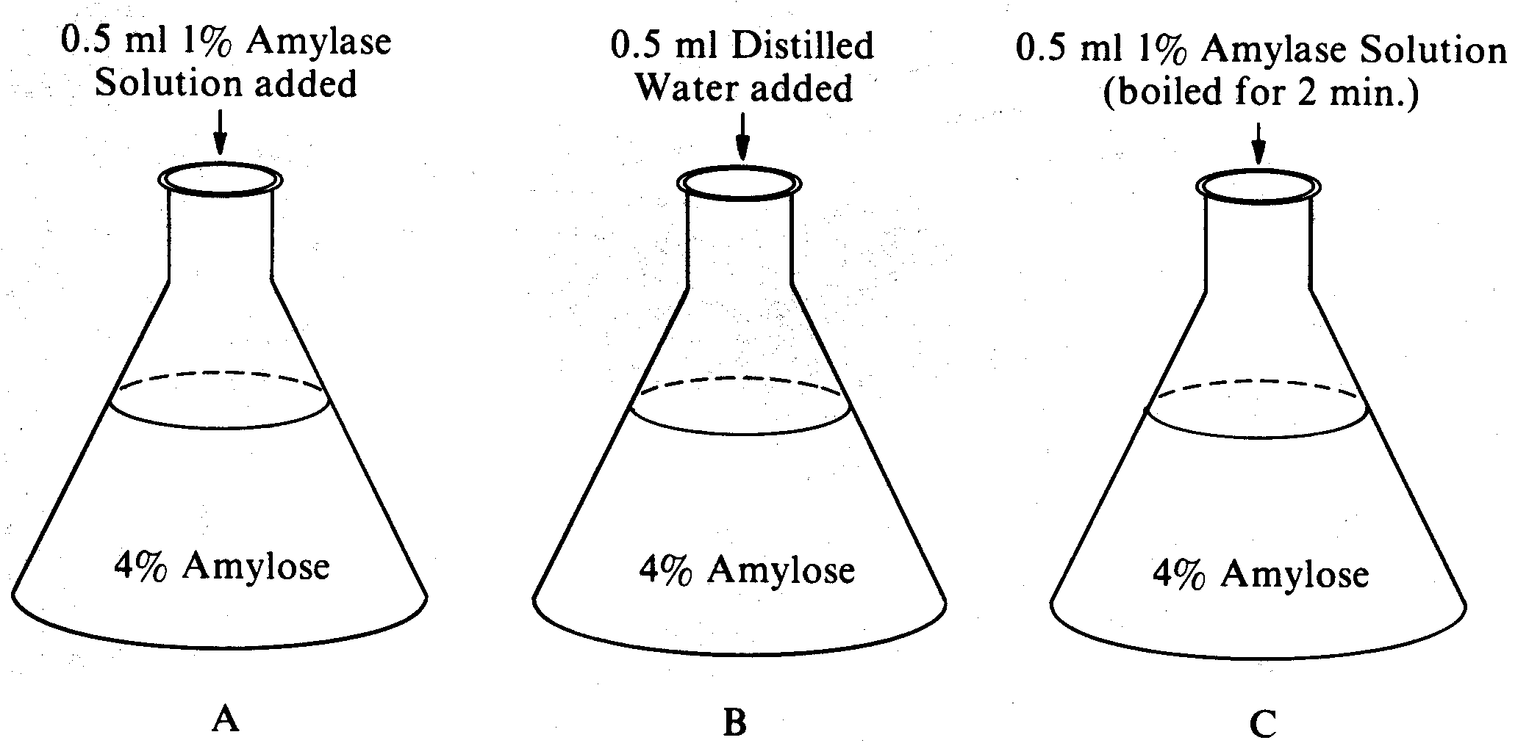
(D) The mice at 25ºC were more active than the mice at 10ºC.

Questions 10-12
A biologist prepares an in vitro analysis of the activity of the enzyme amylase, which promotes the hydrolysis of polysaccharides to monosaccharide residues. Three flasks containing 5 milliliters of 4 percent amylose (starch) in water are prepared with the addition at time zero of each of the substances indicated in the diagrams to the right.

10.In an experiment to test the effect of amylase on starch, the control would be
- flask A only
- flask B only
- flask C only
- flasks A and B

11. After 2 minutes, a positive test for sugar (monosaccharides) would most likely be observed in
- flask A only
- flask B only
- flask C only
- flasks A and C

12. Support for the hypothesis of enzyme denaturation can be obtained by comparing starch digestion in
- flasks A and B after 5 minutes
- flasks Band C after 5 minutes
- flasks A and C after 5 minutes
- flask A at time zero and again after 5 minutes

Frogs of three different species are weighed and the amount of oxygen consumed by each species is determined by placing them in a respirometer for 1 hour. The results of this experiment are listed below.
Average Total Cubic Centimeters of Oxygen
Species Weight in Grams Consumed in 1 Hour

1 15 0.75
2 11 0.55
3 21 1.05

13. From the information in the table, it is most reasonable to conclude that
- since all frogs respire through their skin, smaller frogs with smaller surface areas will consume less oxygen per gram of body weight than larger frogs with larger surface areas
- frogs placed in a warm environment will respire more rapidly than frogs placed in a colder environment
- each species of frog has its own unique rate of respiration
- the amount of oxygen consumed per gram of body weight for each species is the same

Questions 14-16
In a laboratory experiment using spectrophotometry, an enzyme is combined with its substrate at time zero. The absorbance of the resulting solution is measured at time zero and at five-minute intervals. In this procedure an increase in absorbance is related to the amount of product formed during the reaction. The experiment is conducted using the three preparations shown in the table below.

Enzyme Preparation 0 min 5 min 10min 15 min 20min

I. 3 mL of enzyme preparation 0.0 0.22 0.33 0.38 0.37
2 mL of substrate
pH 5.0

II. 3 mL of boiled enzyme preparation 0.0 0.06 0.04 0.03 0.04
2 mL of substrate
pH 5.0

III. 3 mL of enzyme preparation 0.0 0.32 0.37 0.36 0.38
2 mL of substrate
pH 6.0

14. The most likely reason for the failure of the absorbance to increase significantly after 10 minutes in preparation III is that
- the reaction is thermodynamically impossible at pH 6.0
- the enzyme is not active at this pH
- a pH of 6.0 prevents color development beyond an absorbance of 0.38
- most of the substrate was digested during the first 10 minutes

15. Which of the following statements is best supported by the data?
- Increasing the pH to 7.0 would yield an absorbance higher than 0.30 after 5 minutes.
- The enzyme demonstrates more activity at pH 6.0 than at pH 5.0.
- The enzyme has no activity at pH 6.0.
- A pH of 5.0 is the optimum for the activity of the enzyme.

16. Which of the following can best be concluded from a comparison of the results of preparation II with those of preparation I?
- Heating the enzyme is required to increase the absorbance.
- Boiling does not break down the substrate.
- Most of the increase in the amount of product in preparation I was due to enzymatic degradation of the substrate.
- Enzymatic reactions proceed at a faster rate after boiling the enzyme.
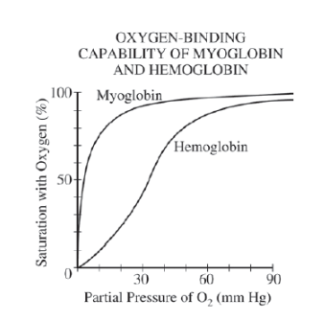

Question 17
Both myoglobin and hemoglobin are proteins that bind reversibly with molecular oxygen. The graph below shows the oxygen-binding saturation of each protein at different concentrations of oxygen.

17. Which of the following statements is correct?
(A) At 10 mm Hg partial pressure, hemoglobin binds oxygen but myoglobin does not.
(B) At 20 mm Hg partial pressure, myoglobin and hemoglobin bind oxygen in equal amounts.
(C) At 40 mm Hg partial pressure, myoglobin has a greater affinity for oxygen than hemoglobin has.
(D) At 80 mm Hg partial pressure, myoglobin binds twice as much oxygen as hemoglobin binds.

Questions 18-20

The following experiment is designed to test the capacity of cell fractions from mouse liver to carry out oxidation of glucose and pyruvic acid.
The liver is first homogenized in a suitable medium and centrifuged to sediment nuclei. The supernatant liquid above the nuclear sediment is centrifuged again at a higher speed to sediment mitochondria. The supernatant above the mitochondrial sediment is the supernatant fraction referred to in the table. The latter fraction contains ribosomes. The separated fractions are then placed in an apparatus designed to measure changes in oxygen pressure.

Oxygen Consumption Expressed As Per Cent of Oxygen
Consumed By the Whole Homogenate
Glucose as Pyruvate as
Fractions Being Tested Substrate Substrate
1. Whole Homogenate 100 100
2. Nuclei 10 5
3. Supernatant 5 5
4. Mitochondria 3 75
5. Mitochondria + nuclei 5 50
6. Mitochondria + supernatant 150 130
7. Mitochondria + supernatant + nuclei 95 100

18. The capacity to oxidize pyruvate resides largely in the
- supernatant fraction
- mitochondria
- nuclei
- microsomes

19. From the data in the table, which of the following is an appropriate conclusion about nuclei?
- They have the same capacity to utilize pyruvate as do mitochondria.
- They contain DNA.
- They are unable to oxidize intermediates of the Krebs (oxidative) cycle.
- They lower the level of oxidation of pyruvate by mitochondria.

20. Which of the following is an appropriate conclusion about the supernatant fraction?
- It oxidizes glucose about as well as the homogenate.
- It oxidizes pyruvate more effectively than the homogenate when combined with mitochondria.
- It oxidizes pyruvate about as well as the homogenate.
- It oxidizes pyruvate as well as mitochondria.

Questions 21-22
Intact chloroplasts are isolated from blended spinach leaves by low-speed centrifugation and are suspended in a cold, protective buffer. If these chilled chloroplasts are illuminated in the presence of an oxidized colored dye, one may observe the reduction of the dye as the dye loses its color.
chloroplast
Oxidized blue dye ————>Reduced colorless dye
light

light only
Oxidized blue dye ————>Oxidized blue dye

An experiment is set up to determine the optimal reduction potential of the chloroplasts under different wavelengths of light energy. The chloroplast suspensions are individually or simultaneously exposed to the following wavelengths of light by the use of special filters: 550 nanometers (green), 650 nanometers (red), and 700 nanometers (far-red). All exposures are at the same light intensity. The data are given below.
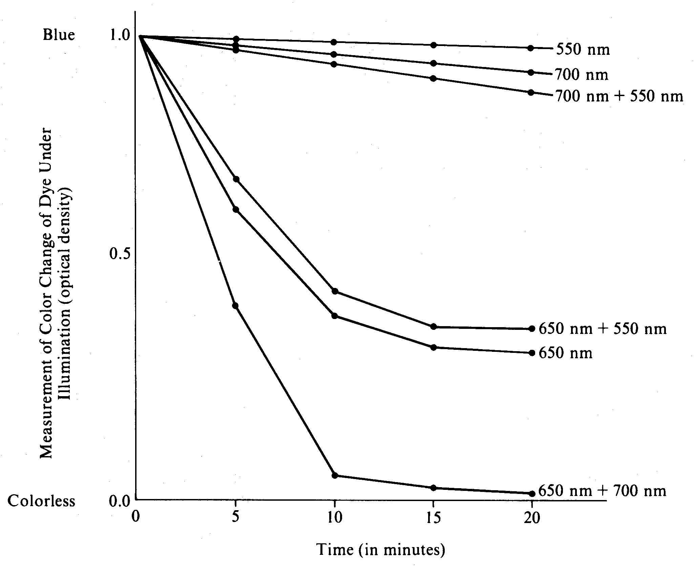
21. According to these data, which of the wavelengths of light energy provides the LEAST energy potential for photosynthesis?
- 550 nm only
- 650 nm only
- 700 nm only
- 550 nm and 650 nm

22. The greatest reduction of the blue dye by two different wavelengths of light suggests which of the following?
- There are two pigment systems present within the same chloroplast, both absorbing at the same wavelength.
- There are at least two pigment systems with different absorption spectra present within the same chloroplast.
- Different portions of the plant (stems, leaves, etc.) absorb light from different wavelengths.
- Both red and far-red light are transmitted.

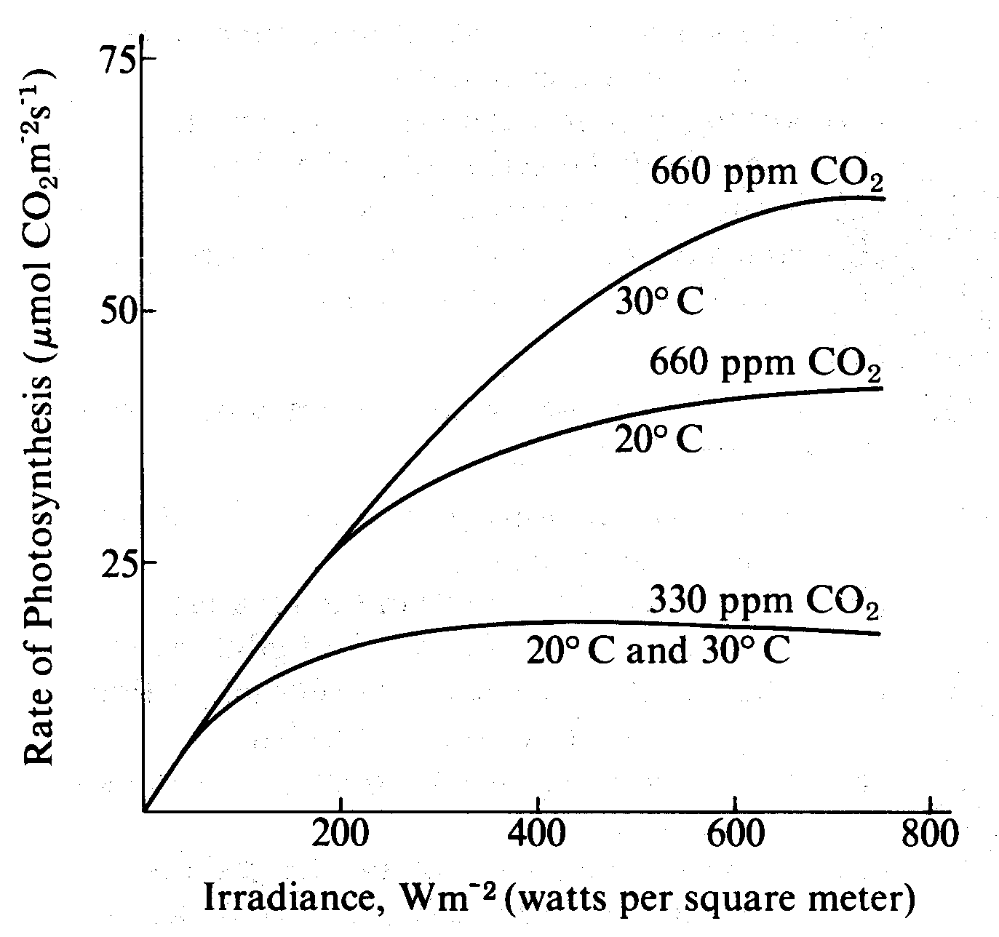
Questions 23-25
The graph shows the relationship of photosynthetic rate and irradiance (light intensity) influenced by both temperature and carbon dioxide level.

23. According to the graph, the greatest rate of photosynthesis occurs when CO₂ is present at
- high concentrations and low temperatures
- low concentrations and high temperatures
- high concentrations and low irradiance levels
- high concentrations and high irradiance levels

24. From the data in the graph, which of the following conclusions is most reasonable?
- The rate of photosynthesis is inversely proportional to light intensity.
- The rate of photosynthesis at 660 ppm CO₂ is more dependent on temperature than the rate at 330 ppm CO₂.
- There is no theoretical maximum for the rate of photosynthesis.
- Attempts to increase the photosynthetic yield in field crops should involve the lowering of CO₂ levels.

25. Which of the following seems most likely from the data?
- Light produces heat, which causes increases in the rates of photosynthesis.
- Light causes the saturation of cytochrome oxidase, which then limits the use of CO₂.
- The photosynthetic rate could be increased further by decreasing the CO₂ concentration.
- Increasing irradiance levels above 800 Wm^{–2} would have less effect on the rate of photosynthesis than would increasing the CO₂ concentration.

Questions 26-29
A scientist determined the rate of an enzyme-catalyzed reaction by measuring the amount of product formed over time. The following curve was generated from the data collected.

26. Based solely on the curve, what can be said concerning the calculated reaction rates at 1 minute and at 2 minutes?
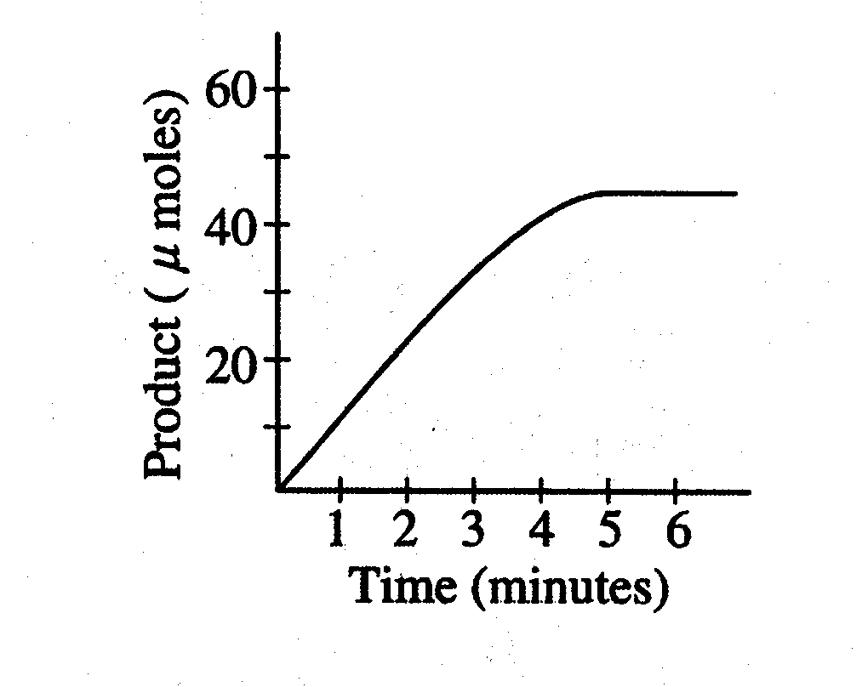
- The rate after 2 minutes is greater than the rate after 1 minute.
- The rates are the same at 1 minute and at 2 minutes.
- The rates are affected by high concentrations of inhibitors.
- The rates are both zero.

27. The rate of the reaction could also be determined by
- measuring the change in the amount of enzyme
- measuring the change in the amount of substrate
- measuring the change in salt concentration
- adding more substrate

28. What is the most likely explanation for the change in the slope of the line between 3 and 5 minutes?
- The enzyme had denatured.
- The enzyme had achieved its maximum velocity.
- A large amount of the substrate had been consumed.
- An allosteric inhibitor appeared.

29.During which time interval is the reaction rate lowest?
- 0-1 minute
- 1-2 minutes
- 2-3 minutes
- 4-5 minutes
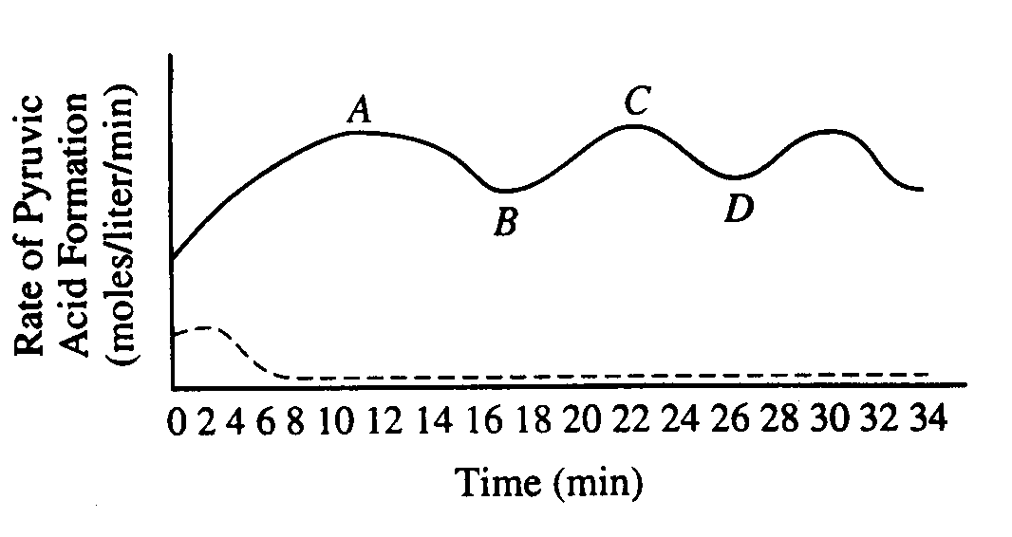
Questions 30-33 refer to the following graph and information.
A tissue culture of vertebrate muscle was provided with a constant excess supply of glucose under anaerobic conditions starting at time zero and the amounts of pyruvic acid and ATP produced were measured. The solid line in the graph above represents the pyruvic acid produced in moles per liter per minute. ATP levels were also found to be highest at points A and C, lowest at B and D. A second culture was set up under the same conditions, except that substance X was added, and the results are indicated by the dotted line.

30. The rate of pyruvic acid formation fluctuates because
- all glucose has reacted
- all enzymes have been used up
- the reaction is accelerated by positive feedback
- the reaction is affected by negative feedback

31. Which of the following best accounts for the shape of the solid line between points A and D?
- After ten minutes the cellular enzymes became ineffective.
- Respiration became uncontrolled.
- ATP acted as an allosteric inhibitor on one or more of the enzymes.
- The measurements of pyruvic acid were unreliable.

32. It is most reasonable to hypothesize that, in the breakdown of glucose, substance X is
- an activator
- an inhibitor
- a substrate
- a coenzyme
33. Which of the following is most likely to result if oxygen is added to the tissue culture?
- Lactic acid formation will increase.
- For each glucose molecule consumed, more ATP will be formed.
- The levels of ATP produced will decrease.
- Ethyl alcohol will be produced.

Practice Long Response Questions

- A controlled experiment was conducted to analyze the effects of darkness and boiling on photosynthetic rate of incubated chloroplast suspension. The dye reduction technique was used. Each chloroplast suspension was mixed with DPIP, an electron acceptor that changes from blue to clear when it is reduced. Each sample was placed in individually in a spectrophotometer and the percent transmittance was recorded. The three samples used were prepared as follows:
- Sample 1 – chloroplast suspension + DPIP
- Sample 2 – chloroplast suspension surrounded by foil wrap to provide a dark environment + DPIP
- Sample 3 – chloroplast suspension that has been boiled + DPIP

Time (min) | Light, unboiled  % Transmittance  Sample 1 | Dark, Unboiled  % Transmittance  Sample 2 | Light, Boiled  % Transmittance  Sample 3
0 | 28.8 | 29.2 | 28.8
5 | 48.7 | 30.1 | 29.2
10 | 57.8 | 31.2 | 29.4
15 | 62.5 | 32.4 | 28.7
20 | 66.7 | 31.8 | 28.5

- Construct and label a graph showing the results of the three samples
- Identify and explain the control OR controls for this experiment
- The differences in the curves of the graphed data indicate that there were differences in the number of electrons produced in the three samples during the experiment. Discuss how electrons are generated in photosynthesis and why the three samples gave different transmittance results.

- Yeast cells are placed in an apparatus with a solution of sugar (a major nutrient for yeast
metabolism). The apparatus detects bubbles of gas released by the yeast cells. The rate of
respiration varies with the surrounding temperatures as indicated by the data below.
a. Graph the results on the axes provided. Determine the optimum temperature for
respiration in the yeast.
b. Respiration is a series of enzyme-catalyzed reactions. Using your knowledge of
enzymes and the data above, analyze and explain the results of this experiment.
c. Design an experiment to test the effect of varying the pH of the sugar solution on the
rate of respiration. Include a prediction of the expected results.

3. The rate of photosynthesis may vary with changes that occur in environmental temperature, wavelength of light, and light intensity. Using a photosynthetic organism of your choice, choose only ONE of the three variables (temperature, wavelength of light, or light intensity) and for this variable
  - design a scientific experiment to determine the effect of the variable on the rate of photosynthesis for the organism;
  - explain how you would measure the rate of photosynthesis in your experiment;
  - describe the results you would expect. Explain why you would expect these results.
4. Explain what occurs during the Krebs (citric acid) cycle and electron transport by describing the following:
  - The location of the Krebs cycle and electron transport chain in mitochondria.
  - The cyclic nature of the reactions in the Krebs cycle.
  - The production of ATP and reduced coenzymes during the cycle.
  - The chemiosmotic production of ATP during electron transport.

5. The results below are measurements of cumulative oxygen consumption by germinating and dry seeds. Gas volume measurements were corrected for changes in temperature and pressure.
Cumulative Oxygen Consumed (mL)
Time (minutes) | 0 | 10 | 20 | 30 | 40
22° C Germinating Seeds | 0.0 | 8.8 | 16.0 | 23.7 | 32..0
Dry Seeds | 0.0 | 0.2 | 0.1 | 0.0 | 0.1
10° C Germinating Seeds | 0.0 | 2.9 | 6.2 | 9.4 | 12.5
Dry Seeds | 0.0 | 0.0 | 0.2 | 0.1 | 0.2
  - Using the graph paper provided, plot the results for the germinating seeds at 22° C and at 10° C.
  - Calculate function the rate of oxygen consumption for the germinating seeds at 22° C, using the time interval between 10 and 20 minutes.
  - Account for the differences in oxygen consumption observed between:
    - germinating seeds at 22° C and at 10° C
    - germinating seeds and dry seeds
  - Describe the essential features of an experimental apparatus that could be used to measure oxygen consumption by a small organism. Explain why each of these features is necessary.

