Name: _____________________________________________ Date: ____________________________ Period: ______

**AP Biology Exam Review: Cell Signaling and Division (Unit 4)**

**Textbook Chapters:** 11 (Cell Communication), 12 (The Cell Cycle), 13 (Meiosis and Sexual Life Cycles)

**Helpful Videos and Animations:**

1. Bozeman Biology: Cell Communication
2. Bozeman Biology: Signal Transduction Pathways
3. Bozeman Biology: Signal Transmission and Gene Expression
4. Bozeman Biology: Effects of Changes in Pathways
5. Bozeman Biology: Evolutionary Significance of Cell Communication
6. Bozeman Biology: The Cell Cycle, Mitosis, and Meiosis

**Topic Outline:**

1. There are three main steps in cell signaling

* Reception (target cell’s detection of a signal molecule)
* Transduction (conversion of the signal to a form that can bring about a particular cell response)
* Response (the specific cellular response to the signal molecule)

1. Reception

* Ligand (signal molecule) binds to receptor

1. Intracellular receptors (for hydrophobic molecules like steroids that can pass through the cell membrane)
2. Plasma membrane receptors (for hydrophilic molecules that cannot pass through the cell membrane)

Ex: G protein coupled receptor or receptor tyrosine kinase (see notes to recall how these work)

1. Tranduction

* Tranduction involves amplifying the signal (making it stronger) and converting it to a form the cell can respond to

1. Second messengers (ex: calcium ions – Ca2+ -- or cyclic AMP) carry the signal from the receptor and may be used to activate protein kinases or other key molecules in the transduction process… second messengers amplify the signal because multiple second messengers are created from one ligand received and these second messengers can activate multiple kinases
2. Phosphorylation cascade (protein kinases activate molecules by adding a phosphate group, these molecules then activate other molecules, and ultimately you activate a molecule that causes the specific cell response)
3. Response

* Regulating Synthesis of Proteins: Transduction may activate transcription factors that initiate transcription of particular genes in the nucleus (by enabling the binding of RNA polymerase to start creating mRNA from DNA)
* Regulating Activity of Proteins: ex: In the epiphrine pathway in liver cells that initiates breakdown of glycogen to produce blood glucose to fuel the fight or flight response, protein kinases activate the enzyme phosphorylase, which chops apart glycogen

***CC 3.D.3 -***

***a. Signaling begins with the recognition of a chemical messenger, a ligand, by a receptor protein.***

***Evidence of student learning is a demonstrated understanding of each of the following:***

***1. Different receptors recognize different chemical messengers, which can be peptides, small chemicals***

***or proteins, in a specific one-to-one relationship.***

***2. A receptor protein recognizes signal molecules, causing the receptor protein’s shape to change,***

***which initiates transduction of the signal.***

***To demonstrate understanding, make sure you can explain examples like:***

***● G-protein linked receptors***

***● Ligand-gated ion channels***

***● Receptor tyrosine kinases***

***b. Signal transduction is the process by which a signal is converted to a cellular response.***

***Evidence of student learning is a demonstrated understanding of each of the following:***

***1. Signaling cascades relay signals from receptors to cell targets, often amplifying the incoming signals,***

***with the result of appropriate responses by the cell.***

***2. Second messengers are often essential to the function of the cascade.***

***To demonstrate understanding, make sure you can explain examples like:***

***● Ligand-gated ion channels***

***● Second messengers, such as cyclic GMP, cyclic AMP calcium ions (Ca2+), and inositol***

***triphosphate (IP3)***

***3. Many signal transduction pathways include:***

***i. Protein modifications (an illustrative example could be how methylation changes the***

***signaling process)***

***ii. Phosphorylation cascades in which a series of protein kinases add a phosphate group to the***

***next protein in the cascade sequence***

1. The Cell Cycle

* Mitosis = creation of new body cells (somatic cells) with 46 chromosomes each (diploid cells / 2n = two sets of chromosomes
* Organization of DNA in eukaryotic cells = multiple linear chromosomes vs. organization of DNA in prokaryotic cells = single circular chromosome
* Interphase (normal life of the cell, 90% of cell’s life)… know what happens in the G1,S, and G2 phases
* Be able to describe the events that take place in the following steps of mitosis: prophase, prometaphase, metaphase, anaphase and telophase (+ cytokinesis, division of the cytoplasm by a cleavage furrow in animals or cell plate in plants)
* Be able to explain how/why eukaryotic cell division is different from binary fission
* **Vocabulary:** chromosome, sister chromatids, centromere, nuclear envelope, mitotic spindle, microtubules, kinetochore, centrioles / centrosome, metaphase plate, cleavage furrow, cell plate

1. Control of the Cell Cycle

* There are internal checkpoints that tell the cell to continue dividing or stop dividing
* Major checkpoints = G1 phase checkpoint (after G1 phase), G2 phase checkpoint, and M phase checkpoint
* If the cell does not receive the “go ahead” signal at the G1 checkpoint, it enters the “G0 phase,” a state of semi-dormancy where no cell division is occurring (ex: mature nerve cells)
* Example: if cyclin molecules bind to Cdk molecules (cyclin dependent kinases), they produce MPF (mitosis / maturation promoting factor)… enough MPF can allow the cell to pass the G2 checkpoint and enter mitosis… to bring mitosis to a close, MPF switches itself off by starting a process that degrades cyclin
* If checkpoints are normal… cells will show density-dependent inhibition (stop dividing when they are crowded) and anchorage dependency (must be attached to a substrate to divide)
* If cells divide two frequently, they will not show density-dependent inhibition or anchorage dependency 🡪 tumors (know the difference between benign and malignant tumors and be able to define metastasis)

1. Meiosis

* Cell division to create gametes (sex cells) with half the number of chromosomes (23) of a somatic cell (haploid cell / n = one set of chromosomes)
* Understand the difference between sexual vs. asexual reproduction
* There are 23 pairs of homologous chromosomes in a body cell (what are homologous chromosomes?) that divide during meiosis
* 22 pairs are autosomes and 1 pair consists of sex chromosomes (XX for females and XY for males)
* Fertilization = the fusion of haploid gametes (egg + sperm) to create a diploid zygote
* Meiosis includes two rounds of division to produce four daughter cells
* Be able to explain how Meiosis I is different from Meiosis II and describe what occurs in each of the stages of meiosis: Prophase I, Metaphase I, Anaphase I, Telophase I / Cytokinesis, Prophase II, Metaphase II, Anaphase II, Telophase II / Cytokinesis
* Explain what happens during crossing over. Be able to use the following vocab terms: synapsis, tetrad, chiasmata
* Describe the methods by which meiosis increases genetic variation in a population: crossing over, independent assortment, and random fertilization

***CC 3.A.1 –***

***a. Genetic information is transmitted from one generation to the next through DNA or RNA.***

***Evidence of student learning is a demonstrated understanding of each of the following:***

***1. Genetic information is stored in and passed to subsequent generations through DNA molecules and, in***

***some cases, RNA molecules.***

***2. Noneukaryotic organisms have circular chromosomes, while eukaryotic organisms have multiple linear***

***chromosomes, although in biology there are exceptions to this rule.***

***3. DNA replication ensures continuity of hereditary information.***

***b. Genetic information flows from a sequence of nucleotides in a gene to a sequence of amino acids in a***

***protein.***

***c. Phenotypes are determined through protein activities.***

***CC 3.A.2 –***

***a. The cell cycle is a complex set of stages that is highly regulated with checkpoints, which determine the***

***ultimate fate of the cell.***

***Evidence of student learning is a demonstrated understanding of each of the following:***

***1. Interphase consists of three phases: growth, synthesis of DNA, preparation for mitosis.***

***2. The cell cycle is directed by internal controls or checkpoints. Internal and external signals provide stop and-go signs at the checkpoints.***

***To demonstrate understanding, make sure you can explain examples like:***

* ***Mitosis-promoting factor (MPF)***
* ***Action of platelet-derived growth factor (PDGF)***

***3. Cancer results from disruptions in cell cycle control***

***4. Cyclins and cyclin-dependent kinases control the cell cycle.***

***5. Mitosis alternates with interphase in the cell cycle.***

***6. When a cell specializes, it often enters into a stage where it no longer divides, but it can reenter the***

***cell cycle when given appropriate cues. Nondividing cells may exit the cell cycle; or hold at a particular***

***stage in the cell cycle.***

***b. Mitosis passes a complete genome from the parent cell to daughter cells.***

***Evidence of student learning is a demonstrated understanding of each of the following:***

***1. Mitosis occurs after DNA replication.***

***2. Mitosis followed by cytokinesis produces two genetically identical daughter cells.***

***3. Mitosis plays a role in growth, repair, and asexual reproduction***

***4. Mitosis is a continuous process with observable structural features along the mitotic process. Evidence of student learning is demonstrated by knowing the order of the processes (replication, alignment, separation).***

***c. Meiosis, a reduction division, followed by fertilization ensures genetic diversity in sexually reproducing***

***organisms.***

***Evidence of student learning is a demonstrated understanding of each of the following:***

***1. Meiosis ensures that each gamete receives one complete haploid (1n) set of chromosomes.***

***2. During meiosis, homologous chromosomes are paired, with one homologue originating from the***

***maternal parent and the other from the paternal parent.***

***3. Orientation of the chromosome pairs is random with respect to the cell poles.***

***4. Separation of the homologous chromosomes ensures that each gamete receives a haploid (1n) set of***

***chromosomes composed of both maternal and paternal chromosomes.***

***5. During meiosis, homologous chromatids exchange genetic material via a process called “crossing over,”which increases genetic variation in the resultant gametes.***

***6. Fertilization involves the fusion of two gametes, increases genetic variation in populations by providing***

***for new combinations of genetic information in the zygote, and restores the diploid number of***

***chromosomes.***

**Practice Multiple Choice Questions**

1. Of the following, a receptor protein in a membrane that recognizes a chemical signal is most similar to

A) the active site of an allosteric enzyme in the cytoplasm that binds to a specific substrate.

B) RNA specifying the amino acids in a polypeptide.

C) a particular metabolic pathway operating within a specific organelle.

D) an enzyme with an optimum pH and temperature for activity.

E) genes making up a chromosome.

2. At puberty, an adolescent female body changes in both structure and function of several organ systems, primarily under the influence of changing concentrations of estrogens and other steroid hormones. How can one hormone, such as estrogen, mediate so many effects?

A) Estrogen is produced in very large concentration and therefore diffuses widely.

B) Estrogen has specific receptors inside several cell types, but each cell responds in the same way to its

binding.

C) Estrogen is kept away from the surface of any cells not able to bind it at the surface.

D) Estrogen binds to specific receptors inside many kinds of cells, each of which have different

responses to its binding.

E) Estrogen has different shaped receptors for each of several cell types.

3. As humans, we have receptors for two kinds of beta adrenergic compounds such as catecholamines. Cardiac muscle cells have beta 1 receptors that promote increased heart rate. Some drugs that slow heart rate are called beta blockers. Smooth muscle cells, however, have beta 2 receptors which mediate muscle relaxation. Blockers of these effects are sometimes used to treat asthma.

The description above illustrates which of the following?

A) Just because a drug acts on one type of receptor does not mean that it will act on another type.

B) Beta blockers can be used effectively on any type of muscle.

C) Beta adrenergic receptors must be in the cytosol if they are going to influence contraction and

relaxation.

D) The chemical structures of the beta 1 and beta 2 receptors must have the same active sites.

4. *Anabaena* is a simple multicellular photosynthetic cyanobacterium. In the absence of fixed nitrogen, certain newly developing cells along a filament express genes that code for nitrogen-fixing enzymes and become nonphotosynthetic heterocysts. The specialization is advantageous because some nitrogen-fixing enzymes function best in the absence of oxygen. Heterocysts do not carry out photosynthesis but instead provide adjacent cells with fixed nitrogen, in exchange receiving fixed carbon and reduced energy carriers.



As shown in the diagram above, when there is low fixed nitrogen in the environment, an increase in the concentration of free calcium ions and 2-oxyglutarate stimulates the expression of genes that produce two transcription factors (NtcA and HetR) that promote the expression of genes responsible for heterocyst development. HetR also causes production of a signal, PatS, that prevents adjacent cells from developing as heterocysts. Based on your understanding of the ways in which signal transmission mediates cell function, which of the following predictions is most consistent with the information given above?

(A) In an environment with low fixed nitrogen, treating the *Anabaena* cells with a calcium-binding

compound should prevent heterocyst differentiation.

(B) A strain that overexpresses the *patS* gene should develop many more heterocysts in a low fixed

nitrogen environment.

(C) In an environment with abundant fixed nitrogen, free calcium levels should be high in all cells so

that no heterocysts develop.

(D) In environments with abundant fixed nitrogen, loss of the *hetR* gene should induce heterocyst

development.

5. An enzyme that attaches a phosphate group to another molecule is called a

A) phosphatase.

B) phosphorylase.

C) kinase.

D) cyclase.

E) ATPase.

6. A cell containing 92 chromatids at metaphase of mitosis would, at its completion, produce two nuclei each containing how many chromosomes?

A) 12

B) 16

C) 23

D) 46

E) 92

7. Measurements of the amount of DNA per nucleus were taken on a large number of cells from a growing fungus. The measured DNA levels ranged from 3 to 6 picograms per nucleus. In which stage of the cell cycle was the nucleus with 6 picograms of DNA?

A) G0

B) G1

C) S

D) G2

E) M

8. The karyotype of one species of primate has 48 chromosomes. In a particular female, cell division goes awry and she produces one of her eggs with an extra chromosome (25). The most probable source of this error would be a mistake in which of the following?

A) Mitosis in her ovary

B) Metaphase I of one meiotic event

C) Telophase II of one meiotic event

D) Telophase I of one meiotic event

E) Either anaphase I or II

9. Which of the steps below take place in both mitosis and meiosis?

1. Formation of four new nuclei, each with half the chromosomes present in the parental nucleus

2. Alignment of tetrads at the metaphase plate

3. Separation of sister chromatids

4. Separation of the homologues; no uncoupling of the centromere

5. Synapsis; chromosomes moving to the middle of the cell in pairs

A) 2

B) 3

C) 5

D) 2 and 3 only

E) 2, 3, and 5

10. How do cells at the completion of meiosis compare with cells that have replicated their DNA and are just about to begin meiosis?

A) They have twice the amount of cytoplasm and half the amount of DNA.

B) They have half the number of chromosomes and half the amount of DNA.

C) They have the same number of chromosomes and half the amount of DNA.

D) They have half the number of chromosomes and one-fourth the amount of DNA.

E) They have half the amount of cytoplasm and twice the amount of DNA.

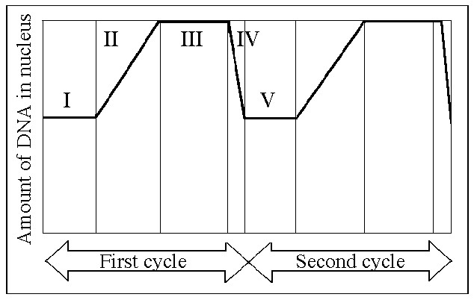

11. Which number above represents the point in the cell cycle during which the chromosomes are replicated?

A) I

B) II

C) III

D) IV

E) V

12.

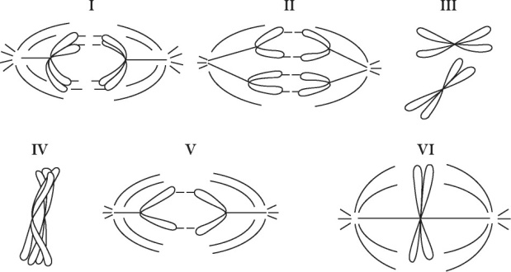

Which diagram represents prophase I of meiosis?

A) I

B) II

C) IV

D) V

E) VI

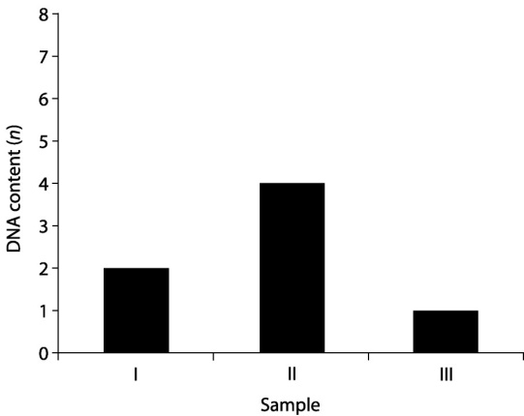

13. You have isolated DNA from three different cell types of an organism, determined the relative DNA content for each type, and plotted the results on the graph shown in the figure to the right. Refer to the graph to answer the following question:

Which sample might represent a sperm cell?

A) I

B) II

C) III

D) Either I or II

E) Either II or III

14. A research team used the setup to study the incorporation of labeled nucleotides into a culture of lymphocytes and found that the lymphocytes incorporated the labeled nucleotide at a significantly higher level after a pathogen was introduced into the culture. They concluded that

A) the presence of the pathogen made the experiment too contaminated

to trust the results.

B) their tissue culture methods needed to be relearned.

C) infection causes lymphocytes to divide more rapidly.

D) infection causes cell cultures in general to reproduce more

rapidly.

E) infection causes lymphocyte cultures to skip some parts of the

cell cycle.

15. Natural selection and recombination due to crossing over during meiosis I are related in which of the following ways?

A) Recombinants are usually selected against.

B) Non-recombinant organisms are usually favored by natural selection if there is environmental change.

C) Most recombinants reproduce less frequently than do non-recombinants.

D) Recombinants may have combinations of traits that are favored by natural selection.

E) Recombination does not affect natural selection.

**Practice Long Response Questions**

1.  Communication occurs among the cells in a multicellular organism. Choose THREE of the following examples of cell-to-cell communication, and for each example, describe the communication that occurs and the types of responses that result from this communication.

1. communication between two plant cells
2. communication between two immune-system cells
3. communication either between a neuron and another neuron, or between a neuron and a muscle cell
4. communication between a specific endocrine-gland cell and its target cell

*\*\*\*Note: We discussed some of these concepts in our Organism Form and Function Unit (#9)\*\*\**

1. An organism is heterozygous at two genetic loci on different chromosomes.
   1. Explain how these alleles are transmitted by the process of mitosis to daughter cells.
   2. Explain how these alleles are distributed by the process of meiosis to gametes.
   3. Explain how the behavior of these two pairs of homologous chromosomes during meiosis provides the physical basis for Mendel’s two laws of inheritance.

*\*\*\*Note: We discussed some of these concepts in our Classical Genetics Unit (#5)\*\*\**