Cell Theory Rap
Listen close to the story I tell.
It's the rapping story of the living cell.
It's a happy tune that's sort of cheery.
About a real tough topic called the cell theory.
All animals, plants, and protists too,
Are made of cells with different jobs to do.
They're the basic units of all organisms,
And I hope by now you got the rhythm.
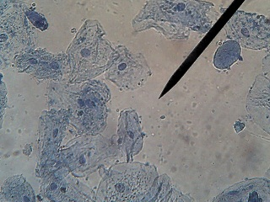
It all started with one dude named Hooke.
Who at some cork cells took a look.
He used a scope and took his time.
'Cause a cell is small and thinner than a dime.
Say 1, 2, 3, 4,
Are you ready to learn some more?
The animal cell has many parts,
And you must know each one by heart.
Like the farmer man in the dell.
The nucleus controls the cell.
its gives the orders -- kind of like a brain.
And it's protected by a nuclear membrane.
Around the cell, you'll find another "skin,"
The cellular membrane holds the whole cell in
But its job isn't simple there's no doubt,
It lets some particles go in and out.
Now please don't lose your science enthusiasm,
Listen to the story of the cytoplsm.
All around the cell this thick fluid does go,
But in the nucleus it will not flow.
And don't forget those ribosomes -
This is where proteins come from.
These protein factories are so small, you'll agree,
You need an electron microscope to see.
Just when you thought you weren't having any fun,
Along comes teh endoplasmic reticulum.
These tubelike structures serve as a track,
To carry stuff to the membrane and back.
Now have you ever seen any doughnuts without holes?
In a cell, they're called vacuoles.
They're filled with stuff like H2O
And they carry food so the cell can grow.
Las of all, but not the very least,
Mitochondria - mighty cellular beasts,
Since they turn sugars into energy so well,
We call them the powerhouse of the cell.
Now my friend, you know it well,
The unforgettable story of the living cell.
"Science World"
10-5-90

