# **Cell Organelle Politician for Office Project**



**Introduction**

Imagine that your cell organelle is running for office and you are the campaign manager. You are to create a campaign billboard for your organelle that explains why your cell organelle should become president of Cell Country. You have to convince your classmates that your organelle should be elected based on your billboard design and campaign platform. Research the structure and function of the organelles typical in eukaryotic cells (plant and/or animal).

**Materials:**

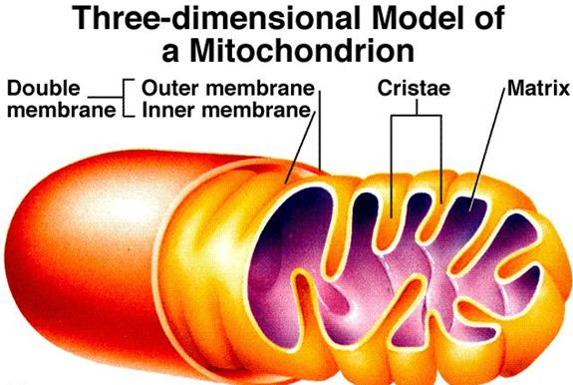

Full poster board or trifold board (any color)

Colorful pictures (draw or printed)

Paper (optional)

Crayons/Markers/Coloring Pencils

Any extra items that you can use to decorate your billboard

**Criteria:**

* You will be randomly assigned an organelle
* Choose a name for your organelle (i.e. nucleus…Nancy Nucleus)
* Include a campaign slogan (i.e. “the low price leader”)
* Draw or print a picture of your organelle and make sure it is in color
* Include at least 3 reasons why your organelle should be president (make sure the reasons relate to the **actual structure and/or functions** of the organelle (i.e. Matthew Mitochondria should be president because he never runs out of energy he is always on the go!)

**Grading:**

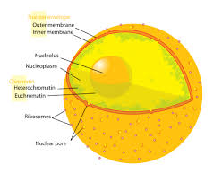

* Campaign/ Debate Speech (20 points)
* Organelle Pictures (20pts)
* Creative Organelle Name (8 pts)
* Campaign Slogan (10 pts)
* Color (10 pts)
* At least 3 Reasons for Presidency (24 pts)
* Creativity (2 points)
* Organization (2 points)
* Neat (2 points)
* Effort (2 points)

**Worth: 100 pts**

**Additional Resources**

* See [The Living Room Candidate](http://www.livingroomcandidate.org/) for advertisements from every presidential election from 1952 to the most recent election.
* See [Campaign Slogans](http://www.presidentsusa.net/campaignslogans.html) for slogan ideas.
* See [Political Campaign Posters](http://ronwade.freeservers.com/posterset.html) for campaign poster ideas.
* See [Lori Ferber's website](http://www.loriferber.com/categories/campaign-posters.html) for more poster ideas.
* See [eHow](http://www.ehow.com/how_2061775_write-campaign-speech.html) on how to write a campaign speech.
* See [Info Please](http://www.infoplease.com/ipa/A0878601.html) for famous presidential speeches. While these aren't campaign speeches, they might give you an idea of how to structure your speech.
* On Election Day, after watching the campaign speeches, each voter will receive a ballot with the candidates listed. The number of votes your candidate receives will factor into your final grade (as bonus points).