Name: _____________________________________________ Date: ____________________________ Period: ______

AP Biology Exam Review: Classical Genetics (Unit 5)

Textbook Chapters: 13 (Meiosis and Sexual Life Cycles), 14 (Mendel and the Gene Idea)

Helpful Videos and Animations: The links to these videos are posted on the class Wiki page

- Bozeman Biology: Mendelian Genetics
- Bozeman Biology: Chromosomal Genetics
- Bozeman Biology: A Beginner's Guide To Punnett Squares
- Bozeman Biology: Probability in Genetics - Multiplication and Addition Rules
- Bozeman Biology: Linked Genes
- Bozeman Biology: The Genetics of Blood Types
- Andrew Douch: Pedigree Analysis 1
- Andrew Douch: Pedigree Analysis 2
Topic Outline:

- Mendel’s experiments
- Pea plants with distinct dominant vs. recessive traits
- Know what happens in the P F1 F2 generations
- Mendel’s Laws
- Law of Dominance
- Law of Segregation (and explain how disorders caused by nondisjunction – ex. Trisomy 21 / Down Syndrome – are related to this law ; be able to define aneuploidy, monosomy, and trisomy)
- Law of Independent Assortment
- Basic Genetics Vocabulary
- Gene vs. allele
- Homozygous vs. heterozygous
- Genotype vs. Phenotype
- Monohybrid Cross vs. Dihybrid Cross
- Testcross
- Setting up / analyzing genetic crosses with Punnett squares
- Know how to set up monohybrid and dihybrid crosses given information regarding parent genotypes and phenotypes and analyze offspring genotype / phenotype ratios
- Understand the rules of probability in Punnett Square analysis
- Rule of Multiplication: when calculating the probability that two or more independent events will occur together in a specific combination, multiply the probabilities of each of the two events
For example, the probability of a coin landing face up two times in two flips is ½ X ½ = ¼
In genetics, if you cross two organisms with the genotypes AABbCc and AaBbCc, the probability of an offspring having the genotype AaBbcc is ½ X ½ X ¼ = 1/16
- Rule of Addition: when calculating the probability that any of two or more mutually exclusive events will occur, you need to add together their individual probabilities. For example, if you are tossing a die, what is the probability that it will land on either the side with four spots or the side with five spots? (1/6 + 1/6 = 1/3)
- Analyzing a pedigree of a human inherited condition
- Be able to describe the methods of fetal testing for inherited genetic conditions (amniocentesis and chorionic villi sampling)
- Be able to determine the type of inheritance shown in a pedigree (autosomal dominant, autosomal recessive, sex-linked dominant, and sex-linked recessive) Here are a couple hints:
- If there are significantly more males with a condition than females, the trait is sex-linked (be able to explain why sex-linked recessive conditions are found more often in males)
- With an autosomal trait, if a child has a trait but the parents don’t, the trait is recessive (both parents are carriers)

CC 3.C.2: Biological systems have multiple processes that increase genetic variation.
a. The imperfect nature of DNA replication and repair increases variation.
b. Sexual reproduction in eukaryotes involving gamete formation, including crossingover
during meiosis and the random assortment of chromosomes during meiosis, and
fertilization serve to increase variation. Reproduction processes that increase genetic
variation are evolutionarily conserved and are shared by various organisms.

CC 3.A.3: The chromosomal basis of inheritance provides an understanding of the pattern of passage (transmission) of genes from parent to offspring.
a. Rules of probability can be applied to analyze passage of single gene traits from parent
to offspring.
b. Segregation and independent assortment of chromosomes result in genetic variation.
Evidence of student learning is a demonstrated understanding of each of the following:
1. Segregation and independent assortment can be applied to genes that are on
different chromosomes.
2. Genes that are adjacent and close to each other on the same chromosome tend to
move as a unit; the probability that they will segregate as a unit is a function of the
distance between them.
3. The pattern of inheritance (monohybrid, dihybrid, sex-linked, and genes linked on
the same homologous chromosome) can often be predicted from data that gives
the parent genotype/phenotype and/or the offspring phenotypes/genotypes.
c. Certain human genetic disorders can be attributed to the inheritance of single gene
traits or specific chromosomal changes, such as nondisjunction.
To demonstrate your understanding, make sure you can explain examples like:
● Sickle cell anemia
● Tay-Sachs disease
● Huntington’s disease
● X-linked color blindness
● Trisomy 21/Down syndrome
● Klinefelter’s syndrome
d. Many ethical, social and medical issues surround human genetic disorders.
To demonstrate your understanding, make sure you can explain examples like:
● Reproduction issues
● Civic issues such as ownership of genetic information, privacy, historical contexts,
etc.

- Non-Mendelian Patterns of Inheritance
- Explain how sex-linkage is different from autosomal patterns of inheritance and be able to set up a sex-linked Punnett square
- Codominance and Incomplete Dominance (be able to complete Punnett squares for these two patterns of inheritance)
- Multiple Alleles (blood type Punnett squares! Use the alleles i, I^{A}, and I^{B})
- Pleiotropy
- Polygenic Inheritance
- Nonnuclear inheritance (traits determined by DNA in mitochondria or chloroplasts, not DNA in the nucleus)
- Traits influenced by the environment (ex: human height)
- Linked Genes (found on the same chromosome and inherited together during cell division)
- Crossing over between homologous chromosomes during Prophase I of meiosis may separate linked genes onto different chromosomes. The frequency of recombination of linked genes due to crossing over increases if two genes are farther apart on the chromosome
- We can create a linkage map shown the location of genes on a chromosome. The distance between genes is measured in map units. 1 map unit = 1% recombination frequency those genes are close together!

CC 3.A.4: The inheritance pattern of many traits cannot be explained by simple Mendelian genetics.
a. Many traits are the product of multiple genes and/or physiological processes.
Evidence of student learning is a demonstrated understanding of the following:
1. Patterns of inheritance of many traits do not follow ratios predicted by Mendel’s
laws and can be identified by quantitative analysis, where observed phenotypic
ratios statistically differ from the predicted ratios.
b. Some traits are determined by genes on sex chromosomes.
To demonstrate your understanding, make sure you can explain examples like:
● Sex-linked genes reside on sex chromosomes (X in humans).
● In mammals and flies, the Y chromosome is very small and carries few genes.
● In mammals and flies, females are XX and males are XY; as such, X-linked recessive
traits are always expressed in males.
● Some traits are sex limited, and expression depends on the sex of the individual,
such as milk production in female mammals and pattern baldness in males.
c. Some traits result from nonnuclear inheritance.
Evidence of student learning is a demonstrated understanding of each of the following:
1. Chloroplasts and mitochondria are randomly assorted to gametes and daughter
cells; thus, traits determined by chloroplast and mitochondrial DNA do not follow
simple Mendelian rules.
2. In animals, mitochondrial DNA is transmitted by the egg and not by sperm; as
such, mitochondrial-determined traits are maternally inherited.

CC 4.C.2: Environmental factors influence the expression of the genotype in an organism.
a. Environmental factors influence many traits both directly and indirectly.
b. An organism’s adaptation to the local environment reflects a flexible response of its
genome.
To demonstrate your understanding, make sure you can explain examples like:
● Height and weight in humans
● Flower color based on soil pH
● Seasonal fur color in arctic animals

Practice Multiple Choice Questions

1. In garden peas, a single gene controls stem length. The recessive allele (t) produces short stems when homozygous. The dominant allele (T) produces long stems. A short-stemmed plant is crossed with a heterozygous long-stemmed plant. Which of the following represents the expected phenotypes of the offspring and the ratio in which they will occur?
(A) 3 long-stemmed plants: 1 short-stemmed plant
(B) 1 long-stemmed plant: 1 short-stemmed plant
(C) 1 long-stemmed plant: 3 short-stemmed plants
(D) Long-stemmed plants only

2. Arctic foxes typically have a white coat in the winter. In summer, when there is no snow on the ground, the foxes typically have a darker coat. Which of the following is most likely responsible for the seasonal change in coat color?
(A) The decrease in the amount of daylight in winter causes a change in gene expression, which results in the foxes growing a lighter appearing coat.
(B) The diet of the foxes in summer lacks a particular nutrient, which causes the foxes to lose their white coat and grow a darker colored coat.
(C) Competition for mates in the spring causes each fox to increase its camouflage with the environment by producing a darker appearing coat.
(D) The lower temperatures in winter denature the pigment molecules in the arctic fox coat, causing the coat to become lighter in color.

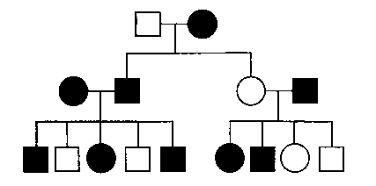
3. In the pedigree below, squares represent males and circles represent females. Individuals who express a particular trait are represented by shaded figures. Which of the following patterns of inheritance best explains the transmission of the trait?
(A) Sex-linked dominant
(B) Sex-linked recessive
(C) Autosomal recessive
(D) Autosomal dominant

4. In humans, red-green color blindness is a sexlinked recessive trait. If a man and a woman produce a color-blind son, which of the following must be true?
(A) The father is color-blind.
(B) Both parents carry the allele for color blindness.
(C) Neither parent carries the allele for color blindness.
(D) The mother carries the allele for color blindness.

5. In peas the trait for tall plants is dominant (T) and the trait for short plants is recessive (t). The trait for yellow seed color is dominant (Y) and the trait for green seed color is recessive (y). A cross between two plants results in 296 tall yellow seed plants and 104 tall green seed plants. Which of the following are most likely to be the genotypes of the parents?
(A) TTYY x TTYY
(B) TTyy x TTYy
(C) TtYy x TtYy
(D) TtYy x TTYy

6. In sheep, eye color is controlled by a single gene with two alleles. When a homozygous brown-eyed sheep is crossed with a homozygous green-eyed sheep, blue-eyed offspring are produced. If the blue-eyed sheep are mated with each other, what percent of their offspring will most likely have brown eyes?
(A) 0%
(B) 25%
(C) 50%
(D) 75%

7. A couple has 5 kids, all sons. If they have a sixth kid, what is the probability that the sixth kid will be a son?
(A) 5/6
(B) 1/2
(C) 1/5
(D) 1/6

8. Assume that genes A and B are not linked. If the probability of allele A in a gamete is 1/2 and the probability of allele B in a gamete is 1/2, then the probability that both A and B are in the same gamete is
(A) 1/2 x 1/2
(B) 1/2 + l/2
(C) 1/2 ÷ 1/2
(D) 1/2

9. In corn, the trait for tall plants (T) is dominant to the trait for dwarf plants (r) and the trait for colored kernels (C) is dominant to the trait for white kernels (c). In a particular cross of corn plants, the probability of an offspring being tall is 1/2 and the probability of a kernel being colored is 3/4. Which of the following most probably represents the parental genotypes?
(A) TtCc x ttCc
(B) TtCc x TtCc
(C) TtCc x ttcc
- TTCc x ttCc

10. A form of vitamin D-resistant rickets, known as hypophosphatemia, is inherited as an X-linked dominant trait. If a male with hypophosphatemia marries a normal female, which of the following predictions concerning their potential progeny would be true?
(A) All of their sons would inherit the disease.
(B) All of their daughters would inherit the disease.
(C) About 50% of their sons would inherit the disease.
- About 50% of their daughters would inherit the disease.

11. In fruit flies, vermilion eyes are a sex-linked recessive characteristic. If a vermilion-eyed female is crossed with a wild-type male, what proportion of the male offspring should have vermilion eyes?
(A) 0%
(B) 25%
(C) 50%
(D) 100%

12. In female cats the genotype BB is black. Bb is tortoise shell. and bb is yellow. The locus of this pair of alleles is on the X chromosome. If a tortoise-shell female is crossed with a black male. one would expect the different kinds of offspring to be in which of the following ratios to one another?
(A) 9 black females: 3 tortoise-shell females: 3 black males: 1 yellow male
(B) 1 black female: 1 tortoise-shell female: 1 black male: 1 yellow male
(C) 1 black female: 1 yellow male
- 1 tortoise-shell female: 1 yellow male

13. If red hair, blue eyes, and freckles were consistently inherited together, the best explanation would be that
(A) these traits are recessive characteristics
(B) both parents have red hair, blue eyes, and freckles
(C) the genes for these traits are linked on the same chromosome
(D) gene duplications have occurred

Questions 14-15
(A) 1/l6
(B) 1/4
(C) 1/2
(D) 9/16
(E) 1

Galactosemia is a simple, inherited, autosomal recessive trait. A normal couple has a child affected with galactosemia. For each of the following situations, select from the list above the appropriate probability.

14. The probability that the next two children will both be affected with galactosemia A
15. The probability that the father of the galactosemic child is heterozygous for the recessive allele E

Questions 16-18
A culture of white-eyed fruit flies (Drosophila melanogaster) was maintained for many generations. Females from the stock white-eyed culture were crossed with red-eyed (wild-type) males. The F₁ females were crossed with the white-eyed males from the original culture. The resulting phenotypes of the progeny are summarized below.

Parental Generation Cross F₁ Generation (at least 500 flies)
White-eyed females x red-eyed males 100% of females are red-eyed
100% of males are white-eyed

F₁ Generation Cross F₂ Generation (at least 500 flies)
F₁ red-eyed females x white-eyed males 50% of females are red-eyed and 50% are white-eyed
50% of males are red-eyed and 50% are white-eyed

16. The best explanation for the red-eyed F₁ females is
(A) mutation
(B) culture contamination
(C) dominance
(D) multiple loci

17. There are white-eyed females in the F₂ generation because
(A) white is a dominant allele
(B) the white allele is autosomal
(C) a mutation has occurred
(D) these F₂ females have two white alleles

18. Which of the following best describes the mode of inheritance of eye color in the white culture?
(A) Autosomal
(B) Dominant
(C) Located on the Y chromosome
(D) Sex-linked
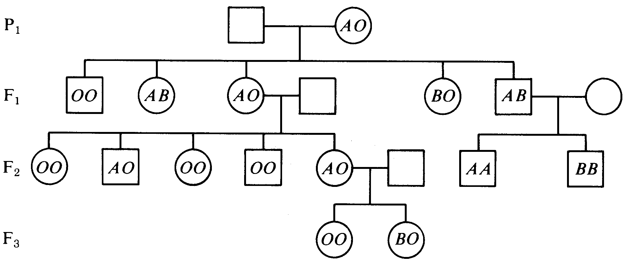
Questions 19-21 refer to the pedigree below in which females are indicated by circles and males are indicated by squares.
19. The genotype of the P₁ male must be
(A) OO
(B) AO
(C) BO
(D) AB

20. The only other possible genotype for children of the F₁ AB male would be
(A) OO
(B) BO
(C) AO
(D) AB

21. The most likely genotype of the mate of the F₁ AO female is
(A) AB
(B) BB
(C) OO
(D) AA

Questions 22-26
In a mating of a male Drosophila collected in nature with a normal female from a laboratory strain, 237 offspring were obtained. All of the offspring had normal eyes, except one unusual male, which had very narrow eyes. A series of matings is shown in the table below.

P₁ Unusual male x Normal female sisters
↓
68 males, normal eyes
73 females, slightly narrow eyes

F₁ Male. normal eyes (68) x female, slightly narrow eyes (73)
↓
¼ male, very narrow eyes
¼ male, normal eyes
¼ female, slightly narrow eyes
¼ female, normal eyes

22.The most likely explanation for the appearance of the narrow-eyed male in the PI is the
(A) appearance of hidden variability
(B) occurrence of a mutation
(C) consequence of laboratory culture of larvae on artificial media
(D) result of hybridizing a wild fly with a laboratory fly
(E) culture of the offspring at a higher temperature than is usual in nature

23. Assuming that a single locus causes the eye characteristic. the gene appears to function as
(A) a dominant allele
(B) a recessive allele
(C) an incompletely dominant allele
(D) a gene typical of that found in nature

24. From the breeding data, it is clear that the gene is physically located on which chromosome?
(A) X chromosome
(B) Y chromosome
(C) Chromosome 2
(D) Chromosome 3

25. Why do the F_{l} males not show the genetic trait?
(A) The gene has variable penetrance.
(B) The effect of the gene is blocked by the Y chromosome.
(C) The allele is blocked by its dominant allele.
(D) They do not contain the gene.

26. A promising approach to ascertain if a female with very narrow eyes could be obtained would be to
(A) cross the normal F₂ males with the normal females
(B) cross the F₂ males that are not normal with the females that are not normal
(C) cross the F₂ very narrow-eyed males with normal females
(D) cross the F₂ slightly narrow-eyed females with normal males

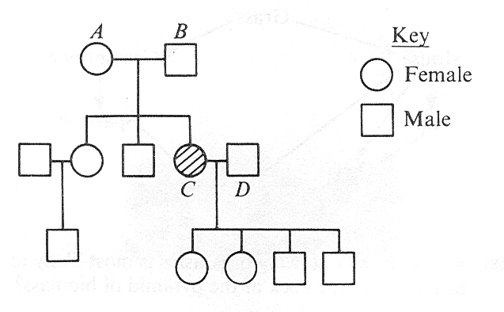
Questions 27-30 refer to the following pedigree that illustrates the inheritance of sickle cell anemia. Shading indicates the presence of sickle cell anemia.

27. The most reasonable explanation for the fact that the offspring of C and D do not have sickle cell anemia is that each received a
(A) sickle allele from the mother
(B) normal allele from the father
(C) sickle allele from each parent
(D) normal allele from each parent

28. Which of the following statements is correct about the four offspring of C and D?
(A) Only the females are carriers of the sickle cell trait.
(B) Only the males are carriers of the sickle cell trait.
(C) Only the females are heterozygous for the sickle cell trait.
(D) All are carriers of the sickle cell trait.

29. The phenotype of individual C is explained by the fact that this individual received an allele for sickle cell anemia from
(A) an autosomal chromosome of each parent
(B) the Y chromosome contributed by the father
(C) the X chromosome contributed by the mother
(D) the X chromosome contributed by the father

30. What is the probability that the next child of parents A and B would have had sickle cell anemia?
(A) 0%
(B) 25%
(C) 60%
(D) 75%

A male fruit fly (Drosophila melanogaster) with red eyes and long wings was mated with a female with purple eyes and vestigial wings. All of the offspring in the F₁ generation had red eyes and long wings. These F₁ flies were test crossed with purple-eyed, vestigial-winged flies. Their offspring, the F₂ generation, appeared as indicated below.
 | F₂ Generation
125 | red eyes, long wings
124 | purple eyes, vestigial wings
18 | purple eyes, long wings
16 | red eyes, vestigial wings
283 | Total

31. If in the F₁ and F₂ generations the same characteristics appeared in both males and females, it would be safe to assume that these traits for eye color and wing length
(A) are sex-linked
(B) vary in dominance according to sex
(C) are sex-influenced characteristics
(D) are autosomal characteristics

32. In the F₂ generation, the results are best explained by the fact that
(A) the test cross with the F₁ flies resulted in sterile offspring
(B) these genes for eye color and wing shape do not pass through the F₁ generation
(C) these genes for eye color and wing shape are found on the same chromosome
(D) crossing-over decreases variability

33. If a single locus controls wing shape, then the alleles for this gene act as
(A) dominant-recessive alleles
(B) incomplete-dominance alleles
(C) codominant alleles
- multiple alleles

Questions 34-35 refer to the birth of a child with blood type A to a mother with blood type B

34.The father must have which of the following blood types?
(A) AB only
(B) Either AB or B
(C) Either AB or O
(D) Either AB or A

35. If the father has blood type AB, which of the following statements is correct about the mother?
(A) She contributes an I^{B} allele, which is recessive to the father's I^{A} allele.
(B) She contributes an i allele which is recessive to the father's I^{A} allele.
(C) She contributes an I^{B} allele which is codominant to the father's I^{A} allele.
(D) She contributes an allele that is codominant to the father's I^{B} allele.
(E) She is homozygous for the I^{B} allele.

Practice Long Response Questions

- In fruit flies, the phenotype for eye color is determined by a certain locus. E indicates the
dominant allele and e indicates the recessive allele. The cross between a male wild-type fruit fly
and a female white-eyed fruit fly produced the following offspring.

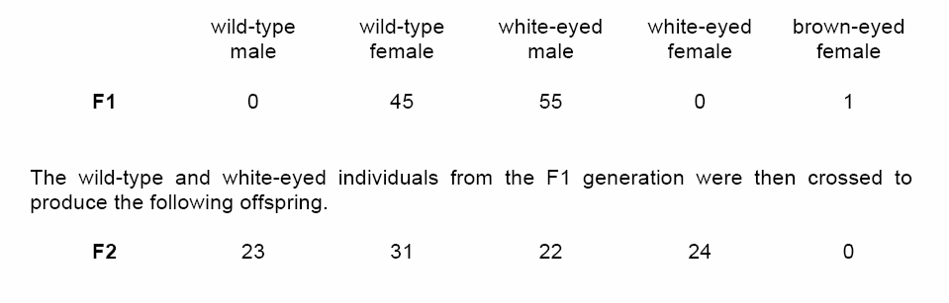
a. Determine the genotypes of the original parents (P generation) and explain your
reasoning. You may use Punnett squares to enhance your description, but the results
from the Punnett squares must be discussed in your answer.
b. Use a Chi-squared test on the F2 generation data to analyze your prediction of the
parental genotypes. Show all your work and explain the importance of your final answer.
c. The brown-eyed female in the F1 generation resulted from a mutational change. Explain
what a mutation is, and discuss two types of mutations that might have produced the
brown-eyed female in the F1 generation.

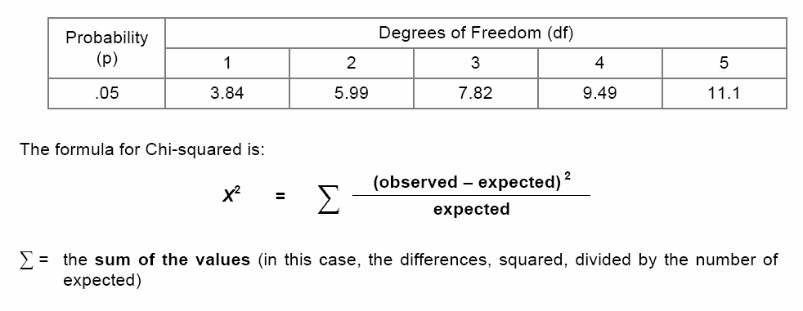
- State the conclusions reached by Mendel in his work on the inheritance of characteristics. Explain how each of the following deviates from these conclusions.
  - Autosomal linkage.
  - Sex-linked (X-linked) inheritance.
  - Polygenic (multiple-gene) inheritance.
3. An organism is heterozygous at two genetic loci on different chromosomes.
  - Explain how these alleles are transmitted by the process of mitosis to daughter cells.
  - Explain how these alleles are distributed by the process of meiosis to gametes.
  - Explain how the behavior of these two pairs of homologous chromosomes during meiosis provides the physical basis for Mendel’s two laws of inheritance.
Labeled diagrams that are explained in your answer may be useful.

