DNA

Multiple Choice
Identify the choice that best completes the statement or answers the question.

____ | 1. In his transformation experiments, what did Griffith observe?  - Mutant mice were resistant to bacterial infections.  - Mixing a heat-killed pathogenic strain of bacteria with a living nonpathogenic strain can convert some of the living cells into the pathogenic form.  - Mixing a heat-killed nonpathogenic strain of bacteria with a living pathogenic strain makes the pathogenic strain nonpathogenic.  - Infecting mice with nonpathogenic strains of bacteria makes them resistant to pathogenic strains.  - Mice infected with a pathogenic strain of bacteria can spread the infection to other mice.
____ | 2. What does transformation involve in bacteria?  - the creation of a strand of DNA from an RNA molecule  - the creation of a strand of RNA from a DNA molecule  - the infection of cells by a phage DNA molecule  - the type of semiconservative replication shown by DNA  - assimilation of external DNA into a cell
____ | 3. The following scientists made significant contributions to our understanding of the structure and function of DNA. Place the scientists' names in the correct chronological order, starting with the first scientist(s) to make a contribution.  - Avery, McCarty, and MacLeod  - Griffith  - Hershey and Chase  - Meselson and Stahl V. Watson and Crick  - V, IV, II, I, III  - II, I, III, V, IV  - I, II, III, V, IV  - I, II, V, IV, III  - II, III, IV, V, I
____ | 4. After mixing a heat-killed, phosphorescent strain of bacteria with a living non-phosphorescent strain, you discover that some of the living cells are now phosphorescent. Which observations would provide the best evidence that the ability to fluoresce is a heritable trait? a. DNA passed from the heat-killed strain to the living strain.  - Protein passed from the heat-killed strain to the living strain.  - The phosphorescence in the living strain is especially bright.  - Descendants of the living cells are also phosphorescent.  - Both DNA and protein passed from the heat-killed strain to the living strain.

____ | 5. In trying to determine whether DNA or protein is the genetic material, Hershey and Chase made use of which of the following facts?  - DNA contains sulfur, whereas protein does not.  - DNA contains phosphorus, but protein does not.  - DNA contains nitrogen, whereas protein does not.  - DNA contains purines, whereas protein includes pyrimidines.  - RNA includes ribose, while DNA includes deoxyribose sugars.
____ | 6. For a science fair project, two students decided to repeat the Hershey and Chase experiment, with modifications. They decided to label the nitrogen of the DNA, rather than the phosphate. They reasoned that each nucleotide has only one phosphate and two to five nitrogens. Thus, labeling the nitrogens would provide a stronger signal than labeling the phosphates. Why won't this experiment work?  - There is no radioactive isotope of nitrogen.  - Radioactive nitrogen has a half-life of 100,000 years, and the material would be too dangerous for too long.  - Avery et al. have already concluded that this experiment showed inconclusive results.  - Although there are more nitrogens in a nucleotide, labeled phosphates actually have 16 extra neutrons; therefore, they are more radioactive.  - Amino acids (and thus proteins) also have nitrogen atoms; thus, the radioactivity would not distinguish between DNA and proteins.
____ | 7. Which of the following investigators was/were responsible for the following discovery? Chemicals from heat-killed S cells were purified. The chemicals were tested for the ability to transform live R cells. The transforming agent was found to be DNA. a. Frederick Griffith  - Alfred Hershey and Martha Chase  - Oswald Avery, Maclyn McCarty, and Colin MacLeod  - Erwin Chargaff  - Matthew Meselson and Franklin Stahl
____ | 8. Which of the following investigators was/were responsible for the following discovery?  Phage with labeled proteins or DNA was allowed to infect bacteria. It was shown that the DNA, but not the protein, entered the bacterial cells, and was therefore concluded to be the genetic material. a. Frederick Griffith  - Alfred Hershey and Martha Chase  - Oswald Avery, Maclyn McCarty, and Colin MacLeod  - Erwin Chargaff  - Matthew Meselson and Franklin Stahl
____ | 9. Which of the following investigators was/were responsible for the following discovery? In DNA from any species, the amount of adenine equals the amount of thymine, and the amount of guanine equals the amount of cytosine. a. Frederick Griffith  - Alfred Hershey and Martha Chase  - Oswald Avery, Maclyn McCarty, and Colin MacLeod  - Erwin Chargaff
e. Matthew Meselson and Franklin Stahl

____ 10. When T2 phages infect bacteria and make more viruses in the presence of radioactive sulfur, what is the result?
- The viral DNA will be radioactive.
- The viral proteins will be radioactive.
- The bacterial DNA will be radioactive.
- both A and B
- both A and C

____ 11. Cytosine makes up 38% of the nucleotides in a sample of DNA from an organism. Approximately what percentage of the nucleotides in this sample will be thymine? a. 12
- 24
- 31
- 38
- It cannot be determined from the information provided.

____ 12. Chargaff's analysis of the relative base composition of DNA was significant because he was able to show that
- the relative proportion of each of the four bases differs within individuals of a species.
- the human genome is more complex than that of other species.
- the amount of A is always equivalent to T, and C to G.
- the amount of ribose is always equivalent to deoxyribose.
- transformation causes protein to be brought into the cell.

____ 13. Which of the following can be determined directly from X-ray diffraction photographs of crystallized DNA?
- the diameter of the helix
- the rate of replication
- the sequence of nucleotides
- the bond angles of the subunits
- the frequency of A vs. T nucleotides

____ 14. Why does the DNA double helix have a uniform diameter?
- Purines pair with pyrimidines.
- C nucleotides pair with A nucleotides.
- Deoxyribose sugars bind with ribose sugars.
- Nucleotides bind with nucleosides.
- Nucleotides bind with nucleoside triphosphates.

____ 15. What kind of chemical bond is found between paired bases of the DNA double helix? a. hydrogen
- ionic
- covalent
- sulfhydryl
- phosphate

____ 16. It became apparent to Watson and Crick after completion of their model that the DNA molecule could carry a vast amount of hereditary information in which of the following? a. sequence of bases
- phosphate-sugar backbones
- complementary pairing of bases
- side groups of nitrogenous bases
- different five-carbon sugars

____ 17. In an analysis of the nucleotide composition of DNA, which of the following will be found? a. A = C
- A = G and C = T
- A + C = G + T
- G + C = T + A

____ 18. Replication in prokaryotes differs from replication in eukaryotes for which of these reasons?
- The prokaryotic chromosome has histones, whereas eukaryotic chromosomes do not.
- Prokaryotic chromosomes have a single origin of replication, whereas eukaryotic chromosomes have many.
- The rate of elongation during DNA replication is slower in prokaryotes than in eukaryotes.
- Prokaryotes produce Okazaki fragments during DNA replication, but eukaryotes do not.
- Prokaryotes have telomeres, and eukaryotes do not.

____ 19. What is meant by the description "antiparallel" regarding the strands that make up DNA?
- The twisting nature of DNA creates nonparallel strands.
- The 5' to 3' direction of one strand runs counter to the 5' to 3' direction of the other strand.
- Base pairings create unequal spacing between the two DNA strands.
- One strand is positively charged and the other is negatively charged.
- One strand contains only purines and the other contains only pyrimidines.

____ 20. Suppose you are provided with an actively dividing culture of E. coli bacteria to which radioactive thymine has been added. What would happen if a cell replicates once in the presence of this radioactive base?
- One of the daughter cells, but not the other, would have radioactive DNA.
- Neither of the two daughter cells would be radioactive.
- All four bases of the DNA would be radioactive.
- Radioactive thymine would pair with nonradioactive guanine.
- DNA in both daughter cells would be radioactive.

Use Figure 16.1 to answer the following questions.

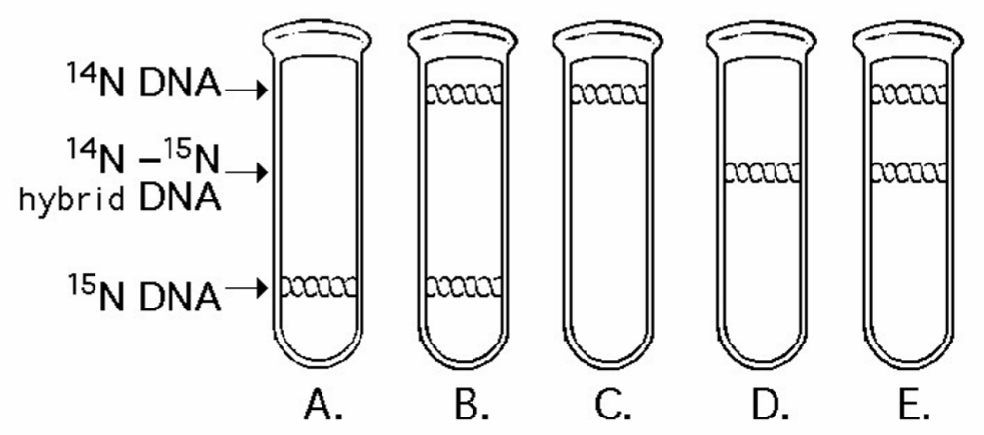

Figure 16.1

____ 21. Once the pattern found after one round of replication was observed, Meselson and Stahl could be confident of which of the following conclusions? a. Replication is semi-conservative.
- Replication is not dispersive.
- Replication is not semi-conservative.
- Replication is not conservative.
- Replication is neither dispersive nor conservative.

____ 22. In E. coli, there is a mutation in a gene called dnaB that alters the helicase that normally acts at the origin. Which of the following would you expect as a result of this mutation? a. No proofreading will occur.
- No replication fork will be formed.
- The DNA will supercoil.
- Replication will occur via RNA polymerase alone.
- Replication will require a DNA template from another source.

____ 23. Which enzyme catalyzes the elongation of a DNA strand in the 5' → 3' direction? a. primase
- DNA ligase
- DNA polymerase III
- topoisomerase
- helicase

____ 24. What determines the nucleotide sequence of the newly synthesized strand during DNA replication?
- the particular DNA polymerase catalyzing the reaction
- the relative amounts of the four nucleoside triphosphates in the cell
- the nucleotide sequence of the template strand
- the primase used in the reaction
- the arrangement of histones in the sugar phosphate backbone

____ 25. The DNA of telomeres has been found to be highly conserved throughout the evolution of eukaryotes. What does this most probably reflect? a. the inactivity of this DNA
- the low frequency of mutations occurring in this DNA
- that new evolution of telomeres continues
- that mutations in telomeres are relatively advantageous
- that the critical function of telomeres must be maintained

____ 26. In an experiment, DNA is allowed to replicate in an environment with all necessary enzymes, dATP,
dCTP, dGTP, and radioactively labeled dTTP (³H thymidine) for several minutes and then switched to nonradioactive medium. It is then viewed by electron microscopy and autoradiography. The drawing below represents the results.

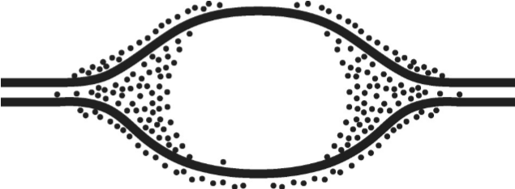

Grains represent radioactive material within the replicating eye.

Figure 16.2

Which is the most likely interpretation?
- There are two replication forks going in opposite directions.
- Thymidine is only being added where the DNA strands are furthest apart.
- Thymidine is only added at the very beginning of replication.
- Replication proceeds in one direction only.

____ 27. At a specific area of a chromosome, the sequence of nucleotides below is present where the chain opens to form a replication fork:
3' C C T A G G C T G C A A T C C 5'
An RNA primer is formed starting at the underlined T (T) of the template. Which of the following represents the primer sequence? a. 5' G C C T A G G 3'
- 3' G C C T A G G 5'
- 5' A C G T T A G G 3'
- 5' A C G U U A G G 3'
- 5' G C C U A G G 3'

____ 28. To repair a thymine dimmer by nucleotide excision repair, in which order do the necessary enzymes act?
- exonuclease, DNA polymerase III, RNA primase
- helicase, DNA polymerase I, DNA ligase
- DNA ligase, nuclease, helicase
- DNA polymerase I, DNA polymerase III, DNA ligase
- endonuclease, DNA polymerase I, DNA ligase

____ 29. What is the function of DNA polymerase III?
- to unwind the DNA helix during replication
- to seal together the broken ends of DNA strands
- to add nucleotides to the end of a growing DNA strand
- to degrade damaged DNA molecules
- to rejoin the two DNA strands (one new and one old) after replication

____ 30. You briefly expose bacteria undergoing DNA replication to radioactively labeled nucleotides. When you centrifuge the DNA isolated from the bacteria, the DNA separates into two classes. One class of labeled DNA includes very large molecules (thousands or even millions of nucleotides long), and the other includes short stretches of DNA (several hundred to a few thousand nucleotides in length). These two classes of DNA probably represent a. leading strands and Okazaki fragments.
- lagging strands and Okazaki fragments.
- Okazaki fragments and RNA primers.
- leading strands and RNA primers.
- RNA primers and mitochondrial DNA.

____ 31. Which of the following removes the RNA nucleotides from the primer and adds equivalent DNA nucleotides to the 3' end of Okazaki fragments? a. helicase
- DNA polymerase III
- ligase
- DNA polymerase I
- primase

____ 32. Which of the following separates the DNA strands during replication? a. helicase
- DNA polymerase III
- ligase
- DNA polymerase I
- primase

____ 33. Which of the following covalently connects segments of DNA? a. helicase
- DNA polymerase III
- ligase
- DNA polymerase I
- primase

____ 34. Which of the following synthesizes short segments of RNA? a. helicase
- DNA polymerase III
- ligase
- DNA polymerase I
- primase

____ 35. The leading and the lagging strands differ in that
- the leading strand is synthesized in the same direction as the movement of the replication fork, and the lagging strand is synthesized in the opposite direction.
- the leading strand is synthesized by adding nucleotides to the 3' end of the growing strand, and the lagging strand is synthesized by adding nucleotides to the 5' end.
- the lagging strand is synthesized continuously, whereas the leading strand is synthesized in short fragments that are ultimately stitched together.
- the leading strand is synthesized at twice the rate of the lagging strand.

____ 36. A new DNA strand elongates only in the 5' to 3' direction because
- DNA polymerase begins adding nucleotides at the 5' end of the template.
- Okazaki fragments prevent elongation in the 3' to 5' direction.
- the polarity of the DNA molecule prevents addition of nucleotides at the 3' end.
- replication must progress toward the replication fork.
- DNA polymerase can only add nucleotides to the free 3' end.

____ 37. Which of the following help to hold the DNA strands apart while they are being replicated? a. primase
- ligase
- DNA polymerase
- single-strand binding proteins
- exonuclease

____ 38. Individuals with the disorder xeroderma pigmentosum are hypersensitive to sunlight. This occurs because their cells have which impaired ability? a. They cannot replicate DNA.
- They cannot undergo mitosis.
- They cannot exchange DNA with other cells.
- They cannot repair thymine dimers.
- They do not recombine homologous chromosomes during meiosis.

____ 39. Which would you expect of a eukaryotic cell lacking telomerase?
- a high probability of becoming cancerous
- production of Okazaki fragments
- inability to repair thymine dimers
- a reduction in chromosome length
- high sensitivity to sunlight

____ 40. Which of the following statements describes the eukaryotic chromosome?
- It is composed of DNA alone.
- The nucleosome is its most basic functional subunit.
- The number of genes on each chromosome is different in different cell types of an organism.
- It consists of a single linear molecule of double-stranded DNA.
- Active transcription occurs on heterochromatin.

____ 41. If a cell were unable to produce histone proteins, which of the following would be a likely effect?
- There would be an increase in the amount of "satellite" DNA produced during centrifugation.
- The cell's DNA couldn't be packed into its nucleus.
- Spindle fibers would not form during prophase.
- Amplification of other genes would compensate for the lack of histones.
- Pseudogenes would be transcribed to compensate for the decreased protein in the cell.

____ 42. Why do histones bind tightly to DNA?
- Histones are positively charged, and DNA is negatively charged.
- Histones are negatively charged, and DNA is positively charged.
- Both histones and DNA are strongly hydrophobic.
- Histones are covalently linked to the DNA.
- Histones are highly hydrophobic, and DNA is hydrophilic.

____ 43. Which of the following statements is true of chromatin?
- Heterochromatin is composed of DNA, whereas euchromatin is made of DNA and RNA.
- Both heterochromatin and euchromatin are found in the cytoplasm.
- Heterochromatin is highly condensed, whereas euchromatin is less compact.
- Euchromatin is not transcribed, whereas heterochromatin is transcribed.
- Only euchromatin is visible under the light microscope.

____ 44. In his work with pneumonia-causing bacteria and mice, Griffith found that
- the protein coat from pathogenic cells was able to transform nonpathogenic cells.
- heat-killed pathogenic cells caused pneumonia.
- some substance from pathogenic cells was transferred to nonpathogenic cells, making them pathogenic.
- the polysaccharide coat of bacteria caused pneumonia.
- bacteriophages injected DNA into bacteria.

____ 45. E. coli cells grown on ¹⁵N medium are transferred to ¹⁴N medium and allowed to grow for two more generations (two rounds of DNA replication). DNA extracted from these cells is centrifuged. What density distribution of DNA would you expect in this experiment? a. one high-density and one low-density band
- one intermediate-density band
- one high-density and one intermediate-density band
- one low-density and one intermediate-density band
- one low-density band

____ 46. A biochemist isolates and purifies various molecules needed for DNA replication. When she adds some DNA, replication occurs, but each DNA molecule consists of a normal strand paired with numerous segments of DNA a few hundred nucleotides long. What has she probably left out of the mixture?
- DNA polymerase
- DNA ligase
- nucleotides
- Okazaki fragments
- primase

____ 47. What is the basis for the difference in how the leading and lagging strands of DNA molecules are synthesized?
- The origins of replication occur only at the 5' end.
- Helicases and single-strand binding proteins work at the 5' end.
- DNA polymerase can join new nucleotides only to the 3' end of a growing strand.
- DNA ligase works only in the 3' → 5' direction.
- Polymerase can work on only one strand at a time.

____ 48. In analyzing the number of different bases in a DNA sample, which result would be consistent with the base-pairing rules? a. A = G
- A + G = C + T
- A + T = G + T
- A = C
- G = T

____ 49. In a nucleosome, the DNA is wrapped around
- polymerase molecules.
- ribosomes.
- histones.
- a thymine dimer.
- satellite DNA.

