Name: _____________________________________________ Date: ____________________________ Period: ______

AP Biology Exam Review : Ecology (Unit 10)

Textbook Chapters: 52 (Population Ecology), 53 (Community Ecology), 54 (Ecosystems), 55 (Conservation Biology and Restoration Ecology), 36 (Transport In Vascular Plants)

Helpful Videos and Animations:
Bozeman Biology: Ecosystems
Bozeman Biology: Ecosystem Change
Bozeman Biology: Ecological Succession
Bozeman Biology: Populations
Bozeman Biology: R and K Selection
Bozeman Biology: Cooperative Interactions
Bozeman Biology: Communities
Bozeman Biology: Niche
Bozeman Biology: Biogeochemical Cycling

Topic Outline:

Note: Curriculum connections are not included here, as the curriculum document for the ecology unit is long and unhelpful… in Ms. Ottolini’s PERSONAL opinion!

Sorry, there are no practice multiple choice questions on plant transport!

- Population Ecology (Notes: Part A)
- Population Density
- Methods of Measurement: Quadrant Technique vs. Mark and Recapture Technique
- Population Distribution
- Uniform vs. Random vs. Clumped
- Population Growth
- Know how to use the equations (see equations worksheet)
- Exponential vs. Logistic Growth (be able to recognize / explain the graphs)
- Carrying Capacity
- Limiting Factors (Density Dependent vs. Density Independent)
- Demography
- Age structure pyramids
- Life history curves (Types I, II, and III)
- R-selected vs. K-selected population

- Community Ecology (Notes: Part B)
- Symbiosis
- Mutualism
- Commensalism
- Parasitism
- Competition (Niche, Resource Partitioning, Competitive Exclusion Principle)
- Predator Prey Relationships (population growth cycling, predator vs. prey adaptations)
- The Importance of Species Diversity in a Community
- Ecological Succession
- Primary vs. Secondary Succession
- Pioneer Species
- Climax Community
- Animal Behavior
- Cooperative Behavior (ex: plant and pollinator)
- Altruistic Behavior (kin selection)
- Learned vs. Innate Behavior (ex: Fixed Action Patterns like yawning)
- Communication via pheromones (ex: warning pheromones or sex pheromones) or behaviors (ex: bee waggle dance)
- Movement (taxis vs. kinesis)

- Ecosystem Ecology
- Be able to analyze food chains and food webs / identify trophic levels
- Location of decomposers on a food chain
- Limits on food chain length: energetic hypothesis vs. dynamic stability hypothesis
- Dominant species vs. keystone species vs. foundation species
- Biotic vs. Abiotic Factors
- How energy transfers relate to the second law of thermodynamics
- Primary productivity (gross vs. net)
- Limiting nutrients and eutrophication
- Trophic Efficiency: energy pyramids vs. pyramids of biomass vs. pyramids of numbers

- Biogeochemical / Nutrient Cycles (know the processes by which the atoms / molecules listed below are cycled between living things and the non-living components of their environment ; also, be able to summarize reservoirs, assimilation, and release for each cycle)
- Carbon Cycle
- Nitrogen Cycle
- Water Cycle
- Phosphorus Cycle

- Plant Transport
- Basic Functions of Plant Structures (Roots, Shoots, Leaves)
- Vascular Tissues (know the function and basic structure of each)
- Xylem
- Phloem
- Transport of Water Into Roots (osmosis + aquaporins)
- Mycorrhizae
- Mechanism of Transpiration + Capillary Action in xylem
- Compromise between photosynthesis and transpiration
- Mechanism of movement of phloem sap through the phloem (must mention the connection to water potential)
- Methods of Measuring the Rate of Transpiration

- Ecological Issues
- Dead Zones and Eutrophication
- Ozone Depletion
- Acid Rain
- Global Warming
- Biological Magnification
- Invasive Species
- Habitat Destruction
- Habitat Fragmentation
- Overhunting

Practice Multiple Choice Questions:

1. Which of the following is true of innate behaviors?
a. | Genes have very little influence on the expression of innate behaviors.
b. | Innate behaviors tend to vary considerably among members of a population.
c. | Innate behaviors are limited to invertebrate animals.
d. | Innate behaviors are expressed in most individuals in a population across a wide range of environmental conditions.
e. | Innate behaviors occur in invertebrates and some vertebrates but not in mammals.

2. A certain species of pine tree survives only in scattered locations at elevations above 2,800 m in the western United States. To understand why this tree grows only in these specific places an ecologist should
a. | conclude that lower elevations are limiting to the survival of this species.
b. | study the anatomy and physiology of this species.
c. | investigate the various biotic and abiotic factors that are unique to high altitude.
d. | analyze the soils found in the vicinity of these trees, looking for unique chemicals that may support their growth.
e. | collect data on temperature, wind, and precipitation at several of these locations for a year.

3. How are matter and energy used in ecosystems?
a. | Matter is cycled through ecosystems; energy is not.
b. | Energy is cycled through ecosystems; matter is not.
c. | Energy can be converted into matter; matter cannot be converted into energy.
d. | Matter can be converted into energy; energy cannot be converted into matter.
e. | Matter is used in ecosystems; energy is not

4. Imagine that you are designing an experiment aimed at determining whether the initiation of migratory behavior is largely under genetic control. Of the following options, the best way to proceed is to
a. | observe genetically distinct populations in the field and see if they have different migratory habits.
b. | perform within-population matings with birds from different populations that have different migratory habits. Do this in the laboratory and see if offspring display parental migratory behavior.
c. | bring animals into the laboratory and determine the conditions under which they become restless and attempt to migrate.
d. | perform within-population matings with birds from different populations that have different migratory habits. Rear the offspring in the absence of their parents and observe the migratory behavior of offspring.
e. | All of the options are equally productive ways to approach the question.
5. Long–term studies of Belding's ground squirrels show that immigrants move nearly 2 km from where they are born and become 1% –8% of the males and 0.7% –6% of the females in other populations. On an evolutionary scale, why is this significant?
a. | These immigrants make up for the deaths of individuals, keeping the other populations' size stable.
b. | Young reproductive males tend to stay in their home population and are not driven out by other territorial males.
c. | These immigrants provide a source of genetic diversity for the other populations.
d. | Those individuals that emigrate to these new populations are looking for less crowded conditions with more resources.
e. | Gradually, the populations of ground squirrels will move from a clumped to a uniform population pattern of dispersion.

6. Which of the following scenarios would provide the most legitimate data on population density?
a. | Count the number of nests of a particular species of songbird and multiply this by a factor that extrapolates these data to actual animals.
b. | Count the number of pine trees in several randomly selected 10 m 10 m plots and extrapolate this number to the fraction of the study area these plots represent.
c. | Use the mark–and–recapture method to estimate the size of the population.
d. | Calculate the difference between all of the immigrants and emigrants to see if the population is growing or shrinking.
e. | Add the number of births and subtract the individuals that die to see if the population's density is increasing or decreasing.

7. Starting from a single individual, what is the size of a population of bacteria that reproduce by binary fission every 20 minutes at the end of a 2–hour time period? (Assume unlimited resources and no mortality.)
a. | 6
b. | 64
c. | 128
d. | 512
e. | 1,024

8. As N approaches K for a certain population, which of the following is predicted by the logistic equation?
a. | The growth rate will not change.
b. | The growth rate will approach zero.
c. | The population will show an Allee effect.
d. | The population will increase exponentially.
e. | The carrying capacity of the environment will increase.

9. Which of the following graphs illustrates the REALISTIC growth curve of a small population of rodents that has grown to reach a static carrying capacity? D
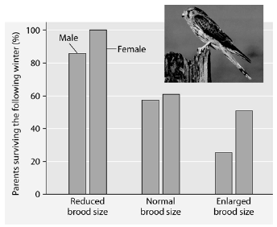
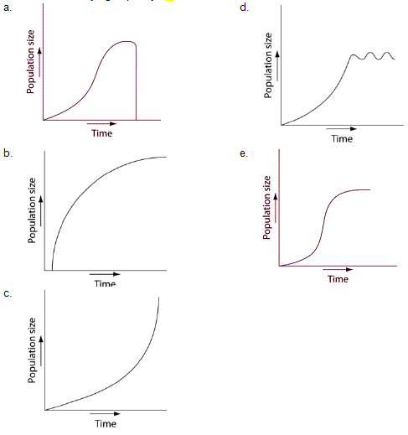
10. Please read the paragraph below and review Figure 53.2 to answer the following question.

Researchers in the Netherlands studied the effects of parental care given in European kestrels over five years. The researchers transferred chicks among nests to produce reduced broods (three or four chicks), normal broods (five or six chicks), and enlarged broods (seven or eight chicks). They then measured the percentage of male and female parent birds that survived the following winter. (Both males and females provide care for chicks.)

Figure 53.2: Brood size manipulations in the kestrel: Effects on offspring and parent survival.

Which of the following is a conclusion that can be drawn from this graph?
a. | Female survivability is more negatively affected by larger brood size than is male survivability.
b. | Male survivability decreased by 50% between reduced and enlarged brood treatments.
c. | Both males and females had increases in daily hunting with the enlarged brood size.
d. | There appears to be a negative correlation between brood enlargements and parental survival.
e. | Chicks in reduced brood treatment received more food, weight gain, and reduced mortality.

Refer to Figure 53.4 and then answer the following questions.

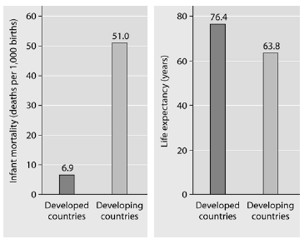

Figure 53.4: Infant mortality and life expectancy at birth in developed and developing countries (data as of 2005).

11. What is a logical conclusion that can be drawn from the graphs above?
a. | Developed countries have lower infant mortality rates and lower life expectancy than developing countries.
b. | Developed countries have higher infant mortality rates and lower life expectancy than developing countries.
c. | Developed countries have lower infant mortality rates and higher life expectancy than developing countries.
d. | Developed countries have higher infant mortality rates and higher life expectancy than developing countries.
e. | Developed countries have a life expectancy that is about 42 years more than life expectancy in developing countries.

12. Approximately how many kg of carnivore (secondary consumer) biomass can be supported by a field plot containing 1,000 kg of plant material?
a. | 10,000
b. | 1,000
c. | 100
d. | 10
e. | 1

13. Elephants are not the most dominant species in African grasslands, yet they influence community structure. The grasslands contain scattered woody plants, but they are kept in check by the uprooting activities of the elephants. Take away the elephants, and the grasslands convert to forests or to shrublands. The newly growing forests support fewer species than the previous grasslands. Which of the following describes why elephants are the keystone species in this scenario?
a. | Essentially all of the other species depend on the presence of the elephants to maintain the community.
b. | Grazing animals depend upon the elephants to convert forests to grassland.
c. | Elephants prevent drought in African grasslands.
d. | Elephants are the biggest herbivore in this community.
e. | Elephants help other populations survive by keeping out many of the large African predators.

14. Which of the following is the most accepted hypothesis as to why invasive species take over communities into which they have been introduced?
a. | Invasive species are more aggressive than native species in competing for the limited resources of the environment.
b. | Invasive species are not held in check by the predators and agents of disease that have always been in place for the native species.
c. | Humans carefully select which species will outcompete nuisance native species.
d. | Invasive species have a higher reproductive potential than native species.
e. | Invasive species come from geographically isolated regions, so when they are introduced to regions where there is more competition, they thrive.

Use the following diagram to answer the next few questions.

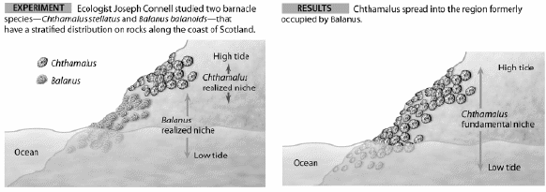Figure 54.1

15. Connell conducted this experiment to learn more about
a. | character displacement in the color of barnacles.
b. | habitat preference in two different species of barnacles.
c. | desiccation resistance and barnacle species.
d. | how sea–level changes affect barnacle distribution.
e. | competitive exclusion and distribution of barnacle species.

The symbols +, –, and o are to be used to show the results of interactions between individuals and groups of individuals in the examples that follow. The symbol + denotes a positive interaction, – denotes a negative interaction, and o denotes where individuals are not affected by interacting. The first symbol refers to the first organism mentioned.

16. What interactions exist between a lion pride and a hyena pack? (Hint: they eat the same prey species)
a. | +/+
b. | +/o
c. | +/–
d. | o/o
e. | –/–

17. Food chains are sometimes short because
a. | only a single species of herbivore feeds on each plant species.
b. | local extinction of a species causes extinction of the other species in its food chain.
c. | most of the energy in a trophic level is lost as it passes to the next higher level.
d. | predator species tend to be less diverse and less abundant than prey species.
e. | most producers are inedible.
18. Why is net primary production (NPP) a more useful measurement to an ecosystem ecologist than gross primary production (GPP)?
a. | NPP can be expressed in energy/unit of area/unit of time.
b. | NPP can be expressed in terms of carbon fixed by photosynthesis for an entire ecosystem.
c. | NPP represents the stored chemical energy that is available to consumers in the ecosystem.
d. | NPP is the same as the standing crop.
e. | NPP shows the rate at which the standing crop is utilized by consumers.

19. Owls eat rats, mice, shrews, and small birds. Assume that, over a period of time, an owl consumes 5,000 J of animal material. The owl loses 2,300 J in feces and owl pellets and uses 2,500 J for cellular respiration. What is the primary efficiency of this owl?
a. | 0.02%
b. | 1%
c. | 4%
d. | 10%
e. | 40%

20. Consider the food chain grass  grasshopper  mouse  snake  hawk. How much of the chemical energy fixed by photosynthesis of the grass (100%) is available to the hawk?
a. | 0.01%
b. | 0.1%
c. | 1%
d. | 10%
e. | 60%

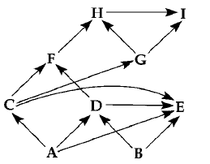
Diagram of a food web (arrows represent energy flow and letters represent species)

21. If the figure above represents a terrestrial food web, the combined biomass of C + D would probably be
a. | greater than the biomass of A.
b. | less than the biomass of H.
c. | greater than the biomass of B.
d. | less than the biomass of A + B.
e. | less than the biomass of E.

22. Suppose you are studying the nitrogen cycling in a pond ecosystem over the course of a month. While you are collecting data, a flock of 100 Canada geese lands and spends the night during a fall migration. What could you do to eliminate error in your study as a result of this event?
a. | Find out how much nitrogen is consumed in plant material by a Canada goose over about a 12 –hour period, multiply this number by 100, and add that amount to the total nitrogen in the ecosystem.
b. | Find out how much nitrogen is eliminated by a Canada goose over about a 12–hour period, multiply this number by 100, and subtract that amount from the total nitrogen in the ecosystem.
c. | Find out how much nitrogen is consumed and eliminated by a Canada goose over about a 12–hour period and multiply this number by 100; enter this +/– value into the nitrogen budget of the ecosystem.
d. | Do nothing. The Canada geese visitation to the lake would have negligible impact on the nitrogen budget of the pond.
e. | Put a net over the pond so that no more migrating flocks can land on the pond and alter the nitrogen balance of the pond.
Use the graph and information provided in the paragraph below to answer the following questions.
Flycatcher birds that migrate from Africa to Europe feed their nestlings a diet that is almost exclusively moth caterpillars. The graph below shows the mean dates of arrival, bird hatching, and peak caterpillar season for the years 1980 and 2000.

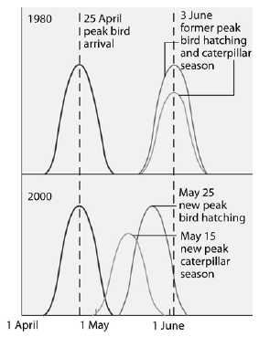

23. Why were ecologists concerned about the shift in the peak caterpillar season from June 3, 1980, to May 15, 2000?
a. | The caterpillars would have eaten much of the foliage of the trees where flycatchers would have nested, rendering their nests more open to predation.
b. | The earlier hatching of caterpillars would compete with other insect larval forms which the flycatchers would also use to feed their young.
c. | The 2000 flycatcher nestlings would miss the peak caterpillar season and might not be as well fed.
d. | The flycatchers would have to migrate sooner to match their brood–rearing to the time of peak caterpillar season.
e. | Pesticides, which have a negative effect on the ecosystem, would have to be used to control the earlier outbreak of caterpillar hatching.

Practice Calculations Questions

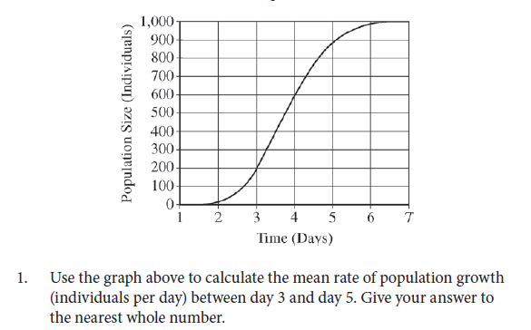
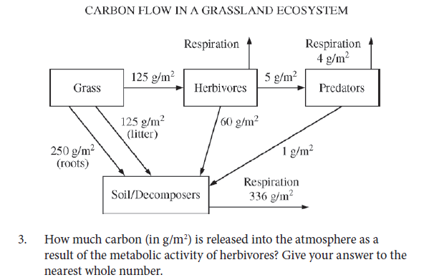

Practice Long Response Questions:

1. Describe the trophic levels in a typical ecosystem. Discuss the flow of energy through the ecosystem, the relationship between the different trophic levels, and the factors that limit the number of trophic levels.

2. Describe the biogeochemical cycles of carbon and nitrogen. Trace these elements from the point of their release from a decaying animal to their incorporation into a living animal.

3. A group of students designed an experiment to measure transpiration rates in a particular species of herbaceous plant. Plants were divided into four groups and were exposed to the following conditions.
Group I- | Room conditions (light, low humidity, 20° C, and little air movement.)
Group II- | Room conditions with increased humidity.
Group III- | Room conditions with increased air movement (fan)
Group IV- | Room conditions with additional light
The cumulative water loss due to transpiration of water from each plant was measured at 10-minute intervals for 30 minutes. Water loss was expressed as milliliters of water per square centimeter of leaf surface area. The data for all plants in Group I (room conditions) were averaged. The average cumulative water loss by the plants in Group I is presented in the table below.
Average Cumulative Water Loss by the Plants in Group I
Time (minutes) | Average Cumulative Water Loss (milliliter H₂O centimeter²)
10 | 3.5 x 10⁻⁴
20 | 7.7 x 10⁻⁴
30 | 10.6 x 10⁻⁴
  - Construct and label a graph using the data for Group I. Using the same set of axes, draw and label three additional lines representing the results that you would predict for Groups II, III, and IV.
  - Explain how biological and physical processes are responsible for the difference between each of your predictions and the data for Group I.
  - Explain how the concept of water potential is used to account for the movement of water from the plant stem to the atmosphere during transpiration.

