I. Genetic Engineeringmodification of DNA of organisms to produce new genes with new characteristics
-genes are small compared to chromosomes
-need methods to get gene-sized pieces of DNA
-direct manipulation of genes for practical purposes
change genetic material artificially in cells of an organism
launched a revolution in biotechnology
-manipulation of organisms or their components to make useful products
- production of strains of bacteria that manufacture useful protein products
- development of plants and animals that express foreign genes

Today-applications:
Medicine-better health
Pharmaceutical-production of antibiotics
Foods-wine, cheese, beer
Agriculture-selective breeding

One methodrecombinant DNA technology
-the set of techniques for recombining genes from different sources in vitro and transferring this DNA into a cell where it may be expressed specific genes can be taken from one organism and replaced in another
-moves genes across the species barrier!

Insulin
-Islets of Langerhans
-cell membrane permeable to sugar
Bacteriapick up plasmids (DNA ring) from environment
-adding human insulin gene to plasmid
bacterium picks up plasmid
bacterium synthesizes insulin
all bacterial offspring have mutated plasmid
all offspring produce insulin because from human genewill be human insulin
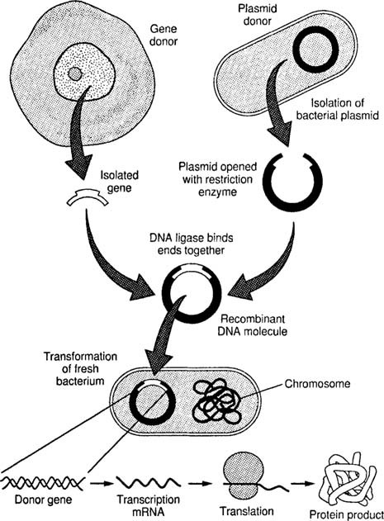

Steps in forming recombinant DNA:
- Gene splicingcutting gene out of human DNA and putting into plasmid
  - gene must be removed at sequence that codes for insulin gene
  - done by restriction enzymes (major tool in recombinant DNA technology; in nature, protect bacteria from foreign DNA, especially viral; bacteria protects itself with methylation)
    - discovered in the late 1960s
    - in bacteria
-over 3,000 studied
-600 used commercially
-why have? To cut viral DNA
    - cut at specific recognition sequences or restriction sites
-very specific; only cut at specific points
-asymmetric sequences of 4-8 nucleotides found on both
strands running in antiparallel directions (palindromic sequence)
GAATTC GAATTC
CTTAAG CTTAAG
    - cut phosphodiester bonds leaving sticky ends
-double-stranded (d.s.) DNA with single-stranded (s.s.) ends will H-bond with complementary base pairs -union is temporary; must add DNA ligase to make permanent
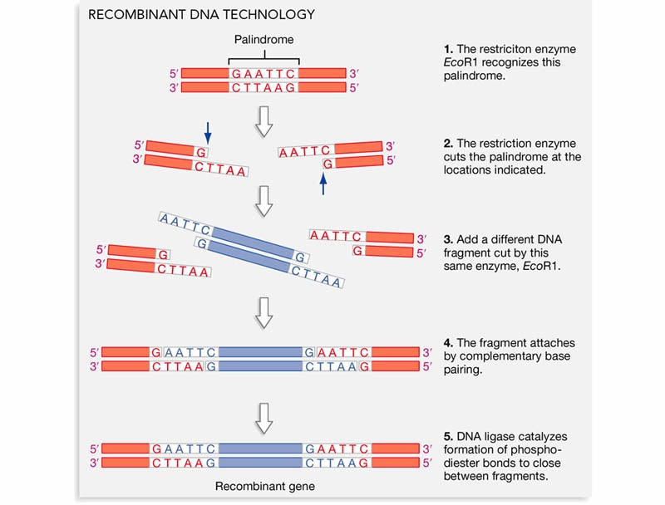

    - this cleavage allows gene with sticky ends to be isolated 6. genecalled passengerwill be carried to new organism
  - once snipped out, gene must be placed in cloning vector (bacterial plasmid or virus used to move DNA into cells) or vehicle
plasmid will carry gene into bacterium
    - same restriction enzyme is used on vector to cut at same sequence and leave complimentary sticky ends
    - insulin genes and new plasmids are mixed
    - sticky ends attract; H-bond temporarily
    - phosphodiester linkages are reformed by DNA ligase
  - plasmid and insulin gene are considered recombinant DNA
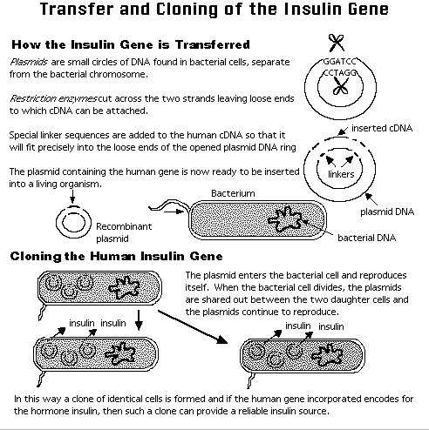
- Transformation
  - bacterium picks up plasmid- single recognition sequence in lac Z gene
  - now E.coli contains gene; therefore, will begin to produce insulin
  - reproduces via asexual reproductionclones
  - E.coli now source of human insulin
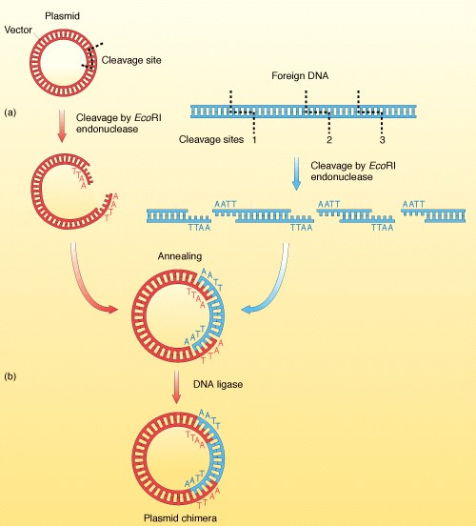

Vectors
1. plasmids (original cloning vectors-carries foreign DNA into a cell)by transformation
How can scientists know if the gene of interest has been picked up?
If no lac Z gene no ȕ-galactosidase is made
Grow bacteria on X-gal, a modified sugar, added to the culture medium
-colonies turn blue when hydrolyzed by ȕ-galactosidase (lac Z gene
still present)
-colonies are white if ȕ-galactosidase is not present (lac Z gene was cut and gene of interest is inserted)
-used as an indicator that cells have been transformed by plasmids containing foreign insert
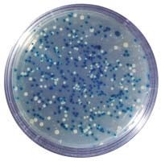

Let’s do the handout!

How else can scientists ID cell clones carrying the gene of interest?
How do they distinguish between the colony containing the gene of interest from many 1,000s of colonies carrying other pieces of human DNA?
-Look for the gene itself!
-method to detect depends on base pairing between the gene and a complementary sequence on another nucleic acid molecule
-process called nucleic acid hybridization
-the complementary molecule, a short single-stranded nucleic acid can be either RNA or DNA -called a nucleic acid probe
-if know part of sequence of gene, can synthesize a complementary probe
-trace probe with radioactivity or fluorescent tag

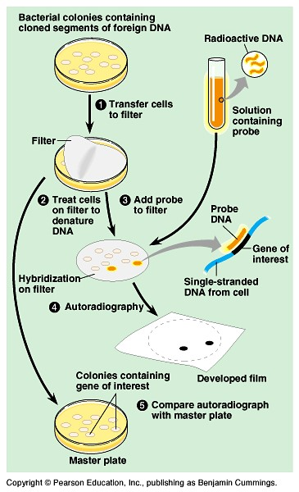
2. virusesvia transduction
- nonessential genes are spliced out of middle of linear genome of
virus by restriction enzymes
- recombinant fragments of DNA are introducedreplace deleted area
- recombinant phage inserts DNA into bacterium
- phage replicates itself-each new phage carries passenger gene
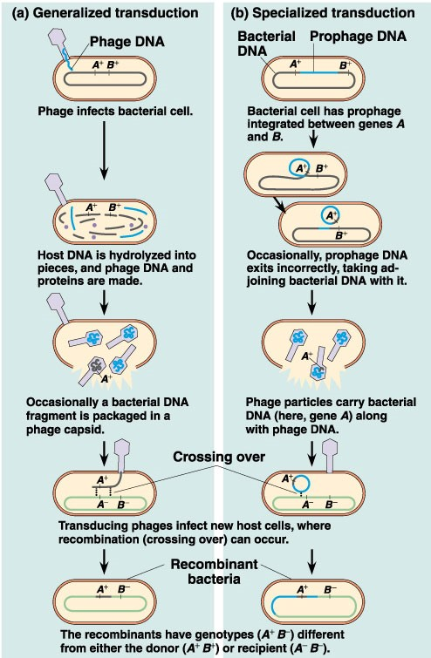

Host organisms
- Bacteria
1.advantages
  - DNA can be easily isolated and reintroduced
  - grow and reproduce quickly-producing many clones of desired gene
  - genome can easily be manipulated
2. disadvantages
  - may not have ability to use information in eukaryotic gene
prokaryotes/ eukaryotes use different enzymes and regulatory mechanisms during synthesis, i.e. during transcription and translation
Post-translational:
  - cannot modify proteins as eukaryotes can (ex: no Golgi- to add lipids or carb groups)
  - cannot splice out introns-code for unneeded amino acids
- Eukaryotic cells-yeast as host (rare eukaryote with plasmids)
  - overcome limitations
  - difficult to get cells to pick up foreign DNA
-must shock electrically (electroporation) to make plasma membrane porous
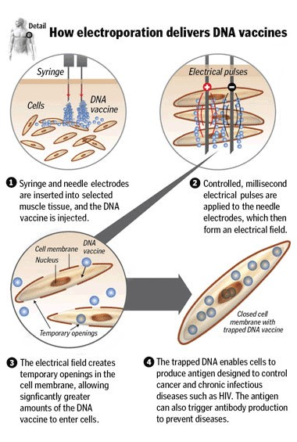

Sources of DNA which can be inserted into vectors and cloned:
- DNA isolated from an organism
  - contains all genes, including gene of interest
  - restriction enzymes cut DNA into 1,000s of pieces
  - all pieces are inserted into plasmids or viral DNA
  - vectors into bacteria
  - wait for production of protein
  - produces genomic library (a collection of many bacterial or phage clones of a particular DNA segment from a foreign genome. In a complete library, the foreign DNA segments represented cover the entire genome of an organism.)
-each bacterium carries separate desirable gene

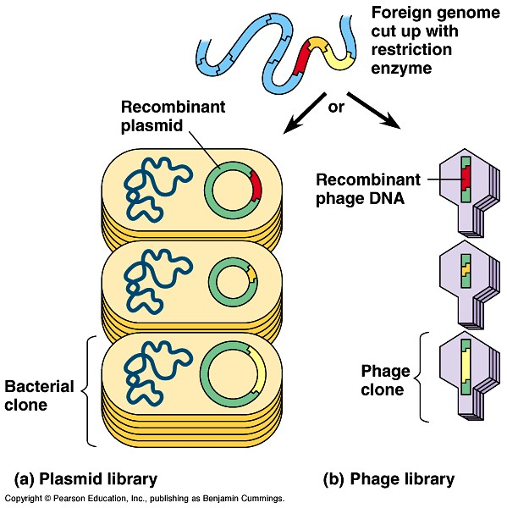

  - problems:
    - no modification of genes with introns
    - no need to make entire library
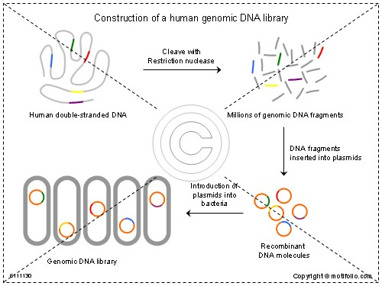
- Make complimentary DNA library (cDNA)
  - use recently made mRNA molecules from cytoplasm of cell
after processing, contains only information necessary for expression of that trait
  - reverse transcriptaseused to catalyze DNA strand
-2nd made via DNA polymerase

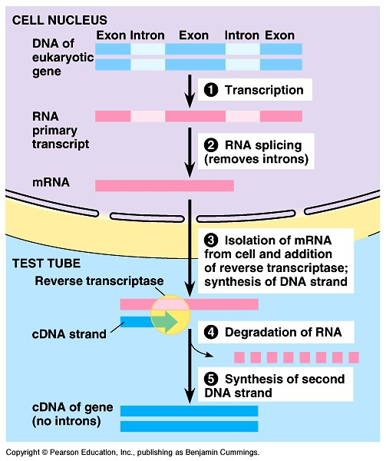
  - positive because:
    - cDNAno introns 2. manageable in size
  - have to carry out and place into bacterial cell to see which protein is produced
cannot distinguish mRNA when isolated
    - use mRNA from certain tissues because more likely to contain mRNA or certain proteins
    - ex: bone marrowhemoglobin
Islets of Langerhans
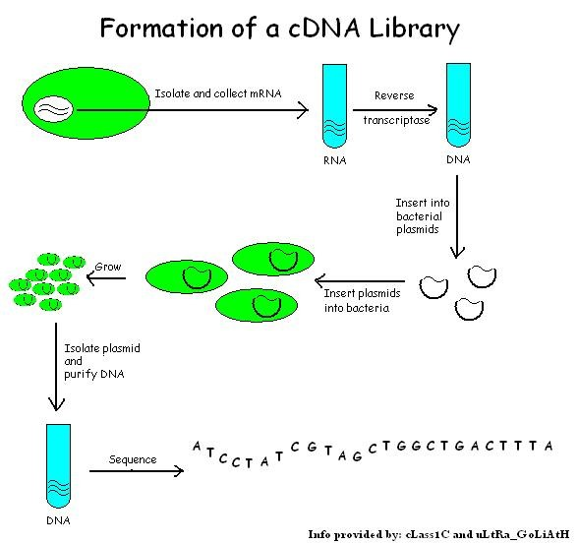

Once genes are cloned, can we distinguish genes in different people?
- Gel Electrophoresis
    - can be used to separate nucleic acids or proteins based on molecular charge, size, etc.
    - viral, plasmid, and segments of chromosomal DNA can be “i.d.-ed” by characteristic banding patterns
    - set up: gel box connected to power source
      - insideDNA of interest is place in wells of agar plate
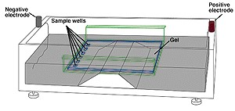
      - covered with TBE buffer
      - power sourceDNA is negative; therefore, DNA is pulled
towards positive electrode
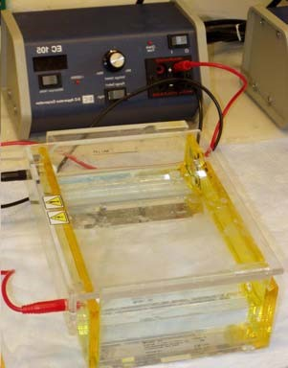
4. DNA can be cleaved by using restriction enzymes cleave one molecule of DNA into 1,000s of fragments
      - each restriction enzyme cleaves DNA at certain recognition sequences
      - cleaves DNA into long and short segments
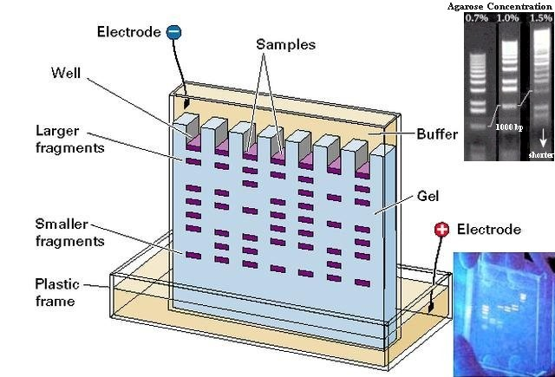
      - fragments of different lengths are separated as they diffuse through gel material
        - shorter fragments migrate farther than long, heavier fragments
        - can be used to compare DNA fragments (cut by same restriction enzyme) of closely related species to determine evolutionary relationships
        - member of a species have vast majority of DNA the same
-chimpanzee 99.3% same DNA as humans
-therefore, most bands will be same between
individuals of a species
-differences in bands in certain areas vary between individuals
5. Different alleles between individuals will cause restriction enzymes to cleave in different places
      - causes differences in restriction fragment lengths  differences are called restriction fragment length polymorphisms (RFLPs)
      - RFLPs can be used for making genetic markers for making linkage maps
1. allows mapping of human genome because expands options of scientists from looking at phenotypic differences to looking at actual differences in DNA
c. allows for DNA fingerprinting
        - because different alleles cause different RFLPs and ultimately different bands in gel electrophoresis; each person’s DNA makes a distinct pattern when cleaved with specific restriction enzymes
        - each person, then has a specific “DNA fingerprint” that differs from person to person
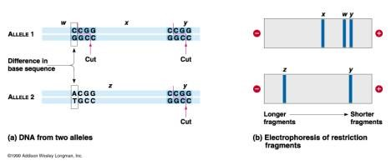
        - used by forensic scientists to analyze DNA left at crime scenes in blood, skin, hair, semen, etc.
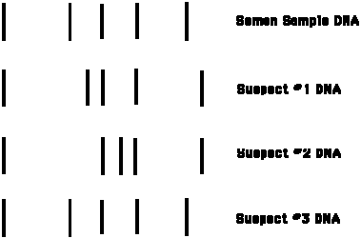

        - how reliable?
          - most tests don’t analyze entire genome; rather, focus on small regions known to be highly variable from person to person
          - even though 1/1 million chance that 2 people (other than twins) in same region could have same fingerprints, some courts have thrown out evidence completely
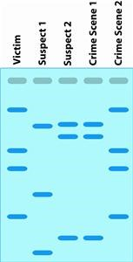

- The Polymerase Chain Reaction (PCR)- 1985
    - allows pieces of DNA to be amplified (copied many times), entirely in vitro (in culture, in vivo- inside the organism)
    - can be used instead of using bacteria to clone DNA fragments
    - uses DNA directly and DNA polymerase (heat resistant from bacterium in hot springs, Thermus aquaticus, or Taq polymerase) to clone genes
    - Process:
      - DNA incubated under appropriate conditions with special
synthetic primersinitiate replication at specific nucleotide sequences via DNA polymerase
      - billions of copies of specific sections of DNA are produced in only
a few hours; each cycle approximately 5 minutes
-s.s. DNA primers determine sequence to be amplified;
therefore, PCR is highly specific
-only minute amounts of DNA are needed
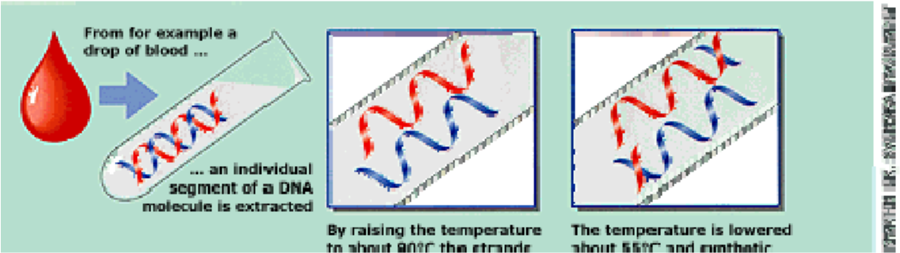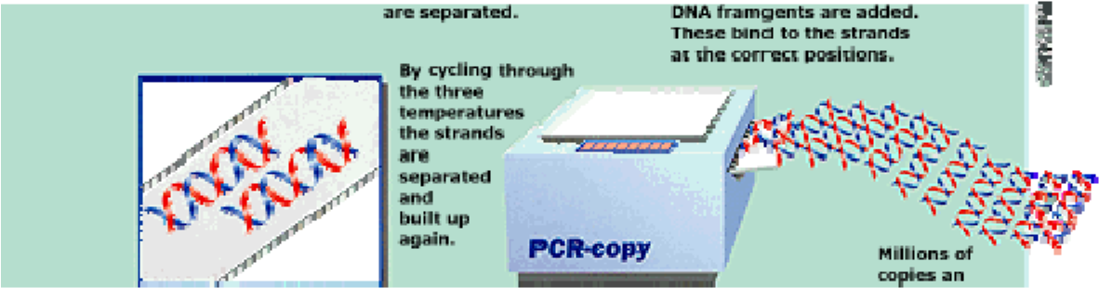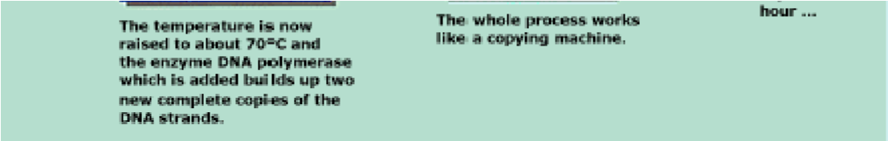
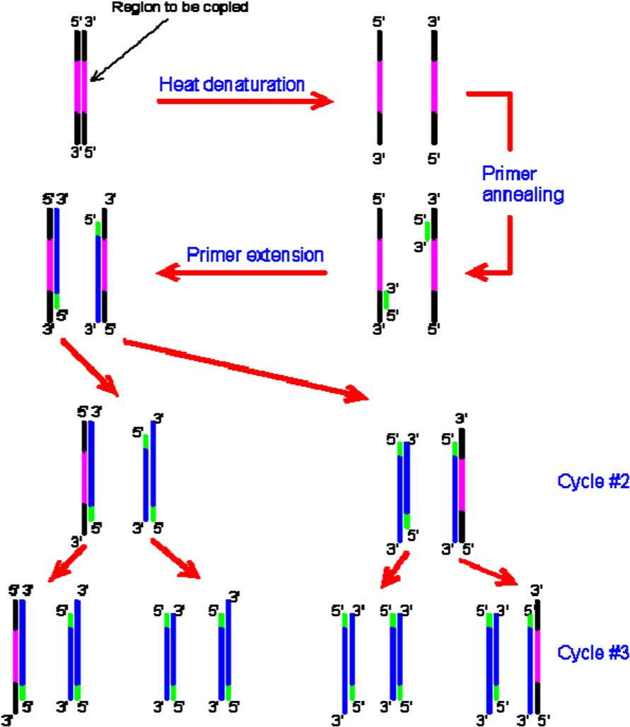
5. Usesanalysis of small amounts of DNA
a. Wooly mammoth (DNA is 40,000 years old)
1. extinct, DNA can be preserved for 1,000s or millions of years
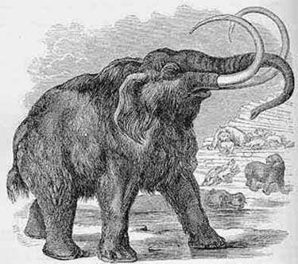
      - amplify tiny amounts of DNA from tissue/semen found at crime scenes
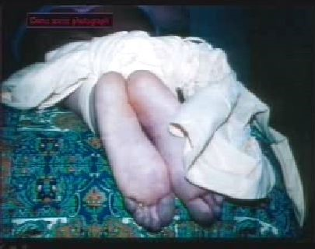

      - DNA from single embryonic cells for prenatal diagnosis to assess genetic disorders
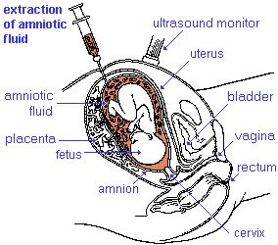
      - DNA from viral genes from cells infected with difficult to detect viruses, such as HIV
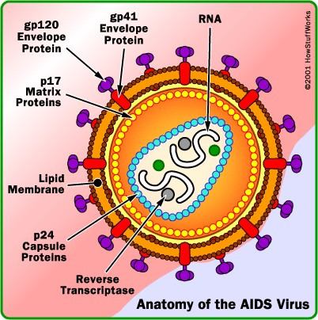
      - family analysis
        - DNA from sperm can be analyzed to determine immediate products of genetic recombination
        - limits chance for offspring to carry particular trait
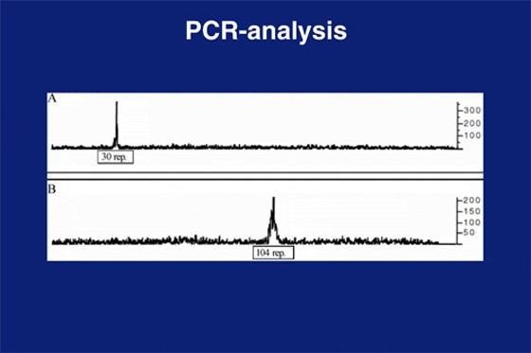

- Southern blotting- used for DNA hybridization
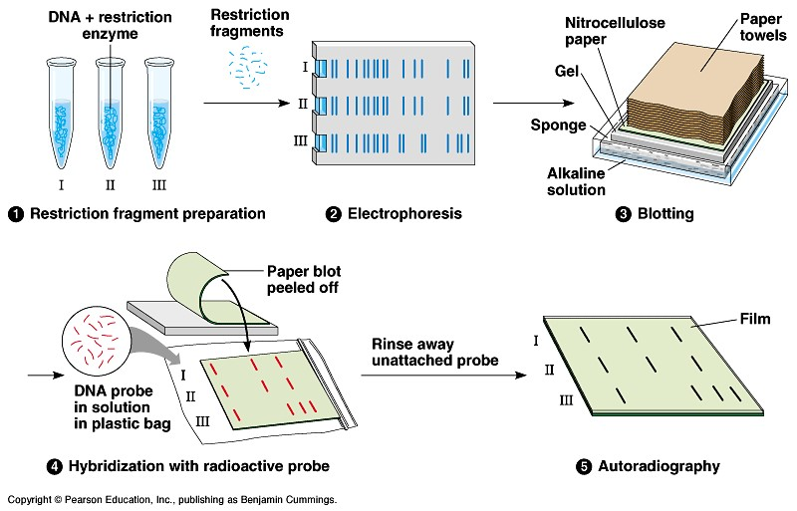

- Northern blotting- used for RNA hybridization
-it is used to hybridize mRNA with probes to determine whether a particular gene is being transcribed and how much mRNA is present.
- DNA microarray assay
-uses cDNA
-scientists can test all the genes expressed in a tissue for hybridization with thousands of short, single-stranded DNA fragments from different genes arrayed on a microscope slide.

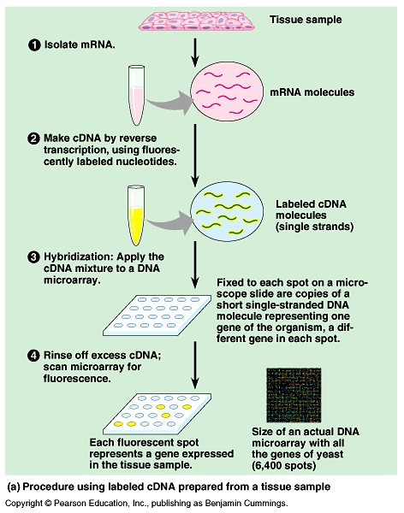

- T_{i} plasmid in Agrobacterium tumefaciens
-tumor-inducing plasmid
-causes galls
-for vector purposes, work with version of plasmid that does not cause disease
-dicots only
-not monocots
-electroporation/guns to get into cells

