INTERPHASE = NON DIVIDING PHASE
DNA is spread out as ____________________
Cell is “doing its ________ “
G₁- “Gap 1”
_________________________________________
_________________________________________
_________________________________________
_________________________________________

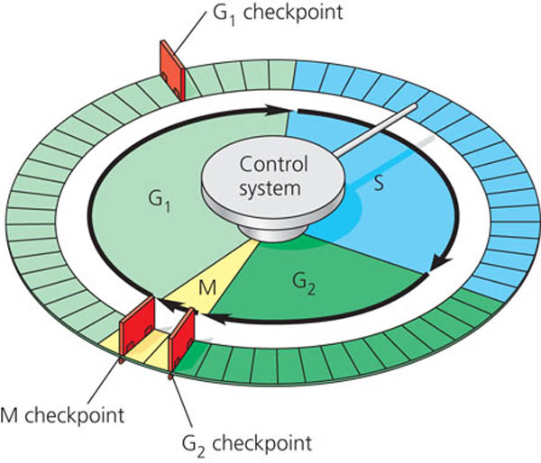

G₀₋
_______________________________________________________________
_____________________
_____________________
_____________________
____________________________________________________________________________________

S = ________________

___________________

G₂ = ”Gap 2”
__________________________________________________________________
____________________________________________________________________________________________________________________________________ checkpoint

