**MITOTIC (M) PHASE = DIVISION OF NUCLEUS**

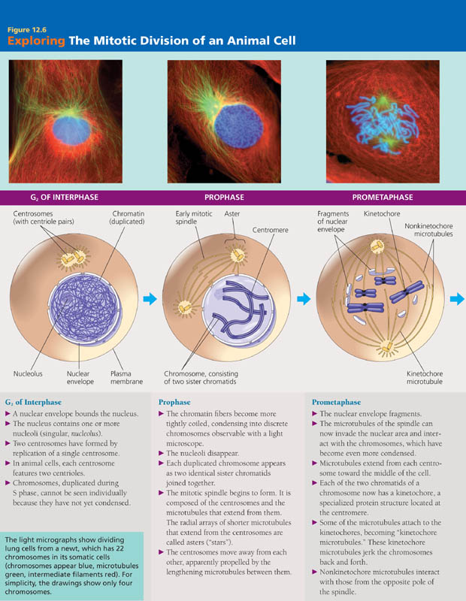

**INTERPHASE = ________________________________**

**______________________________________________________________________________________________________________________________________________________________________________________________________________________________________________________________________________**



**PROPHASE**

**____________________________________________**

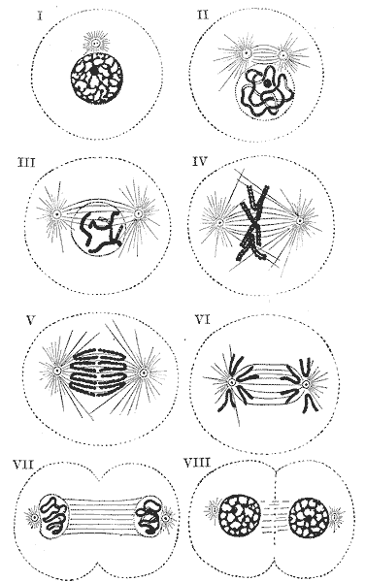

**____________________________________________**

**____________________________________________**

**____________________________________________**

**PROMETAPHASE  
 ____________________________________________**



**____________________________________________  
 ____________________________________________**

**____________________________________________**

**METAPHASE**

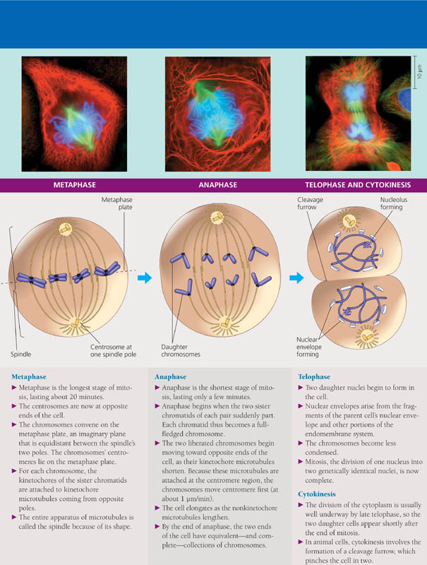

**____________________________________________**

**____________________________________________  
 ____________________________________________**

**ANAPHASE**



**_____________________________________________**

**_____________________________________________  
 _____________________________________________**

**_____________________________________________**

**TELOPHASE**

**_____________________________________________**



**_____________________________________________  
 _____________________________________________**

**_____________________________________________**

**CYTOKINESIS = DIVISION OF CYTOPLASM**

**_____________________________________________**

**_____________________________________________  
 _____________________________________________**