Name: _____________________________________________ Date: ____________________________ Period: ______

**AP Biology Exam Review : Molecular Genetics and Biotechnology (Unit 6)**

Ms. Ottolini, 2012-2013

**Textbook Chapters:** 16 (The Molecular Basis of Inheritance), 17 (From Gene to Protein), 18 (The Genetics of Viruses and Bacteria), 19 (Eukaryotic Genomes: Organization, Regulation, and Evolution), 20 (DNA Technology and Genomics)

**Helpful Videos and Animations:** *\*\*\*See wiki page section on Molecular Genetics for links corresponding to the following videos and animations\*\*\**

1. [Bozeman Biology: DNA Replication](http://www.youtube.com/watch?v=FBmO_rmXxIw)
2. [Bozeman Biology: DNA and RNA - Part 1](http://www.youtube.com/watch?v=qoERVSWKmGk&list=PLFCE4D99C4124A27A&index=33)
3. [Bozeman Biology: DNA and RNA - Part 2](http://www.youtube.com/watch?v=W4mYwsr9gGE)
4. [McGraw-Hill Animation: DNA Replication](http://highered.mcgraw-hill.com/sites/0072507470/student_view0/chapter3/animation__dna_replication__quiz_1_.html)
5. [Sumanas Animation: Meselson Stahl Experiment](http://www.sumanasinc.com/webcontent/animations/content/meselson.html)
6. [McGraw-Hill Animation: Hershey Chase Experiment](http://highered.mcgraw-hill.com/olc/dl/120076/bio21.swf)
7. [Bozeman Biology: Transcription and Translation](http://www.youtube.com/watch?v=h3b9ArupXZg)
8. [McGraw-Hill Animation: Transcription](http://highered.mcgraw-hill.com/sites/0072507470/student_view0/chapter3/animation__mrna_synthesis__transcription___quiz_1_.html)
9. [McGraw-Hill Animation: Translation](http://highered.mcgraw-hill.com/sites/0072507470/student_view0/chapter3/animation__protein_synthesis__quiz_3_.html)
10. [McGraw-Hill Animation: Intron Removal by Spliceosomes containing snRNP's (small nuclear riboproteins)](http://highered.mcgraw-hill.com/olcweb/cgi/pluginpop.cgi?it=swf::535::535::/sites/dl/free/0072437316/120077/bio30.swf::How%20Spliceosomes%20Process%20RNA)
11. [Sumanas Animation: Gel Electrophoresis](http://www.sumanasinc.com/webcontent/animations/content/gelelectrophoresis.html)
12. [Sumanas Animation: Polymerase Chain Reaction (PCR)](http://www.sumanasinc.com/webcontent/animations/content/pcr.html)
13. [Cold Spring Harbor Lab Animation: Bacterial Transformation](http://www.dnalc.org/resources/animations/transformation1.html)
14. [Sumanas: Constructing a DNA Library (aka Genomic Library)](http://www.sumanasinc.com/webcontent/animations/content/dnalibrary.html)
15. [Cold Spring Harbor Lab Animation: Full Organism Cloning](http://www.dnalc.org/resources/animations/cloning101.html)
16. [McGraw-Hill Animation: Restriction Enzymes (AKA Restriction Endonucleases)](http://highered.mcgraw-hill.com/olcweb/cgi/pluginpop.cgi?it=swf::535::535::/sites/dl/free/0072437316/120078/bio37.swf::Restriction%20Endonucleases)
17. [McGraw-Hill Animation: Restriction Fragment Length Polymorphisms](http://highered.mcgraw-hill.com/olcweb/cgi/pluginpop.cgi?it=swf::535::535::/sites/dl/free/0072437316/120078/bio20.swf::Restriction%20Fragment%20Length%20Polymorphisms)
18. [Cold Spring Harbor Lab Animation: DNA Sequencing](http://www.dnalc.org/resources/animations/cycseq.html)
19. [McGraw-Hill Animation: Microarray Analysis](http://highered.mcgraw-hill.com/sites/0072556781/student_view0/chapter15/animation_quiz_2.html)
20. [Sumanas Animation: Microarray Analysis of Normal vs. Cancer Cell Gene Expression](http://www.sumanasinc.com/webcontent/animations/content/dnachips.html)
21. [Plasmid Mapping Practice Video #1](http://www.youtube.com/watch?v=c97VqOJkQ88)
22. [Plasmid Mapping Practice Video #2](http://www.youtube.com/watch?v=v2T8Y3-8674)
23. [McGraw-Hill Animation: Mechanism of Viral Infection (Lytic)](http://highered.mcgraw-hill.com/sites/0072556781/student_view0/chapter17/animation_quiz_1.html)
24. [McGraw-Hill Animation: Lytic vs. Lysogenic Cycle of Viral Infection](http://highered.mcgraw-hill.com/sites/0072556781/student_view0/chapter17/animation_quiz_2.html)
25. [Sumanas Animation: Life Cycle of HIV, a Retrovirus](http://www.sumanasinc.com/webcontent/animations/content/lifecyclehiv.html)
26. [McGraw-Hill Animation: Bacterial Transduction Using a Temperate Phage](http://highered.mcgraw-hill.com/sites/0072556781/student_view0/chapter17/animation_quiz_3.html)
27. [Bozeman Biology: Mechanisms of Genetic Variation in Prokaryotic vs. Eukaryotic Cells](http://www.youtube.com/watch?v=UjMn4oHfYL4)
28. [McGraw-Hill Animation: Prion Diseases](http://highered.mcgraw-hill.com/sites/dl/free/0072835125/126997/animation44.html)
29. [Sumanas Animation: Trp Operon (Repressible Operon)](http://bcs.whfreeman.com/thelifewire/content/chp13/1302002.html)
30. [Sumanas Animation: Lac Operon (Inducible Operon)](http://www.sumanasinc.com/webcontent/animations/content/lacoperon.html)
31. [Bozeman Biology: Gene Regulation in Prokaryotic vs. Eukaryotic Cells](https://www.youtube.com/watch?v=3S3ZOmleAj0)
32. [Bozeman Biology: Gene Regulation in Embryonic Development](https://www.youtube.com/watch?v=pa9uPnIeVKU)

**Topic Outline:**

1. Nucleic Acid Structure

* Understand the difference between DNA structure in prokaryotes vs. eukaryotes

1. Prokaryotic DNA = in a single circular chromosome ; some small circular sections of plasmid DNA
2. Eukaryotic DNA = multiple linear chromosomes

* Be able to describe the experiments leading to the discovery of DNA as the cell’s genetic material. Key scientists include

1. Franklin, Watson, Crick, Wilkins
2. Griffith
3. Hershey / Chase
4. Avery-MacLeod-McCarty

* Explain the differences between DNA and RNA structure (see CC’s below)

1. DNA Replication

* Be able to explain how DNA replicates using the following enzymes: DNA polymerase, helicase, single-stranded binding proteins, topoisomerase, and ligase
* Explain how the creation of the leading strand is different from the creation of the lagging strand (use the terms 3’ and 5’)
* Explain how DNA replication is a semi-conservative process and given experimental evidence to support this theory (Meselson-Stahl Experiment)

1. Protein Synthesis

* Explain how proteins are made from DNA and RNA in the processes of transcription and translation (for details see CC’s below)
* Be able to identify the organelles, enzymes, etc. involved in the following processes:

1. Transcription
2. mRNA processing
3. Translation

***CC 3.A.1: DNA, and in some cases RNA, is the primary source of heritable information.***

***a. Genetic information is transmitted from one generation to the next through DNA or RNA.***

***Evidence of student learning is a demonstrated understanding of each of the following:***

***1. Genetic information is stored in and passed to subsequent generations through DNA molecules and, in***

***some cases, RNA molecules.***

***2. Noneukaryotic organisms have circular chromosomes, while eukaryotic organisms have multiple linear***

***chromosomes, although in biology there are exceptions to this rule.***

***3. Prokaryotes, viruses and eukaryotes can contain plasmids, which are small extra-chromosomal, double stranded circular DNA molecules.***

***4. The proof that DNA is the carrier of genetic information involved a number of important historical***

***experiments. These include:***

***i. Contributions of Watson, Crick, Wilkins, and Franklin on the structure of DNA***

***ii. Avery-MacLeod-McCarty experiments***

***iii. Hershey-Chase experiment***

***5. DNA replication ensures continuity of hereditary information.***

***i. Replication is a semiconservative process; that is, one strand serves as the template for a new,***

***complementary strand.***

***ii. Replication requires DNA polymerase plus many other essential cellular enzymes, occurs***

***bidirectionally, and differs in the production of the leading and lagging strands.***

***b. DNA and RNA molecules have structural similarities and differences that define function.***

***Evidence of student learning is a demonstrated understanding of each of the following:***

***1. Both have three components — sugar, phosphate and a nitrogenous base — which form nucleotide***

***units that are connected by covalent bonds to form a linear molecule with 3' and 5' ends, with the***

***nitrogenous bases perpendicular to the sugar-phosphate backbone.***

***2. The basic structural differences include:***

***i. DNA contains deoxyribose (RNA contains ribose).***

***ii. RNA contains uracil in lieu of thymine in DNA.***

***iii. DNA is usually double stranded, RNA is usually single stranded.***

***iv. The two DNA strands in double-stranded DNA are antiparallel in directionality.***

***3. Both DNA and RNA exhibit specific nucleotide base pairing that is conserved through evolution: adenine pairs with thymine or uracil (A-T or A-U) and cytosine pairs with guanine (C-G).***

***i. Purines (G and A) have a double ring structure.***

***ii. Pyrimidines (C, T and U) have a single ring structure.***

***4. The sequence of the RNA bases, together with the structure of the RNA molecule, determines RNA***

***function.***

***i. mRNA carries information from the DNA to the ribosome.***

***ii. tRNA molecules bind specific amino acids and allow information in the mRNA to be translated***

***to a linear peptide sequence.***

***iii. rRNA molecules are functional building blocks of ribosomes.***

***iv. The role of RNAi includes regulation of gene expression at the level of mRNA transcription.***

***c. Genetic information flows from a sequence of nucleotides in a gene to a sequence of amino acids in a***

***protein.***

***Evidence of student learning is a demonstrated understanding of each of the following:***

***1. The enzyme RNA-polymerase reads the DNA molecule in the 3' to 5' direction and synthesizes***

***complementary mRNA molecules that determine the order of amino acids in the polypeptide.***

***2. In eukaryotic cells the mRNA transcript undergoes a series of enzyme-regulated modifications.***

***To demonstrate student understanding of this concept, make sure you can explain:***

***i. Addition of a poly-A tail***

***ii. Addition of a GTP cap***

***iii. Excision of introns***

***3. Translation of the mRNA occurs in the cytoplasm on the ribosome.***

***4. In prokaryotic organisms, transcription is coupled to translation of the message. 5. Translation involves energy and many steps, including initiation, elongation and termination. The salient features include:***

***i. The mRNA interacts with the rRNA of the ribosome to initiate translation at the (start) codon.***

***ii. The sequence of nucleotides on the mRNA is read in triplets called codons.***

***iii. Each codon encodes a specific amino acid, which can be deduced by using a genetic code chart. Many amino acids have more than one codon.***

***iv. tRNA brings the correct amino acid to the correct place on the mRNA.***

***v. The amino acid is transferred to the growing peptide chain.***

***vi. The process continues along the mRNA until a “stop” codon is reached.***

***vii. The process terminates by release of the newly synthesized peptide/protein.***

***d. Phenotypes are determined through protein activities.***

***To demonstrate student understanding of this concept, make sure you can explain:***

* ***Enzymatic reactions***
* ***Transport by proteins***
* ***Synthesis***
* ***Degradation***

1. Regulation of Gene Expression *\*\*\*For this section, I am including an excerpt from my Gene Regulation Notes (Chapter 18). Please also check the CC’s below the Notes Excerpt\*\*\**

**Why do cells regulate gene expression?**

1. Cells in multicellular organisms express different genes based on the cell type (ex: the gene for hemoglobin protein is highly expressed / used in red blood cells)
2. Cells in unicellular organisms express different genes based on their stage in life / environmental requirements (ex: when a bacterial cell encounters a food source, the cell must begin producing digestive enzymes)
3. Cells need to be able to stop expression of genes when they no longer need a particular gene product (protein) and increase expression of genes when their corresponding gene product is needed to respond to a change in the environment

|  |  |
| --- | --- |
| **Feedback Inhibition** | **Gene Regulation** |
| When the product of an enzyme pathway acts as an allosteric inhibitor on the first enzyme in the pathway ; can be wasteful because it uses resources on creating enzymes | Instead of blocking enzyme function, you block the transcription of genes for all enzymes in the pathway ; is not as wasteful because you do not use resources on unnecessary protein synthesis |
|  |  |

**Prokaryotic Gene Regulation**

1. In bacteria, genes are often clustered into units called operons (ex: genes that create all the enzymes in a metabolic pathway) ; if genes are clustered, it makes them easier to regulate as a unit
2. An operon consists of three parts:

* An operator that controls the access of RNA polymerase to the genes. The operator is found within the promoter site or between the promoter and the protein coding genes of the operon
* The promoter, which is where RNA polymerase attaches to begin transcription of the genes
* The genes of the operon. This is the entire stretch of DNA required for creating proteins.

1. A regulatory gene can be found some distance away from the operon. It makes repressor proteins that may bind to the operator site. When a repressor protein is in the operator site, RNA polymerase cannot transcribe the genes of the operon. This turns the operon off
2. Types of Operons:

|  |  |
| --- | --- |
| **Repressible Operon** | **Inducible Operon** |
| 1. Normally on but can be inhibited 2. Usually an anabolic operon that builds an essential organic molecule 3. The repressor protein produced by the regulatory gene is inactive 4. If the organic molecule being produced by the operon is in high concentrations, it can act as a “corepressor” and activate the repressor protein 5. The activated repressor protein binds to the operator site and shuts down the operon 6. Example: tryptophan operon… makes enzymes used in tryptophn synthesis ; should make tryptophan all the time except if there is too much tryptophan present in the cell | 1. Normally off but can be activated 2. Usually a catabolic operon which creates enzymes that break down food molecules for energy 3. The repressor protein produced by the regulatory protein is active 4. A molecule called an inducer can bind to and inactivate the repressor 5. With the repressor out of the operator site, RNA polymerase cannot bind to the operon and transcribe the genes 6. Example: lactose operon… makes enzymes used in lactose digestion ; only needs to be on when lactose is present |
| ***Normal State: Tryptophan Operon is Active*** | ***Normal State: Lac Operon is Inactive*** |
| ***Repressed State: Tryptophan Operon is Inactive*** | ***Induced State: Lac Operon is Active*** |

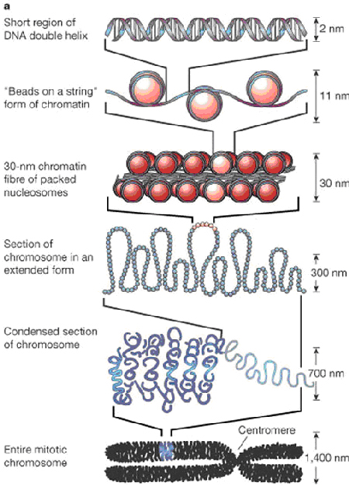**Eukaryotic Gene Regulation**

1. Whereas prokaryotic cells regulate gene expression by regulating transcription, eukaryotic gene expression can be regulated at any step along the pathway from gene to functional protein
2. The different cell types in multicellular eukaryotic organisms (ex: skin cells, blood cells) are not due to different genes being present (the same set of DNA is found in each cell in a multicellular organisms. Instead, the cell types result from differential gene expression, the expression of different genes by cells with the same genome.

**Regulation Based on Chromatin Structure**

1. DNA is normally bound to histone proteins. (DNA + protein forms a complex called a nucleosome.) The more tightly bound it is, the more inaccessible it is for transcription.
2. DNA Methylation = the addition of methyl groups to DNA. It causes the DNA to be more tightly packaged, thus reducing gene expression
3. Histone Acetylation = acetyl groups are added to amino acids of histone proteins, thus making the chromatin less tightly packed and encouraging transcription

**Regulation at the Transcription Level**

1. In the promoter region, binding of RNA polymerase / transcription factors controls speed of transcription
2. 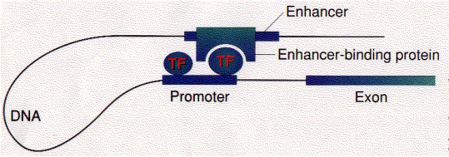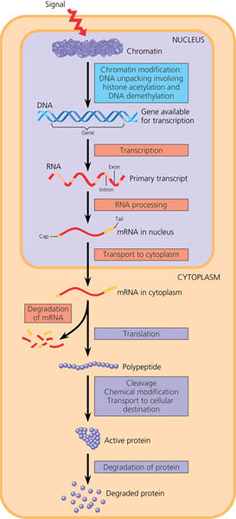Enhancer sequences, “upstream” from gene… binding of proteins called activators (AKA enhancer binding proteins) in this region speeds up transcription
3. Generally eukaryotic genes are not organized in operon… genes coding for enzymes in the same metabolic pathway may be scattered on different chromosomes, but their expression may be controlled by the same activator molecules

**Post-Transcriptional Control**

1. Alternative splicing of introns from pre-mRNA 🡪 creation of different proteins
2. Micro RNA’s (miRNA’s) and small interfering RNA’s (siRNA’s) are single-stranded RNA molecules that can bind to mRNA and degrade the mRNA or block translation
3. Control of speed of nuclear transport of mRNA out of the nucleus

**Translational Control**

1. Regulatory proteins can bind to the 5’ end of mRNA to prevent ribosome attachment
2. Control rate of aminoacyl-tRNA synthetases recharging tRNA’s with amino acids

**Post-Translational Control**

1. May need to alter the protein before it can be used

* Cleavage – cutting polypeptide chain to produce a functional protein

Ex: proinsulin (1 chain) 🡪 insulin (2 chains)

* Chemical modification – add sugars, phosphates, etc. to make the protein “act” different
* Transport tags – identify destination of functional protein in the cell
* Ubiquitin tag – identifies proteins for degradation by proteasomes

***CC 3.B.1: Gene regulation results in differential gene expression, leading to cell specialization.***

***a. Both DNA regulatory sequences, regulatory genes, and small regulatory RNAs are involved in gene***

***expression.***

***Evidence of student learning is a demonstrated understanding of each of the following:***

***1. Regulatory sequences are stretches of DNA that interact with regulatory proteins to control***

***transcription.***

***To demonstrate student understanding of this concept, make sure you can explain:***

***i. Promoters***

***ii. Terminators***

***iii. Enhancers***

***2. A regulatory gene is a sequence of DNA encoding a regulatory protein or RNA.***

***b. Both positive and negative control mechanisms regulate gene expression in bacteria and viruses.***

***Evidence of student learning is a demonstrated understanding of each of the following:***

***1. The expression of specific genes can be turned on by the presence of an inducer.***

***2. The expression of specific genes can be inhibited by the presence of a repressor.***

***3. Inducers and repressors are small molecules that interact with regulatory proteins and/or regulatory***

***sequences.***

***4. Regulatory proteins inhibit gene expression by binding to DNA and blocking transcription (negative***

***control).***

***5. Regulatory proteins stimulate gene expression by binding to DNA and stimulating transcription (positive control) or binding to repressors to inactivate repressor function.***

***6. Certain genes are continuously expressed; that is, they are always turned “on,” e.g., the ribosomal***

***genes.***

***c. In eukaryotes, gene expression is complex and control involves regulatory genes, regulatory elements and***

***transcription factors that act in concert.***

***Evidence of student learning is a demonstrated understanding of each of the following:***

***1. Transcription factors bind to specific DNA sequences and/or other regulatory proteins.***

***2. Some of these transcription factors are activators (increase expression), while others are repressors***

***(decrease expression).***

***3. The combination of transcription factors binding to the regulatory regions at any one time determines***

***how much, if any, of the gene product will be produced.***

***d. Gene regulation accounts for some of the phenotypic differences between organisms with similar genes.***

***CC 3.B.2: A variety of intercellular and intracellular signal transmissions mediate gene expression.***

***a. Signal transmission within and between cells mediates cell function.***

***To demonstrate student understanding of this concept, make sure you can explain:***

* ***Mating pheromones in yeast trigger mating genes expression and sexual reproduction.***
* ***Morphogens stimulate cell differentiation and development.***
* ***Changes in p53 activity can result in cancer.***
* ***HOX genes and their role in development.***

***CC 4.A.3: Interactions between external stimuli and regulated gene expression result in specialization of cells, tissues and organs.***

***a. Differentiation in development is due to external and internal cues that trigger gene regulation by proteins***

***that bind to DNA.***

***b. Structural and functional divergence of cells in development is due to expression of genes specific to a***

***particular tissue or organ type.***

***c. Environmental stimuli can affect gene expression in a mature cell.***

1. Mutations and Increasing Genetic Diversity *\*\*\*For this section, I am including an excerpt from my “From Gene to Protein Notes.” Please also check the CC’s below the Notes Excerpt\*\*\**

* Changes to the DNA sequence are not all harmful…some can increase genetic variability 🡪 more possible forms of traits so that not all organisms can be killed off by any one factor (ex: a disease that kills all tall people)
* They can be spontaneous errors in replication or they can be caused by mutagens (environmental factors like radiation, chemicals, cigarette smoke, etc.)
* If a mutagen causes changes in genes that regulate the cell cycle / cell division it is considered a carcinogen (a cancer-causing factor)
* Some mutations are neutral (happen in introns that do not code for proteins)
* Some mutations are harmful (change protein function in a negative way)
* Types of Mutations:

1. Point mutation: change in one base pair of a gene (substitution: replace one base with another)
2. Silent – changes one base, but codes for the same amino acid (due to redundancy)
3. Missense – codes for another amino acid (changes protein sequence and usually function)
   * + Example: sickle cell disease… one T substituted for A in the gene coding for hemoglobin protein

* Nonsense – code changes to a stop codon (makes a nonfunctional protein that is terminated early)
* Frameshift mutation: the mutation effects all nucleotides / codon groupings farther along the DNA / RNA code
* Insertion – adding extra nucleotides (causes a frameshift if you are not adding exactly three extra bases)
* Deletion – removing nucleotides (causes a frameshift if you are not removing exactly three bases)

Example: O blood type allele involves a deletion in the A blood type code

***CC 3.C.1: Changes in genotype can result in changes in phenotype.***

***a. Alterations in a DNA sequence can lead to changes in the type or amount of the protein produced and the***

***consequent phenotype.***

***Evidence of student learning is a demonstrated understanding of the following:***

***1. DNA mutations can be positive, negative or neutral based on the effect or the lack of effect they have on the resulting nucleic acid or protein and the phenotypes that are conferred by the protein.***

***b. Errors in DNA replication or DNA repair mechanisms, and external factors, including radiation and reactive chemicals, can cause random changes, e.g., mutations in the DNA.***

***Evidence of student learning is a demonstrated understanding of the following:***

***1. Whether or not a mutation is detrimental, beneficial or neutral depends on the environmental context.***

***Mutations are the primary source of genetic variation.***

***CC 3.C.2: Biological systems have multiple processes that increase genetic variation.***

***a. The imperfect nature of DNA replication and repair increases variation.***

***CC 4.C.1: Variation in molecular units provides cells with a wider range of functions.***

***a. Multiple copies of alleles or genes (gene duplication) may provide new phenotypes.***

***To demonstrate student understanding of this concept, make sure you can explain:***

***1. A heterozygote may be a more advantageous genotype than a homozygote under particular***

***conditions, since with two different alleles, the organism has two forms of proteins that may provide***

***functional resilience in response to environmental stresses.***

***2. Gene duplication creates a situation in which one copy of the gene maintains its original function, while***

***the duplicate may evolve a new function.***

***To demonstrate student understanding of this concept, make sure you can explain:***

* ***The antifreeze gene in fish***

1. Viral and Bacterial Genetics and Reproduction *\*\*\*Please take a look at your Viral and Bacterial Genetics Notes, which are also posted to the wiki page and the CC's below for more information\*\*\**

* Viral Replication

1. Lytic vs. Lysogenic Cycle of Viral Infection
2. Life Cycle of a Retrovirus (ex: HIV)

* Bacterial Reproduction and Genetic Recombination

1. Transformation
2. Transduction
3. Conjugation
4. Transposition

***CC 3.C.3: Viral replication results in genetic variation, and viral infection can introduce genetic variation into the hosts.***

***a. Viral replication differs from other reproductive strategies and generates genetic variation via various***

***mechanisms.***

***Evidence of student learning is a demonstrated understanding of each of the following:***

***1. Viruses have highly efficient replicative capabilities that allow for rapid evolution and acquisition of new phenotypes.***

***2. Viruses replicate via a component assembly model allowing one virus to produce many progeny***

***simultaneously via the lytic cycle.***

***3. Virus replication allows for mutations to occur through usual host pathways.***

***4. RNA viruses lack replication error-checking mechanisms, and thus have higher rates of mutation.***

***5. Related viruses can combine/recombine information if they infect the same host cell.***

***6. HIV is a well-studied system where the rapid evolution of a virus within the host contributes to the***

***pathogenicity of viral infection.***

***b. The reproductive cycles of viruses facilitate transfer of genetic information.***

***Evidence of student learning is a demonstrated understanding of each of the following:***

***1. Viruses transmit DNA or RNA when they infect a host cell.***

***2. To foster student understanding of this concept, instructors can choose an illustrative example such as:***

***4. Transduction in bacteria***

***5. Transposons present in incoming DNA***

***6. Some viruses are able to integrate into the host DNA and establish a latent (lysogenic) infection. These***

***latent viral genomes can result in new properties for the host such as increased pathogenicity in***

***bacteria.***

***CC 3.A.1: DNA, and in some cases RNA, is the primary source of heritable information.***

***a. Genetic information is transmitted from one generation to the next through DNA or RNA.***

***Evidence of student learning is a demonstrated understanding of each of the following:***

***1. Genetic information in retroviruses is a special case and has an alternate flow of information: from RNA to DNA, made possible by reverse transcriptase, an enzyme that copies the viral RNA genome into DNA. This DNA integrates into the host genome and becomes transcribed and translated for the assembly of new viral progeny.***

***CC 3.C.2: Biological systems have multiple processes that increase genetic variation.***

***b. The horizontal acquisitions of genetic information primarily in prokaryotes via transformation (uptake of***

***naked DNA), transduction (viral transmission of genetic information), conjugation (cell-to-cell transfer) and***

***transposition (movement of DNA segments within and between DNA molecules) increase variation.***

1. Biotechnology *\*\*\*Please use your Biotechnology Charts, Biotechnology Stations Questions and the animation/video links at the beginning of this document to study for this section\*\*\**

Technologies that we focused on in class include

* Gel Electrophoresis

1. You should be able to analyze gel banding patterns
2. You should be able to use the results of a gel showing DNA bands of different sizes created by restriction enzyme “chopping” of plasmid DNA to create a “map” of the plasmid

* Bacterial Transformation (with recombinant DNA)

1. You should be able to analyze results of a bacterial transformation experiment

* Polymerase Chain Reaction
* Whole-Organism Cloning
* DNA sequencing (Sanger vs. Cycle Sequencing)
* Microarray Analysis

***CC 3.A.1: DNA, and in some cases RNA, is the primary source of heritable information.***

***b. Genetic engineering techniques can manipulate the heritable information of DNA and, in special cases, RNA.***

***To demonstrate student understanding of this concept, make sure you can explain:***

* ***Electrophoresis***
* ***Plasmid-based transformation***
* ***Restriction enzyme analysis of DNA***
* ***Polymerase Chain Reaction (PCR)***

***c. Illustrative examples of products of genetic engineering include:***

* ***Genetically modified foods***
* ***Transgenic animals***
* ***Cloned animals***
* ***Pharmaceuticals, such as human insulin or factor X***

**Practice Multiple Choice Questions:**

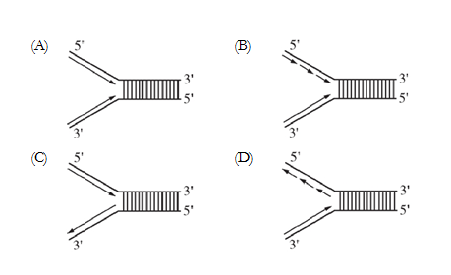**1. When DNA replicates, each strand of the original DNA molecule is used as a template for the synthesis of a second, complementary strand. Which of the following figures most accurately illustrates enzyme-mediated synthesis of new DNA at a replication fork?** D

2. Actinomycin D is an antibiotic drug that inhibits protein synthesis by blocking transcription. In some cells, the application of the drug does not affect the synthesis of certain proteins. Which of the following best explains such an occurrence?

(A) Not all proteins need tRNA molecules for their synthesis.

(B) The proteins that are made are using mRNA synthesized before application of the drug.

(C) Nuclear proteins do not require the cytoplasmic machinery of ribosomes.

(D) Protein synthesis is blocked in the cytoplasm at the ribosome level.

3. Some geneticists consider the third base of a codon to be less important than the first two bases as a code for a specific amino acid. All of the following observations would support this hypothesis EXCEPT:

(A) Any of the bases following a CC_ sequence will position a proline.

(B) Even though the A is replaced by a C, the triplet AGG will still position to an arginine.

(C) Even though the last A is replaced by a G, the triplet UAA will still terminate a polypeptide chain.

(D) An AUU triplet codes for isoleucine, while a UUU triplet codes for phenylalanine.

**Questions 4-6** refer to an experiment that was performed to separate DNA fragments from four samples radioactively labeled with 32P. The fragments were separated by gel electrophoresis. The visualized bands are illustrated in the figure

to the right.

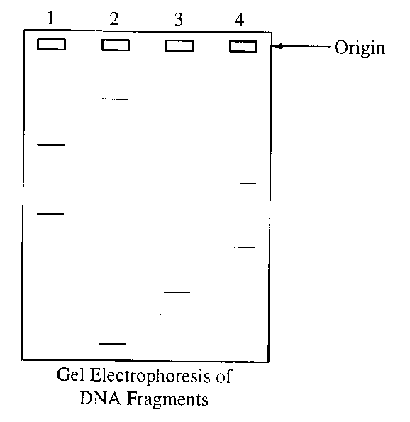

4. The electrophoretic separation of the pieces of DNA in each of the four samples was achieved because of differential migration of the DNA fragments in an electric field. This differential migration was caused by the

(A) relative amounts of radioactivity in the DNA

(B) number of cleavage points per fragment

(C) size of each fragment

(D) overall positive charge of each fragment

5. The DNA was labeled with 32P in order to

(A) stimulate DNA replication

(B) inhibit the uptake of unlabeled ATP

(C) show which fragments included the 5' end and which fragments included the 3' end

(D) visualize the fragments

6. Which of the following is an additional use of the gel electrophoresis technique?

(A) To express a gene

(B) To separate Proteins in a mixture

(C) To ligate DNA fragments

1. To transform E. coli

7. Lactose digestion in E. coli begins with its hydrolysis by the enzyme b-galactosidase. The gene encoding b-galactosidase, lacZ, is part of a coordinately regulated operon containing other genes required for lactose utilization. Which of the following figures correctly depicts the interactions at the lac operon when lactose is NOT being utilized? (The legend below defines the shapes of the molecules illustrated in the options.) D

a. 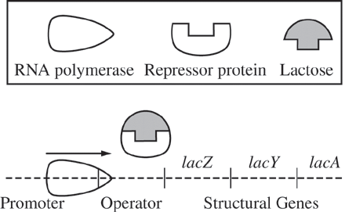

b. 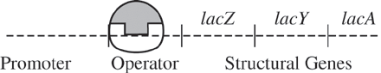

c. 

d. 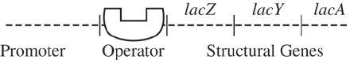

8. The working of the *lac* operon is important for which of the following reasons?

(A) It represents a principal means by which genes are regulated in prokaryotes.

(B) It represents a principal means by which genes are regulated in eukaryotes.

(C) The understanding of it led to the development of an economical means for the biological production of lactose.

(D) It provided the first clues to how DNA replication is controlled during the cell cycle.



9. The regulatory sequences of the operon controlling arabinose metabolism (*ara* operon) were studied to

determine whether bacteria can respond to changes in nutrient availability. It is predicted that if those regulatory

sequences are functioning properly, the bacteria will produce the enzymes involved in arabinose metabolism

(structural genes *B*, *A,* and *D*) in the presence of arabinose.

If a gene that encodes a green fluorescent protein (GFP) is substituted for the structural genes of the operon,

activation of the regulatory sequences can be assayed by GFP expression. A culture of *E. coli* cells underwent a

transformation procedure with a plasmid containing the regulatory sequences of the *ara* operon directly upstream

of the gene encoding the GFP. The plasmid also confers ampicillin resistance to bacteria. Samples were then

plated on different types of culture media. (Note: The GFP fluoresces only under UV light, not under white

light.) The table below shows the results.

# Transformation Results

|  |  |  |  |  |
| --- | --- | --- | --- | --- |
| **Type of Culture Media** | | | **Color of Colonies Under White Light** | **Color of Colonies**  **Under UV Light** |
| **Agar** | **Ampicillin** | **Arabinose** |  |  |
| + | - | - | All white | All white |
| + | + | - | All white | All white |
| + | - | + | All white | Mostly white, some green |
| + | + | + | All white | All green |
| + Indicates the presence of the indicated substance in the culture media  - Indicates the absence of the indicated substance in the culture media | | | | |

Which of the following can best be used to justify why the GFP is expressed by *E. coli* cells after transformation with the plasmid?

(A) The presence of arabinose in the nutrient agar activated the expression of the genes located downstream of the *ara* operon regulatory sequences.

(B) The combination of ampicillin and arabinose in the nutrient agar inhibited the expression of certain gene products, resulting in the increased expression of the GFP.

(C) The nutrient agar without arabinose but with ampicillin activated the expression of the genes located downstream of the *ara* operon regulatory sequences.

(D) Both arabinose and ampicillin were required in the nutrient agar to activate the expression of genes located downstream of the *ara* operon regulatory sequences.

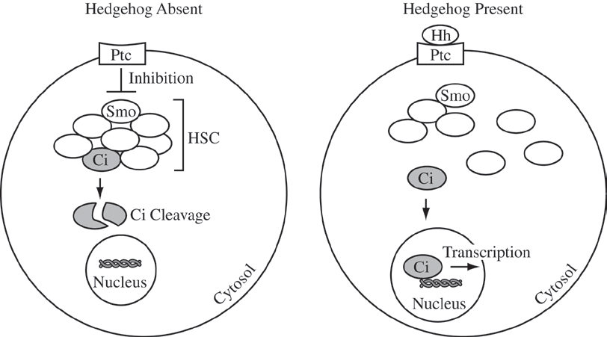10. The Hedgehog protein (Hh) plays a critical role during a certain period of embryo development, but it normally has no role in adults except for the maintenance of adult stem cells. However, the Hedgehog protein has been detected in 70 percent of pancreatic cancer cell samples. As illustrated in the figures below, the Hedgehog protein binds to an integral membrane protein receptor known as Patched (Ptc), thus initiating a pathway of gene expression. When Hedgehog is absent, Ptc inhibits another protein known as Smoothened (Smo), which, in turn, blocks the activation of a group of proteins collectively known as the Hedgehog signaling complex (HSC). The inactivation is the result of proteolytic cleavage of one component of the HSC complex, a transcription factor known as Cubitus interruptus (Ci). When Hedgehog is present, it binds to Ptc, which prevents the inhibition of Smo by Ptc. The result is that Ci remains intact and can enter the nucleus, where it binds to and activates certain genes.

One approach to treating patients with pancreatic cancer and other cancers in which the Hedgehog protein is detected is to modify the Hedgehog signaling pathway. Which of the following is the most useful approach?

(A) Treating patients with a molecule that is structurally similar to Hedgehog and that will bind to and interact

with Ptc in the same fashion as Hedgehog

(B) Injecting patients with embryonic cells so that Hedgehog will bind to those cells instead of the cancer cells

(C) Treating patients with a membrane-soluble compound that can bind to Smo and block its activity

(D) Injecting patients with a preparation of purified membrane-soluble Ci that will enter the nuclei of the cancer cells and induce gene transcription

A scientist is using an ampicillin‑sensitive strain of bacteria that cannot use lactose because it has a nonfunctional gene in the *lac* operon. She has two plasmids. One contains a functional copy of the affected gene of the *lac* operon, and the other contains the gene for ampicillin resistance. Using restriction enzymes and DNA ligase, she forms a recombinant plasmid containing both genes. She then adds a high concentration of the plasmid to a tube of the bacteria in a medium for bacterial growth that contains glucose as the only energy source. This tube (+) and a control tube (‑) with similar bacteria but no plasmid are both incubated under the appropriate conditions for growth and plasmid uptake. The scientist then spreads a sample of each bacterial culture (+ and ‑) on each of the three types of plates indicated below.

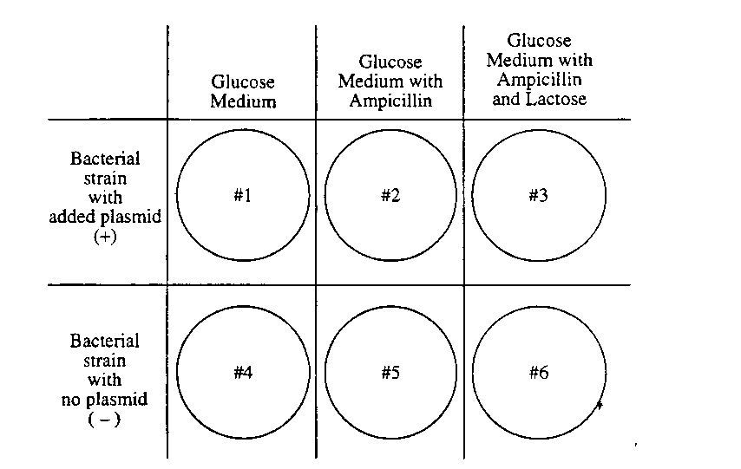

11. If no new mutations occur, it would be most reasonable to expect bacterial growth on which of the following plates?

(A) 1 and 2 only

(B) 3 and 4 only

(C) 5 and 6 only

(D) 4, 5, and 6 only

(E) 1, 2, 3, and 4 only

12. The scientist used restriction enzymes for what purpose in the experiment?

(A) To make the plasmid small enough to transform cells

(B) To make cuts in the plasmid DNA

(C) To make the plasmid enter the cells

(D) To enable the fragments of DNA to form covalent bonds

(E) To enable the plasmid to recognize the bacterial cells

13. If the scientist had forgotten to use DNA ligase during the preparation of the recombinant plasmid, bacterial growth would most likely have occurred on which of the following?

(A) 1 and 2 only

(B) 1 and 4 only

(C) 4 and 5 only

(D) 1, 2, and 3 only

(E) 4, 5, and 6 only

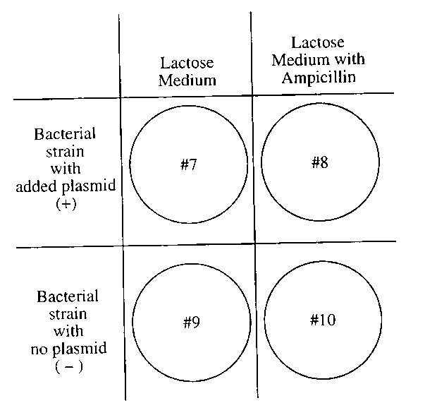14. If the scientist used the cultures to perform another experiment as shown to the right, using medium that contained lactose as the only energy source, growth would most likely occur on which of the following plates?

(A) 10 only

(B) 7 and 8 only

(C) 7 and 9 only

(D) 8 and 10 only

(E) 9 and 10 only

Questions 15-16 refer to the chart below.

mRNA Codons Amino Acids

AGA arginine

GGA glycine

AGC serine

GCA alanine

CAG glutamine

. . . glutamine-glutamine-glutamine . . .

. . . serine-serine-serine . . .

15. Which of the following messenger RNA sequences could code for both of the two amino acid sequences above, simply by a shift in the reading frame?

(A) . . . AGCAGCAGCAGC . . .

(B) . . . AGUAGUAGUAGU . . .

(C) . . . CAACAACAACAA . . .

(D) . . .GCUGCUGCUGCU . . .

. . . glycine-serine-glycine . . .

16. Which of the following DNA strands will code for the amino acid sequence shown above?

(A) . . . ACTCCTTCT . . .

(B) . . . TCTCCGTCG . . .

(C) . . . CCGTCGACT . . .

(D) . . . CCTTCGCCT . . .

Sickle cell disease is an inherited disorder that affects red blood cells. Sickle cell disease affects more than 72,000 Americans, primarily those of African heritage, but also those of Arabian, Asian, Caribbean, Indian, Mediterranean, and South and Central American ancestry.

The maps below show both the frequency of HbS (sickle cell) allele and the areas where Malaria is prevalent.

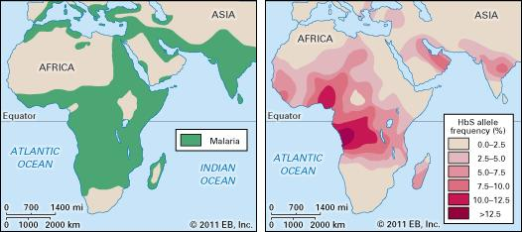

17. Why is the HbS allele more commonly found in people (or their descendants) from parts of tropical and sub-tropical sub-saharan regions where malaria is or was common?

(A) In areas where malaria is common, there is a fitness benefit in carrying only a single sickle-cell gene

(B) Because the individuals homozygous for the HbS allele die shortly after birth

(C) Those with only one of the two alleles of the sickle-cell disease, are more tolerant to the infection and thus show more severe symptoms when infected

(D) The genotype is influenced by natural selection, resulting in more individuals who are homozygous dominant than heterozygous.

18. If malaria spreads to more of Northern Asia what would you predict would happen the HbS allele frequency in that area?

(A) The occurrence of the HbS allele would remain low due to decreased fitness

(B) The occurrence of the HbS allele would increase due to being carried by the malaria

(C) The occurrence of the HbS allele would increase as the heterozygous advantage increased

(D) The occurrence of the HbS allele woulddecrease due to the malaria killing individuals.

19. The genetic variations in organisms

(A) can be less than the phenotypic variations in populations due to missense mutations(B) can be more than the phenotypic variations in populations due to silent mutations

(C) is generally more than the phenotypic variations in populations due to nonsense mutations

(D) is always less than the phenotypic variations in populations due to point mutations

20. A tobacco plant can be made to express a gene from fireflies, resulting in the emission of light. Which of the following is the basis for this phenomenon?

(A) Chloroplasts can be made to produce light if firefly proteins are injected into plant cells.

(B) Fireflies and tobacco plants share a recent common ancestor.

(C) Fireflies and tobacco plants are infected by the same kinds of bacteria.

(D) Transcription and translation are fundamentally similar in both fireflies and tobacco plants.

**Questions 21-22** refer to information in the following table.

21. A single substitution in the third position would have the greatest probability of mutational effect on the codon

(A) GUU

(B) AUU

(C) CGU

(D) AUG

(E) CCC

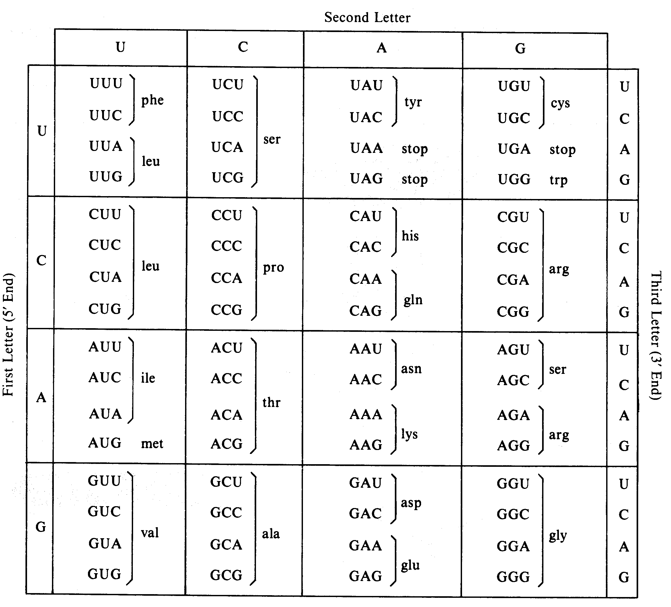22. Which amino acid has the greatest number of codons?

(A) Leucine (leu)

(B) Proline (pro)

(C) Tryptophan (trp) *

(D) Glutamic acid (glu)

(E) Aspartic acid (asp)



23. The figure above shows several steps in the process of bacteriophage transduction in bacteria. Which of the following explains how genetic variation in a population of bacteria results from this process?

(A) Bacterial proteins transferred from the donor bacterium by the phage to the recipient bacterium recombine with genes on the recipient’s chromosome.

(B) The recipient bacterium incorporates the transduced genetic material coding for phage proteins into its chromosome and synthesizes the corresponding proteins.

(C) The phage infection of the recipient bacterium and the introduction of DNA carried by the phage cause increased random point mutations of the bacterial chromosome.

(D) DNA of the recipient bacterial chromosome undergoes recombination with DNA introduced by the phage from the donor bacterium, leading to a change in the recipient’s genotype.

24. During the infection cycle for a typical retrovirus, such as HIV, which uses RNA as genetic material, the genetic variation in the resulting population of new virus particles is very high because of

(A) damage to the virus particle from envelope loss during infection

(B) errors introduced in the DNA molecule through reverse transcription

(C) errors in the protein molecules produced in translation

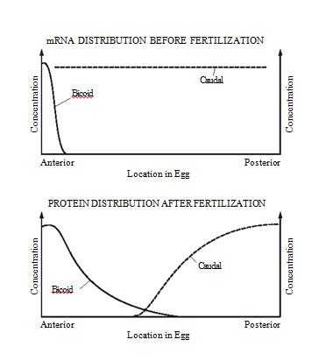(D) recombination of the genomes of free virus particles

25. **The first diagram below shows the levels of mRNA from two different genes (bicoid and caudal) at different positions along the anterior- posterior axis of a Drosophila egg immediately before fertilization. The second diagram shows the levels of the two corresponding proteins along the anterior-posterior axis shortly after fertilization.**  
**Which of the following conclusions is best supported by the data?**  
**(A) Bicoid protein inhibits translation of caudal mRNA.  
(B) Bicoid protein stabilizes caudal mRNA.  
(C) Translation of bicoid mRNA produces caudal protein.  
(D) Caudal protein stimulates development of anterior structures.**  
  
**26. Sickle-cell anemia results from a point mutation in the HBB gene.The mutation results in the replacement of an amino acid that has a hydrophilic R-group with an amino acid that has a hydrophobic R-group on the exterior of the hemoglobin protein. Such a mutation would most likely result in altered**

**(A) properties of the molecule as a result of abnormal interactions between adjacent hemoglobin molecules  
(B) DNA structure as a result of abnormal hydrogen bonding between nitrogenous bases  
(C) fatty acid structure as a result of changes in ionic interactions between adjacent fatty acid chains  
(D) protein secondary structure as a result of abnormal hydrophobic interactions between R-groups in the backbone of the protein**

27. Analysis of DNA sequences from two individuals of the same species results in a greater estimate of genetic variability than does analysis of amino acid sequences from the same individuals because

(A) different DNA sequences can code for the same amino acid

(B) some amino acid variations cannot be detected by protein electrophoresis

(C) DNA sequencing is a more reliable technique than protein electrophoresis

1. proteins are more easily damaged than is DNA

DNA is more heat-sensitive and therefore varies more

28. Arctic foxes typically have a white coat in the winter. In summer, when there is no snow on the ground, the foxes typically have a darker coat. Which of the following is most likely responsible for the seasonal change in coat color?

(A) The decrease in the amount of daylight in winter causes a change in gene expression, which results in the foxes growing a lighter appearing coat.

(B) The diet of the foxes in summer lacks a particular nutrient, which causes the foxes to lose their white coat and grow a darker colored coat.

(C) Competition for mates in the spring causes each fox to increase its camouflage with the environment by producing a darker appearing coat.

(D) The lower temperatures in winter denature the pigment molecules in the arctic fox coat, causing the coat to become lighter in color.

29. Testosterone oxido-reductase is a liver enzyme that regulates testosterone levels in alligators. One study compared testosterone oxido-reductase activity between male and female alligators from Lake Woodruff, a relatively pristine environment, and from Lake Apopka, an area that has suffered severe contamination. The graph above depicts the findings of that study. The data in the graph best support which of the following claims?

(A) Environmental contamination elevates total testosterone oxido-reductase activity in females.

(B) Environmental contamination reduces total testosterone oxido-reductase activity in females.

(C) Environmental contamination elevates total testosterone oxido-reductase activity in males.

(D) Environmental contamination reduces total testosterone oxido-reductase activity in males.

**Practice Long Response Questions**

1. The human genome illustrates both continuity and change.

a. Describe the essential features of two of the procedures/techniques below. For each of the procedures/ techniques you describe, explain how its application contributes to understanding genetics.

• the use of a bacterial plasmid to clone and sequence a human gene

• polymerase chain reaction (PCR)

• restriction fragment length polymorphism (RFLP) analysis

b. All humans are nearly identical genetically in coding sequences and have many proteins that are identical in structure and function. Nevertheless, each human has a unique DNA fingerprint. Explain this apparent contradiction.

2.  Assume that a particular genetic condition in a mammalian species causes an inability to digest starch. This disorder occurs with equal frequency in males and females. In most cases, neither parent of affected offspring has the condition.

* 1. Describe the most probable pattern of inheritance for this condition. Explain your reasoning. Include in your discussion a sample cross(es) sufficient to verify your proposed pattern.
  2. Explain how a mutation could cause this inability to digest starch.
  3. Describe how modern techniques of molecular biology could be used to determine whether the mutant allele is present in a given individual.

3. Describe the operon hypothesis and discuss how it explains the control of messenger RNA production and the regulation of protein synthesis in bacterial cells.

4. Describe the production and processing of a protein that will be exported from a eukaryotic cell. Begin with the separation of the messenger RNA from the DNA template and end with the release of the protein at the plasma membrane.

5. A portion of specific DNA molecule consists of the following sequence of nucleotide triplets: TAC GAA CTT GGG TCC

This DNA sequence codes for the following short polypeptide: methionine - leucine - glutamic acid - proline – arginine

Describe the steps in the synthesis of this polypeptide. What would be the effect of a deletion or an addition in one of the DNA nucleotides? What would be the effects of a substitution in one of the nucleotides.