Name: _____________________________________________ Date: ____________________________ Period: ______

**AP Biology Exam Review : Organism Form and Function (Unit 9)**

Ms. Ottolini, 2012-2013

**Textbook Chapters:** N/A (This unit jumps around in the textbook A LOT. Please use your video notes, nervous system book notes, and endocrine system class notes as your primary resources. You should use the index of your book to find the textbook location for certain terms / concepts that you want to explore further for clarification.)

**Helpful Videos and Animations:**

[Bozeman Biology: Positive and Negative Feedback Loops (Video #1)](https://www.youtube.com/watch?v=CLv3SkF_Eag&list=PLFCE4D99C4124A27A)  
[Bozeman Biology: Response to External Environments (Video #2)](https://www.youtube.com/watch?v=BUlBwe8miTQ&list=PLFCE4D99C4124A27A)  
[Bozeman Biology: Plant and Animal Defense (Video #3)](https://www.youtube.com/watch?v=Sf-0mUgz3KA&list=PLFCE4D99C4124A27A&index=28)  
[Bozeman Biology: Development - Timing and Coordination (Video #4)](https://www.youtube.com/watch?v=pa9uPnIeVKU&list=PLFCE4D99C4124A27A)  
[Bozeman Biology: Cellular Specialization (Video #5)](https://www.youtube.com/watch?v=jp6L5emD8rw&list=PLFCE4D99C4124A27A)  
[Bozeman Biology: Mechanisms of Timing and Control (Video #6)](https://www.youtube.com/watch?v=dju6tTb55Fw&list=PLFCE4D99C4124A27A)  
[Bozeman Biology: Behavior and Natural Selection (Video #7)](https://www.youtube.com/watch?v=vZNeRWchqRc&list=PLFCE4D99C4124A27A)  
[Bozeman Biology: Cell Communication (Video #8)](https://www.youtube.com/watch?v=xnGXItWrJ3k&list=PLFCE4D99C4124A27A)  
[Bozeman Biology: Signal Transduction Pathways (Video #9)](https://www.youtube.com/watch?v=qOVkedxDqQo&list=PLFCE4D99C4124A27A)  
[Bozeman Biology: Effects of Changes in Pathways (Video #10)](https://www.youtube.com/watch?v=W48Gk2Om3wI&list=PLFCE4D99C4124A27A)  
[Bozeman Biology: Evolutionary Significance of Cell Communication (Video #11)](https://www.youtube.com/watch?v=FsGwgiIv_NU&list=PLFCE4D99C4124A27A)

[Bozeman Biology: The Nervous System](https://www.youtube.com/watch?v=UabDiuTtU0M&list=PLFCE4D99C4124A27A)

[McGraw Hill Animation: Action Potential](http://highered.mcgraw-hill.com/sites/0072495855/student_view0/chapter14/animation__the_nerve_impulse.html)  
[Mcraw Hill Animation: Transmission of a Nerve Impulse across a Synapse](http://highered.mcgraw-hill.com/sites/0072495855/student_view0/chapter14/animation__transmission_across_a_synapse.html)

**Topic Outline:**

***Note: Highlighted examples represent examples discussed in class. For the categories with highlighted examples, the College Board Curriculum requires one or a few (but NOT ALL) examples to be covered in class. Teachers can choose which examples to cover. Where no examples are highlighted, assume you need to know ALL the information within the bulleted or numbered section.***

***Note: Sections in bold will be addressed during the review, as they were not adequately covered in this unit.***

1. Maintaining Homeostasis

Essential knowledge 2.C.1: Organisms use feedback mechanisms to maintain their internal environments and

respond to external environmental changes.

a. Negative feedback mechanisms maintain dynamic homeostasis for a particular condition (variable) by

regulating physiological processes, returning the changing condition back to its target set point.

To demonstrate student understanding of this concept, make sure you can explain the following:

● Temperature regulation in animals

● Plant responses to water limitations

b. Positive feedback mechanisms amplify responses and processes in biological organisms. The variable

initiating the response is moved farther away from the initial set-point. Amplification occurs when the stimulus

is further activated which, in turn, initiates an additional response that produces system change.

To demonstrate student understanding of this concept, make sure you can explain the following:

● Lactation in mammals

● Onset of labor in childbirth

● Ripening of fruit

c. Alteration in the mechanisms of feedback often results in deleterious consequences.

To demonstrate student understanding of this concept, make sure you can explain the following:

● Diabetes mellitus in response to decreased insulin

● Dehydration in response to decreased antidiuretic hormone (ADH)

● Graves’ disease (hyperthyroidism)

● Blood clotting

Essential knowledge 2.C.2: Organisms respond to changes in their external environments.

a. Organisms respond to changes in their environment through behavioral and physiological mechanisms.

To demonstrate student understanding of this concept, make sure you can explain the following:

● Photoperiodism and phototropism in plants

● Hibernation and migration in animals

● Taxis and kinesis in animals

● Chemotaxis in bacteria, sexual reproduction in fungi

● Nocturnal and diurnal activity: circadian rhythms

● Shivering and sweating in humans

**Essential knowledge 2.D.2: Homeostatic mechanisms reflect both common ancestry and divergence due to**

**adaptation in different environments.**

**a. Continuity of homeostatic mechanisms reflects common ancestry, while changes may occur in response to**

**different environmental conditions.**

**b. Organisms have various mechanisms for obtaining nutrients and eliminating wastes.**

**To demonstrate student understanding of this concept, make sure you can explain the following:**

**● Gas exchange in aquatic and terrestrial plants**

**● Digestive mechanisms in animals such as food vacuoles, gastrovascular cavities, one-way digestive**

**systems**

**● Respiratory systems of aquatic and terrestrial animals**

**● Nitrogenous waste production and elimination in aquatic and terrestrial animals**

**c. Homeostatic control systems in species of microbes, plants and animals support common ancestry.**

**To demonstrate student understanding of this concept, make sure you can explain the following:**

**● Excretory systems in flatworms, earthworms and vertebrates**

**● Osmoregulation in bacteria, fish and protists**

**● Osmoregulation in aquatic and terrestrial plants**

**● Circulatory systems in fish, amphibians and mammals**

**● Thermoregulation in aquatic and terrestrial animals (countercurrent exchange mechanisms)**

Essential knowledge 2.D.3: Biological systems are affected by disruptions to their dynamic homeostasis.

a. Disruptions at the molecular and cellular levels affect the health of the organism.

To demonstrate student understanding of this concept, make sure you can explain the following:

● Physiological responses to toxic substances

● Dehydration

● Immunological responses to pathogens, toxins and allergens

Essential knowledge 2.D.4: Plants and animals have a variety of chemical defenses against infections that affect

dynamic homeostasis.

a. Plants, invertebrates and vertebrates have multiple, nonspecific immune responses.

To demonstrate student understanding of this concept, make sure you can explain the following:

● Invertebrate immune systems have nonspecific response mechanisms, but they lack pathogen-specific

defense responses.

● Plant defenses against pathogens include molecular recognition systems with systemic responses;

infection triggers chemical responses that destroy infected and adjacent cells, thus localizing the effects. (ex: Hypersensitivity Response)

● Vertebrate immune systems have nonspecific and nonheritable defense mechanisms against

pathogens.

b. Mammals use specific immune responses triggered by natural or artificial agents that disrupt dynamic

homeostasis.

Evidence of student learning is a demonstrated understanding of each of the following:

1. The mammalian immune system includes two types of specific responses: cell mediated and

humoral.

2. In the cell-mediated response, cytotoxic T cells, a type of lymphocytic white blood cell, “target”

intracellular pathogens when antigens are displayed on the outside of the cells.

3. In the humoral response, B cells, a type of lymphocytic white blood cell, produce antibodies against

specific antigens.

4. Antigens are recognized by antibodies to the antigen.

5. Antibodies are proteins produced by B cells, and each antibody is specific to a particular antigen.

6. A second exposure to an antigen results in a more rapid and enhanced immune response.

1. Timing and Coordination

Essential knowledge 2.E.1: Timing and coordination of specific events are necessary for the normal development

of an organism, and these events are regulated by a variety of mechanisms.

a. Observable cell differentiation results from the expression of genes for tissue-specific proteins.

b. Induction of transcription factors during development results in sequential gene expression.

Evidence of student learning is a demonstrated understanding of each of the following:

1. Homeotic genes are involved in developmental patterns and sequences.

2. Embryonic induction in development results in the correct timing of events.

3. Temperature and the availability of water determine seed germination in most plants.

4. Genetic mutations can result in abnormal development.

5. Genetic transplantation experiments support the link between gene expression and normal

development.

6. Genetic regulation by microRNAs plays an important role in the development of organisms and the

control of cellular functions.

c. Programmed cell death (apoptosis) plays a role in the normal development and differentiation.

To demonstrate student understanding of this concept, make sure you can explain the following:

● Morphogenesis of fingers and toes

● Immune function

● C. elegans development

● Flower development

Essential knowledge 2.E.2: Timing and coordination of physiological events are regulated by multiple

mechanisms.

a. In plants, physiological events involve interactions between environmental stimuli and internal molecular

signals. [See also 2.C.3]

To demonstrate student understanding of this concept, make sure you can explain the following:

1. Phototropism, or the response to the presence of light

2. Photoperiodism, or the response to change in length of the night, that results in flowering in long-day

and short-day plants

b. In animals, internal and external signals regulate a variety of physiological responses that synchronize with

environmental cycles and cues.

To demonstrate student understanding of this concept, make sure you can explain the following:

● Circadian rhythms, or the physiological cycle of about 24 hours that is present in all eukaryotes

and persists even in the absence of external cues

● Diurnal/nocturnal and sleep/awake cycles

● Jet lag in humans

● Seasonal responses, such as hibernation, estivation and migration

● Release and reaction to pheromones

● Visual displays in the reproductive cycle

c. In fungi, protists and bacteria, internal and external signals regulate a variety of physiological responses that

synchronize with environmental cycles and cues.

To demonstrate student understanding of this concept, make sure you can explain the following:

● Fruiting body formation in fungi, slime molds and certain types of bacteria

● Quorum sensing in bacteria

1. Cell Communication

Essential knowledge 3.D.1: Cell communication processes share common features that reflect a shared

evolutionary history.

a. Communication involves transduction of stimulatory or inhibitory signals from other cells, organisms or the

environment.

b. Correct and appropriate signal transduction processes are generally under strong selective pressure.

c. In single-celled organisms, signal transduction pathways influence how the cell responds to its environment.

To demonstrate student understanding of this concept, make sure you can explain the following:

● Use of chemical messengers by microbes to communicate with other nearby cells and to regulate

specific pathways in response to population density (quorum sensing)

● Use of pheromones to trigger reproduction and developmental pathways

● Response to external signals by bacteria that influences cell movement

d. In multicellular organisms, signal transduction pathways coordinate the activities within individual cells that

support the function of the organism as a whole.

To demonstrate student understanding of this concept, make sure you can explain the following:

● Epinephrine stimulation of glycogen breakdown in mammals

● Temperature determination of sex in some vertebrate organisms

● DNA repair mechanisms

Essential knowledge 3.D.2: Cells communicate with each other through direct contact with other cells or from a

distance via chemical signaling.

a. Cells communicate by cell-to-cell contact.

To demonstrate student understanding of this concept, make sure you can explain the following:

● Immune cells interact by cell-cell contact, antigen-presenting cells (APCs), helper T-cells and killer Tcells.

[See also 2.D.4]

● Plasmodesmata between plant cells that allow material to be transported from cell to cell.

b. Cells communicate over short distances by using local regulators that target cells in the vicinity of the

emitting cell.

To demonstrate student understanding of this concept, make sure you can explain the following:

● Neurotransmitters

● Plant immune response

● Quorum sensing in bacteria

● Morphogens in embryonic development

c. Signals released by one cell type can travel long distances to target cells of another cell type.

Evidence of student learning is a demonstrated understanding of the following:

1. Endocrine signals are produced by endocrine cells that release signaling molecules, which are specific

and can travel long distances through the blood to reach all parts of the body.

To demonstrate student understanding of this concept, make sure you can explain the following:

● Insulin

● Human growth hormone

● Thyroid hormones

● Testosterone

● Estrogen

Essential knowledge 3.D.4: Changes in signal transduction pathways can alter cellular response.

a. Conditions where signal transduction is blocked or defective can be deleterious, preventative or prophylactic.

To demonstrate student understanding of this concept, make sure you can explain the following:

● Diabetes, heart disease, neurological disease, autoimmune disease (specifically HIV), cancer, cholera

● Effects of neurotoxins, poisons, pesticides

● Drugs (Hypertensives, Anesthetics, Antihistamines and Birth Control Drugs)

Essential knowledge 3.E.2: Animals have nervous systems that detect external and internal signals, transmit

and integrate information, and produce responses.

a. The neuron is the basic structure of the nervous system that reflects function.

Evidence of student learning is a demonstrated understanding of each of the following:

1. A typical neuron has a cell body, axon and dendrites. Many axons have a myelin sheath that acts as

an electrical insulator.

2. The structure of the neuron allows for the detection, generation, transmission and integration of

signal information.

3. Schwann cells, which form the myelin sheath, are separated by gaps of unsheathed axon over which

the impulse travels as the signal propagates along the neuron.

b. Action potentials propagate impulses along neurons.

Evidence of student learning is a demonstrated understanding of each of the following:

1. Membranes of neurons are polarized by the establishment of electrical potentials across the

membranes.

2. In response to a stimulus, Na+ and K+ gated channels sequentially open and cause the membrane to

become locally depolarized.

3. Na+/K+ pumps, powered by ATP, work to maintain membrane potential.

c. Transmission of information between neurons occurs across synapses.

Evidence of student learning is a demonstrated understanding of each of the following:

1. In most animals, transmission across synapses involves chemical messengers called

neurotransmitters.

To demonstrate student understanding of this concept, make sure you can explain the effects of the

following:

● Acetylcholine

● Epinephrine

● Norepinephrine

● Dopamine

● Serotonin

● GABA

2. Transmission of information along neurons and synapses results in a response.

3. The response can be stimulatory or inhibitory.

d. Different regions of the vertebrate brain have different functions.

To demonstrate student understanding of this concept, make sure you can explain the following:

Note: we briefly looked at how the different brain hemispheres / structures coordinated different body functions

● Vision

● Hearing

● Muscle movement

● Abstract thought and emotions

● Neuro-hormone production

● Forebrain (cerebrum), midbrain (brainstem) and hindbrain (cerebellum)

● Right and left cerebral hemispheres in humans

**Essential knowledge 4.A.4: Organisms exhibit complex properties due to interactions between their constituent**

**parts.**

**a. Interactions and coordination between organs provide essential biological activities.**

**To demonstrate student understanding of this concept, make sure you can explain the following:**

**● Stomach and small intestines**

**● Kidney and bladder**

**● Root, stem and leaf**

**b. Interactions and coordination between systems provide essential biological activities.**

**To demonstrate student understanding of this concept, make sure you can explain the following:**

**● Respiratory and circulatory**

**● Nervous and muscular**

**● Plant vascular and leaf**

**Essential knowledge 4.B.2: Cooperative interactions within organisms promote efficiency in the use of energy**

**and matter.**

**a. Organisms have areas or compartments that perform a subset of functions related to energy and matter, and**

**these parts contribute to the whole.**

**To demonstrate student understanding of this concept, make sure you can explain the following:**

**1. At the cellular level, the plasma membrane, cytoplasm and, for eukaryotes, the organelles contribute**

**to the overall specialization and functioning of the cell.**

**2. Within multicellular organisms, specialization of organs contributes to the overall functioning of the**

**organism.**

**To demonstrate student understanding of this concept, make sure you can explain the following:**

**● Exchange of gases**

**● Circulation of fluids**

**● Digestion of food**

**● Excretion of wastes**

**3. Interactions among cells of a population of unicellular organisms can be similar to those of**

**multicellular organisms, and these interactions lead to increased efficiency and utilization of energy and**

**matter.**

**To demonstrate student understanding of this concept, make sure you can explain the following:**

**● Bacterial community in the rumen of animals**

**● Bacterial community in and around deep sea vents**

**Practice Multiple Choice Questions:**

***Note: The questions below are all taken from the AP Biology Practice Test Released for the new 2012-2013 Curriculum. Other questions related to this unit from your print copy of the AP Biology Practice Test are…***

**#21, 33, 34, 46, 57, 63**

***Please also revisit your quizzes from Parts A, B, and C of this unit***

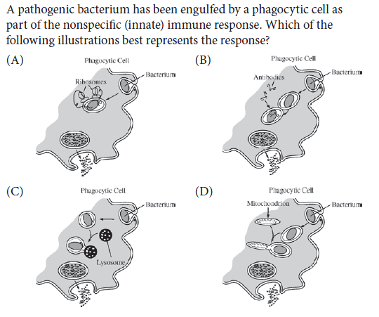



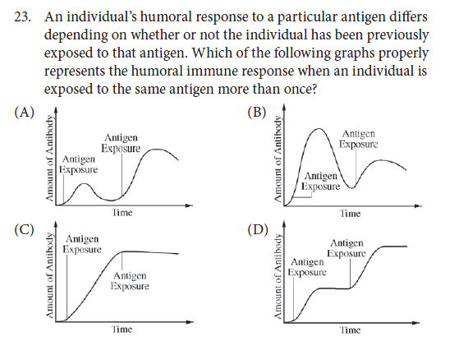



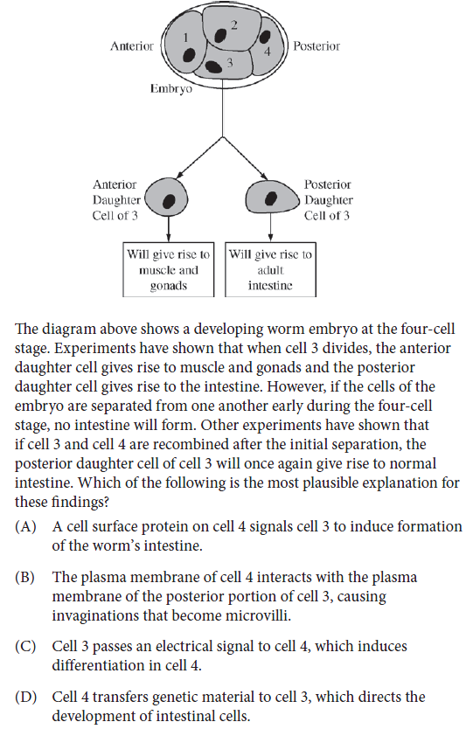

**Practice Long Response Questions:**

1.  Biological recognition is important in many processes at the molecular, cellular, tissue, and organismal levels. Select three of the following, and for each of the three that you have chose, explain how the process of recognition occurs and give an example of each.

* 1. Organisms recognize others as members of their own species.
  2. Neurotransmitters are recognized in the synapse.
  3. Antigens trigger antibody response.
  4. Nucleic acids are complementary.
  5. Target cells respond to specific hormones.

2.  Communication occurs among the cells in a multicellular organism. Choose THREE of the following examples of cell-to-cell communication, and for each example, describe the communication that occurs and the types of responses that result from this communication.

* communication between two plant cells
* communication between two immune-system cells
* communication either between a neuron and another neuron, or between a neuron and a muscle cell

communication between a specific endocrine-gland cell and its target cell

3. 2005:4

An important defense against diseases in vertebrate animals is the ability to eliminate,

inactivate, or destroy foreign substances and organisms. Explain how the immune system

achieves THREE of the following:

* Provides an immediate nonspecific immune response
* Activates T and B cells in response to an infection
* Responds to a later exposure to the same infectious agent
* Distinguishes self from nonself

4. 2004B:3

Homeostasis, maintaining a steady-state internal environment, is a characteristic of all living

organisms. Choose three of the following physiological parameters and for each, describe

how homeostasis is maintained in an organism of your choice. Be sure to indicate what

animal you have chosen for each parameter. You may use the same animal or different

animals for your three descriptions.

* Blood-glucose levels
* Body temperature
* pH of blood
* Osmotic concentration of the blood
* Neuron resting-membrane potential