Name___________________________________ Date ____________ Period _______

RESPIRATORY SYSTEM
Part A – Read and color code the respiratory structures.
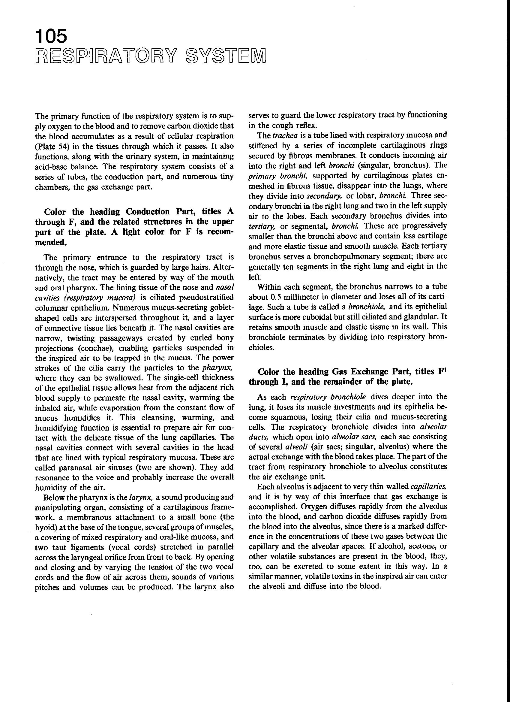
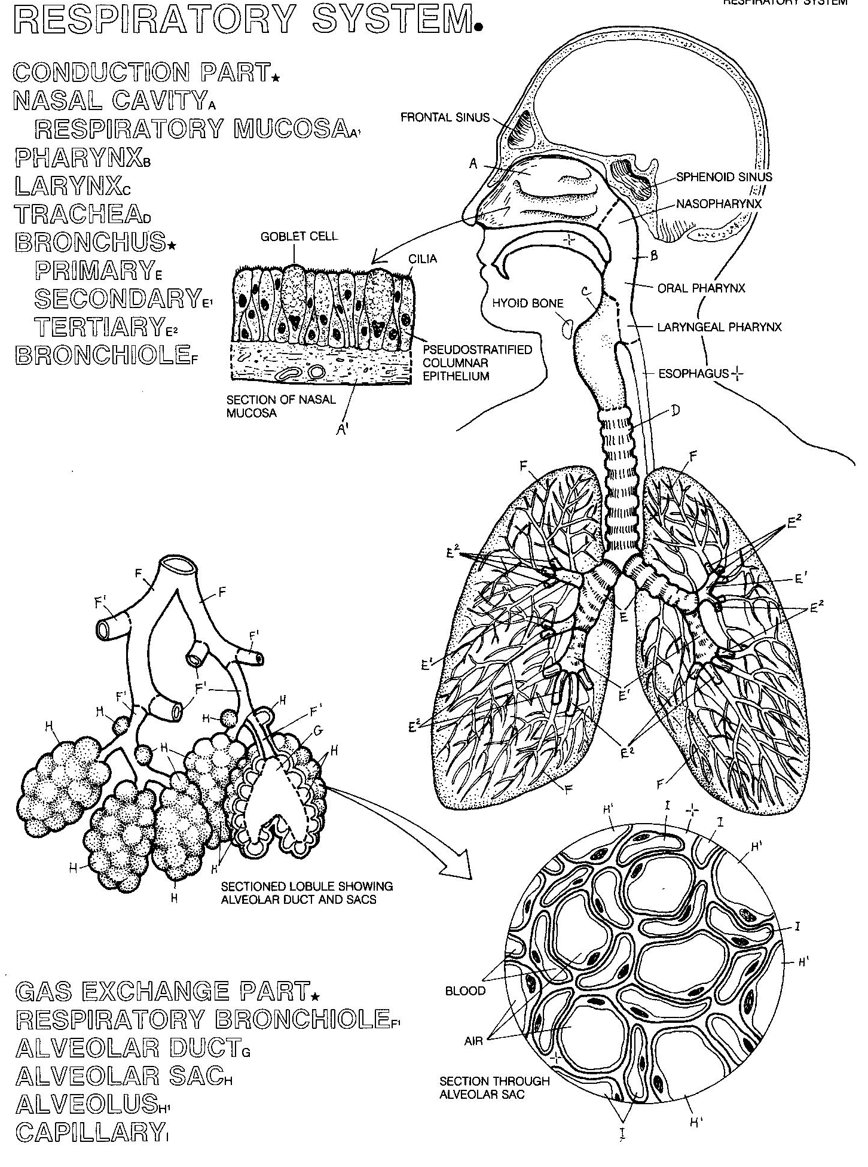
PART B – Trace the pathway of oxygen and carbon dioxide as a person inhales and then exhales. Include all parts of the respiratory and circulatory system involved.

