Scientific Method - Controls and Variables Worksheet #4
Please write your answers on a separate sheet of paper.
Write a definition for each:
Control -
Variable -
Manipulated Variable -
Responding Variable -

SpongeBob and his Bikini Bottom pals have been busy doing a little research. Read the description for each experiment and answer the questions.
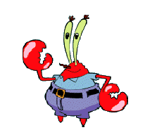
Krusty Krabs Breath Mints
Mr. Krabs created a secret ingredient for a breath mint
that he thinks will “cure” the bad breath people get from
eating crabby patties at the Krusty Krab. He asked 100
customers with a history of bad breath to try his new
breath mint. He had fifty customers (Group A) eat a
breath mint after they finished eating a crabby patty.
The other fifty (Group B) also received a breath mint after
they finished the sandwich, however, it was just a regular
breath mint and did not have the secret ingredient. Both groups were told that they were getting the breath mint that would cure their bad breath. Two hours after eating the crabby patties, thirty customers in Group A and ten customers in Group B reported having better breath than they normally had after eating crabby patties.

1. Which people are in the control group?
2. What is the manipulated variable?
3. What is the responding variable?
4. What should Mr. Krabs’ conclusion be?
5. Why do you think 10 people in group B reported fresher breath?

SpongeBob Clean Pants
SpongeBob noticed that his favorite pants were not as clean as they used to be. His friend Sandy told him that he should try using Clean-O detergent, a new laundry soap she found at Sail-Mart. SpongeBob made sure to wash one pair of pants in plain water and another pair in water with the Clean-O detergent. After washing both pairs of pants a total of three times, the pants washed in the Clean-O detergent did not appear to be any cleaner than the pants washed in plain water.
6. What was the problem SpongeBob wanted to investigate?
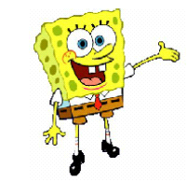
7. What is the manipulated variable?
8. What is the responding variable?
9. What should Sponge Bob’s conclusion be?

T. Trimpe 2003

Squidward’s Symphony
Squidward loves playing his clarinet and believes it attracts more jellyfish than any other instrument he has played. In order to test his hypothesis, Squidward played a song on his clarinet for a total of 5 minutes and counted the number of jellyfish he saw in his front yard. He played the song a total of 3 times on his clarinet and repeated the experiment using a flute and a guitar. He also recorded the number of jellyfish he observed when he was not playing an instrument. The results are shown in the chart.
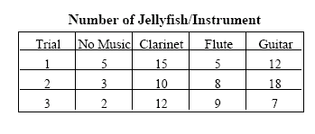

10. What is the manipulated variable?

11. What is the responding variable?

12. What should Squidward’s conclusion be?

13. Are the results reliable? Why or why not?

Super Bubbles
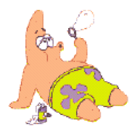
Patrick and SpongeBob love to blow bubbles! Patrick found some Super
Bubble Soap at Sail-Mart. The ads claim that Super Bubble Soap will
produce bubbles that are twice as big as bubbles made with regular bubble
soap. Patrick and SpongeBob made up two samples of bubble solution.
One sample was made with 5 oz. of Super Bubble Soap and 5 oz. of water, while
the other was made with the same amount of water and 5 oz. of regular
bubble soap. Patrick and SpongeBob used their favorite bubble wands to
blow 10 different bubbles and did their best to measure the diameter of
each one. The results are shown in the chart
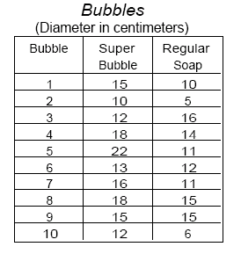

14. What did the Super Bubble ads claim?

15. What is the manipulated variable?

16. What is the responding variable?

17. Look at the results in the chart.
a. Calculate the average diameter for each bubble solution.
Super Bubble = ______ cm Regular Soap = ________ cm

b. What should their conclusion be?

18. Are the results reliable? Why or why not?

T. Trimpe 2003

