CHAPTER 16: DNA, RNA, PROTEINS
NUCLEIC ACIDS (DNA & RNA) = “Information” molecules
NUCLEOTIDE SUBUNITS
SUGAR = Ribose (RNA)
OR Deoxyribose (DNA)
NITROGEN BASES:
DNA | RNA
Adenine | Adenine
Guanine | Guanine
Cytosine | Cytosine
Thymine | Uracil

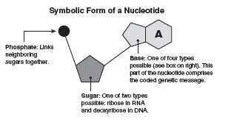

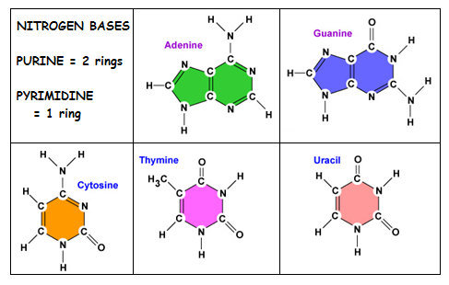

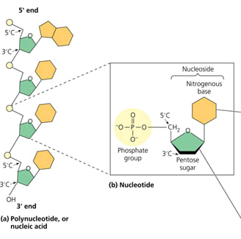
CHARGAFF’S RULES:
A = T and G = C
A Purine always bonds to a Pyrimidine
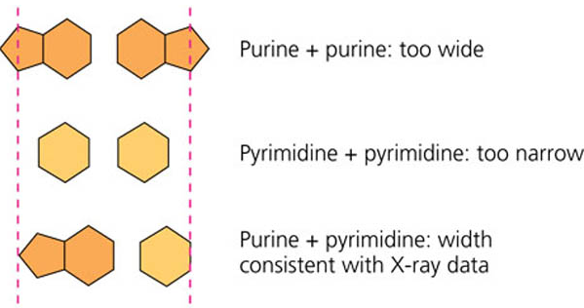

RIBONUCLEIC ACID (RNA)  • Single stranded  • Sugar = ribose  • Nitrogenous bases  = A, U, G, (NO T)  • Can fold up in 3D shape | DEOXYRIBONUCLEIC ACID (DNA)  • Double stranded  • Sugar = deoxyribose  • Nitrogenous bases = A, T, G, C (NO U)  • Strands run in opposite directions (ANTIPARALLEL)  • Ladder twists into a DOUBLE HELIX  • Backbone = sugars and phosphates  • Rungs of ladder = nitrogenous bases  • Hydrogen bonds between nitrogenous bases hold sides of ladder together
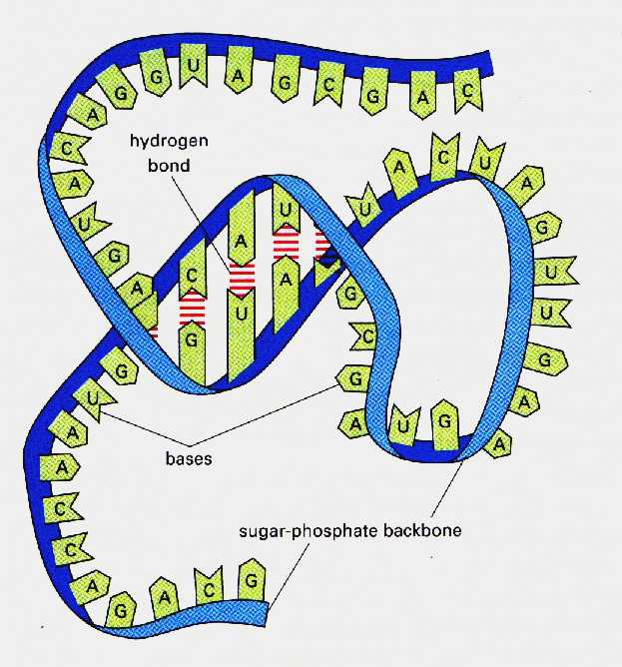 | 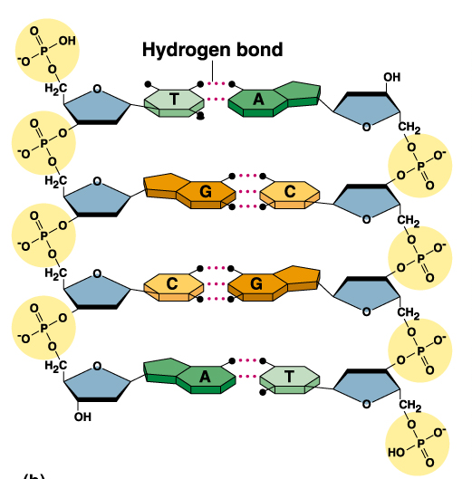
REPLICATION (DNA → DNA)
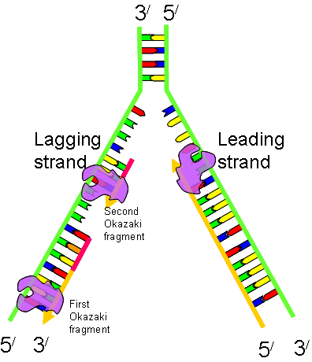
Site where it starts = ORIGIN of REPLICATION
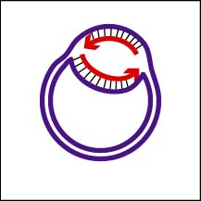
Place where nucleotides add = REPLICATION FORK
Prokaryote- single starting spot
Eukaryotes-multiple sites
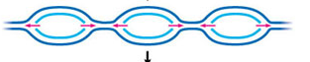

DNA POLYMERASE
• reads code strand in 3’ → 5’ direction
• builds a new strand in 5’→3’ direction
• adds on to 3’ end of sugar in previous nucleotide
Splitting phosphates from nucleotide triphosphate subunits
provides energy for reaction
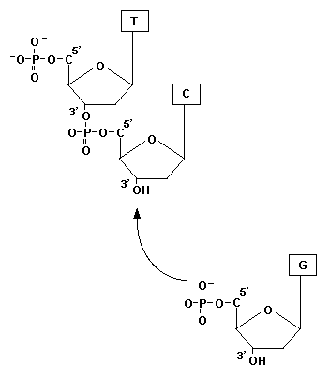
DNA POLYMERASE CAN’T START A CHAIN by itself;
can only add nucleotides to 3’ end of an existing DNA/RNA chain

- HELICASE- untwists double helix to open strands at replication forks
- TOPOISOMERASE- relieves strain caused by untwisting
- SINGLE-STRAND BINDING PROTEINS-
stabilize unpaired strands to hold them open
- PRIMASE-starts segment by adding RNA primer sequence
- DNA POLYMERASE I –
removes RNA primers and replaces them with DNA bases
by adding to the 3’ end of the previous fragment
- LIGASE-joins Okazaki fragments together to make a continuous copied strand

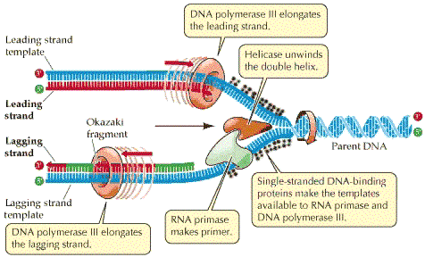

LEADING STRAND (runs 3’→ 5’)
copies toward the replication fork
PRIMASE adds RNA primer
to start chain
DNA POLYMERASE III
adds nucleotides in 5’ → 3’ direction
LAGGING STRAND (runs 5’→ 3’)
copies away from replication fork
PRIMASE
adds RNA primers at various spots as
fork opens
DNA POLYMERASE III
adds nucleotides in 5’ → 3’ direction
short segments= OKAZAKI FRAGMENTS

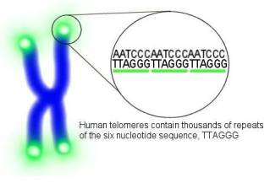
IMPORTANT: Because DNA polymerase can’t fill in last section when primer is removed from lagging strand, the code shortens with each replication

TELOMERE sequences at ends of chromosomes
prevent erosion of essential information in code with each replication
TELOMERASE = enzyme that lengthens telomeres
• found in eukaryotic germ cells that divide frequently
to produce gametes
• may play a role in a aging and cancer

PROOFREADING & REPAIR
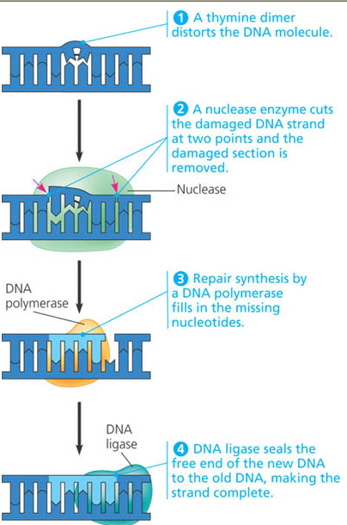
Mistakes in final DNA: 1 in 10 billion
Mistakes in initial base pairing during replication 1 in 100,000
DNA POLYMERASE proofreads each base as it’s added
& fixes errors
Errors can come from “proofreading mistakes” that are not caught OR environmental damage
(Ex: X-rays, UV light, chemical mutagens/carcinogens)

NUCLEOTIDE EXCISION-REPAIR
• Cells continually monitor DNA and make repairs
• NUCLEASES- DNA cutting enzymes remove errors
• DNA POLYMERASE fills in gap using complimentary strand
• LIGASE seals ends

Ex: THYMINE DIMERS = joins THYMINES in same strand
• damage caused by UV light
• can be repaired

Xeroderma pigmentosum-
genetic disorder can’t go out in sun
mutation in DNA enzymes that repair UV
increased skin cancer/cataracts

